|  |
| --- |
| NEA Project |
| 2D Platformer Forces Model |
| AQA Computer Science A-Level |

|  |
| --- |
| John Coplin  Candidate Number: 7631 |

Contents

Analysis 2

The Problem 2

Research 3

Interviews 22

Objectives 25

Constraints 28

Data Dictionary (Analysis) 37

Design 44

Top-Down Diagram 44

IPSO Chart 45

Data Dictionary (Design) 49

Program Structure 58

Algorithms 60

Class Diagrams 67

Interface 75

Hardware and Data Security 77

Technical Solution 79

Complete Code Listing 79

OOP Built Class Diagrams 113

Testing 123

Main Test 123

Secondary Tests 124

Improvements From Tests 132

Evaluation 138

Self-Evaluation 138

Independent Feedback 143

Feedback Analysis 145

# Analysis

## The Problem

Although traditional teaching methods are effective in the sense that they go into a lot of detail, they can be inefficient when it comes to keeping the attention of younger students. As a kid, I often found it hard to stay focused in class, and always found more interactive and engaging forms of learning like educational video games more effective. In fact, I’ve been passionate about video games all throughout my life, namely platforming games in which physics play a major role like Super Mario Bros. and Sonic the Hedgehog.

With this in mind, I’ve decided to solve the problem of creating a 2D platforming game which will give my end users (physics students who want to learn about forces) an introduction to various forces they will learn about in their course. Although the game will primarily be an educational one, in order to make it more fun and engaging than traditional teaching methods it will encourage the player to replay it as much as possible by persuading them to try completing it as fast as they can, in theory giving them a better understanding of the physics involved the more they replay it.

I’ve considered coding the program in Unity and C# so the game could make use of a three-dimensional space, however I ultimately decided against this as I thought learning to code in C# to a degree where I’d be skilled enough to code the program and actually coding the program itself (along with learning how to use Unity) would be impossible to do in the timeframe I’ve been given to make the program.

Instead, I’ve chosen to code the project in Python, as it’s the coding language I have the most experience with and knowledge surrounding (meaning that I won’t have to learn as many new things in order to code the game). Python also has many features which make it a great language to use for the project, including its support for object-oriented programming (which will allow me to code each of the game’s elements (e.g. the player, the ground, interactable objects) as separate entities and have them interact with each other) and its use of the procedural programming paradigm (giving me the ability to code the game’s controls as algorithms which execute when the player presses a key). Python also has a large list of libraries, most notably Pygame (a game engine designed for Python that has many pre-made functions and tools), which will collectively make game creation much more intuitive and allow me to focus on how to clearly illustrate the forces to be displayed without having to worry about how I should code fundamental elements of the game (e.g. how to display the game in a separate window, how to detect inputs from the keyboard).

Although all of these features will help me to design the game itself, many of them are shared with other languages (e.g. C++ also has a large list of libraries, and supports the Unreal Game Engine (which is a much better game engine than Pygame)). However, what makes Python the best language for the project is its advanced mathematical capabilities - the game will require multiple calculations to be taking place every second (e.g. calculating how fast the player should accelerate in any given condition, updating the player’s coordinates whenever they move, calculating how gravity will affect the ball), and other programming languages may not be able to handle them.

I’ve decided to use the integrated development environment Thonny to code the game, as I’ve been using it to code programs for five years, and therefore won’t have to learn how to use it while figuring out how to make the game.

## Research

In order to research the problem and figure out how I’m going to code the game, I'm going to research how real-life accurate physics are implemented in Pygame, as well as examples of vertical 2D platformers in which you descend from the top of a level to its bottom to get inspiration for the level design. I will also be researching how to use Pygame, learning how it works to a degree sufficient enough for me to be able to code the game.

Sources researched:

* <https://www.makeuseof.com/pygame-collision-detection-physics/> (Pygame Physics and Collision Guide):
  + Acceleration can be created using a value which is constantly added to/subtracted from, and multiplying the value which is added/subtracted by an increment as the player moves faster/slower.
  + Pygame has built-in sprite collision detection methods (e.g. *pygame.sprite.spritecollide()* ), which could be useful for generating reaction forces for each piece of terrain.
  + I need to make sure I include gravity in my calculations for velocity on the y-axis.
* Marble It Up (<https://store.steampowered.com/app/864060/Marble_It_Up_Ultra/>):
  + The marble bounces when it hits the ground - I could implement a system where the ball bounces depending on how fast it's falling, although this might be irritating for the player given that the level's design will focus on descending from its top to its bottom (and therefore they may be bouncing a lot).
  + The marble is also allowed to jump – although this may not be accurate to real life, this would make the level easier to design and more fun to play, so I will include this feature in the game.
* Downwell (<https://store.steampowered.com/app/360740/Downwell/>):
  + Downwell has hidden collectibles to find throughout its levels – this could be implemented into the game in many ways (e.g. keys which open doors).
* Celeste (<https://store.steampowered.com/app/504230/Celeste/>):
  + Although Celeste focuses on ascending rather than descending, it splits each level into a variety of different rooms which you can explore, requiring the player to reach rooms below and next to the room they're currently in as well as ones above them in order to reach the goal. This creates a fun gameplay loop in which the game can experiment with a wide variety of different ideas.
* <http://programarcadegames.com/> (Pygame Game Coding Course):
  + Colours in Pygame can be stored as tuples with three elements, in which each element corresponds to a red, green, and blue value respectively (e.g. The tuple *(0, 0, 255)* would correspond to blue).
  + Colour presets can be set as constants, making them more readily available later on (e.g. *RED = (255, 0, 0)*, *GREEN = (0, 255, 0)* )
  + One way of creating games in Pygame is to place the game’s code inside a while loop which repeats while a Boolean variable is set to False, and finishes its execution when the variable is set to True (which in turn closes the game).
  + A screen resolution setting could be implemented by making a screen size value which changes when the user provides certain inputs (e.g. clicking options in an options menu) (e.g. *size = (size_x, size_y)*, *screen = pygame.display.set_mode(size)*, *size_x = 360*, *size_y = 720*).
  + The title of the window can be set using the *pygame.display.set_caption()* function.
  + The program will need extra code in order to be able to be closed using the ‘X’ in the top right of the game’s window.
  + The speed at which the screen updates can be managed using the *pygame.time.Clock()* function, and the frame rate can be set using the *clock.tick()* function.
  + The *pygame.time.Clock()* function should be executed before the while loop, whereas the *clock.tick()* function should be placed inside it.
  + The larger the variable in *clock.tick()* is, the faster the game will run.
  + 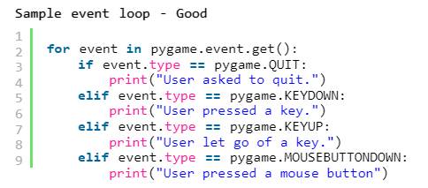Inputs from devices such as keyboards and mouses can be processed with event loops – the for loop runs every time an event takes place, checking which event took place using if statements:
  + 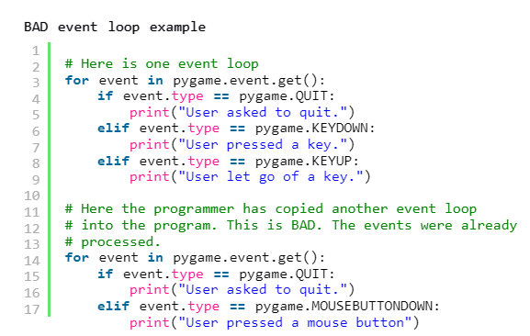The game’s code should only have ONE event loop, as otherwise the event loops which don’t contain the event being executed will run without doing anything. The example below demonstrates this:
  + 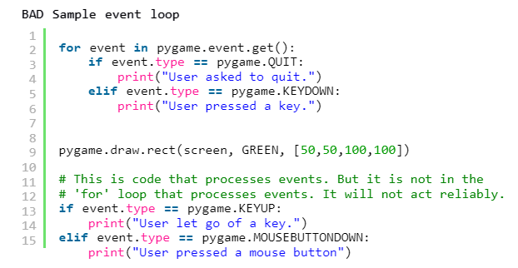Additionally, all events should be placed next to each other in the for loop, and any drawing commands which follow should be written after the for loop. Otherwise, this leads to the following problem:
  + Each frame of a game is processed using the following logic (while the variable which keeps the game looping is set to False):
    1. Use a chain of if statements to handle each event.
    2. Run calculations to figure out what will happen in the next frame (e.g. where objects will move, what will happen when objects collide).
    3. Clear the screen and draw everything onto it.
  + Programs are easier to read and understand when these steps aren’t mixed together (e.g. all necessary calculations should be done before drawing anything onto the screen).
  + The code for drawing images onto the screen should go in the while loop, as otherwise the screen won’t be updated.
  + If the clock tick is set to 10, the window’s contents will be drawn 10 times every second.
  + The *pygame.quit()* function will cause the program to close the game’s window and stop running.
  + The *screen.fill()* function will clear the screen, setting the background to be the colour specified in its parameters (e.g. the background can be set to white by using *(255, 255, 255)* as a parameter). This should be done before any drawing commands are executed, as clearing the screen after graphics are drawn will cause the screen to be completely blank.
  + Although windows have black backgrounds when they’re first created, it’s still important to clear the screen when the program starts running as several things could stop it from starting out cleared.
  + The *pygame.display.flip()* function must be executed after the drawing commands, as otherwise the graphics will not be displayed on the screen.
  + There are several shapes (e.g. rectangles, circles, lines) which can be drawn using preset functions in Pygame.
  + In the function *pygame.draw.rect(Surface, color, Rect, width=0):* ‘*return Rect*, *width=*0’ will cause the width to be set to 0 if a value for it isn’t provided when the function is called (meaning that *pygame.draw.rect(screen, RED, [55, 50, 20, 25])* is the same as *pygame.draw.rect(screen, RED, [55, 50, 20, 25], 0)*).
  + This being said, adding *width=0* to the parenthesis yourself when calling the command will cause the program to crash.
  + *: return Rect* informs you that the function returns a rectangle, and as such it can be ignored when coding programs using it.
  + Lines can be drawn using a function with their colour, the coordinates of the start of the line, the coordinates of the end of the line, and width being specified in the function’s parameters (e.g. *pygame.draw.line(screen, GREEN, [0, 0], [100, 100], 5)*).
  + 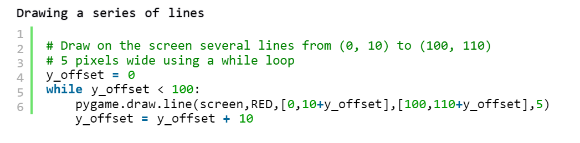In order for a loop to draw multiple instances of the same object in different positions, the coordinates need to be offset by adding a certain value to them each time the while loop is executed. For example:
  + 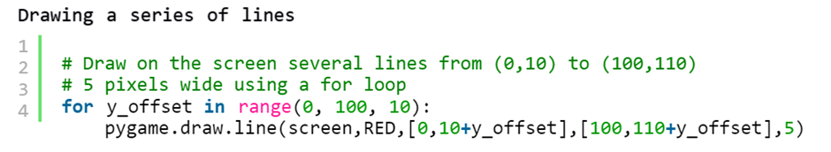Rectangles in pygame can be drawn using a pre-written function, with the programmer being able to specify the rectangle’s colour, the x-coordinate of its top left corner, the y-coordinate of its top left corner, the width of the rectangle, the height of the rectangle, and width of its lines (e.g. *pygame.draw.rect(screen, BLACK, [20, 20, 250, 100], 2)*).
  + Ellipses (ovals) are drawn in Pygame by drawing a rectangle with the image of an ellipse inside. As a result, they are drawn in a similar way to rectangles (e.g. *pygame.draw.ellipse(screen, BLACK, [20,20,250,100], 2)*), however the first two values in the list specify the upper left corner of the rectangle the ellipse is drawn in rather than a starting point on the ellipse.
  + An arc is a section of an ellipse. The function which draws them is similar to the function which draws ellipses, however it also requires the start point and end point of the arc to be specified as angles (in radians) (e.g. *pygame.draw.arc(screen, (255, 0, 0), [100, 100, 250, 200], PI/2, PI, 2*).
  + Programs will need the value of pi to draw arcs (segments of ellipses), so it should be defined in programs when arcs are needed (e.g. *PI = 3.131592653*).
  + Polygons (shapes such as triangles) can be drawn using the *pygame.draw.polygon()* function. This function’s parameters specify the surface the shape is to be drawn on, the colour it should be drawn in, the coordinates each vertex of the polygon should be drawn at, and the width of the lines joining the vertices (e.g. *pygame.draw.polygon(screen, BLACK, [[100, 100], [0, 200], [200, 200]], 5)*).
  + Text can be displayed on the screen using pygame, however the program needs to go through multiple steps in order to do so. Firstly, the programmer needs to create a variable containing information about the font to be used (e.g. its typeface, its size). This variable is then used as a parameter for a function which creates an image of the text, and finally the programmer tells the program where to place this image. Here’s an example of this in action:

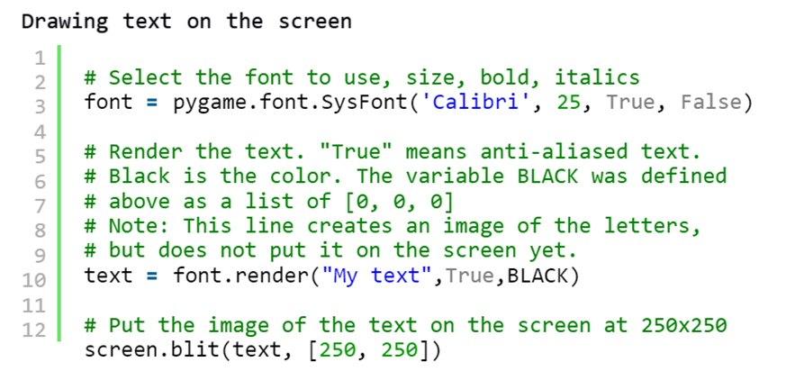

* + In order to add variables to a line of text, they must be converted to strings and added to the text (e.g. *text = font.render(“Score: “ + str(score), True, BLACK)*).
  + As the values inside a tuple can’t be changed, they allow for the program to run faster and are more useful than lists in cases where you don’t want the values they contain to change.
  + You can create arrays which contain the same value in each location by multiplying an array by how many times you want it to contain each element (e.g. *my_list = [0] * 100*).
  + You can create a total of the values inside an array by initializing a variable for the total with an initial value of 0 and adding each item in the array to it. This can be done using two methods:

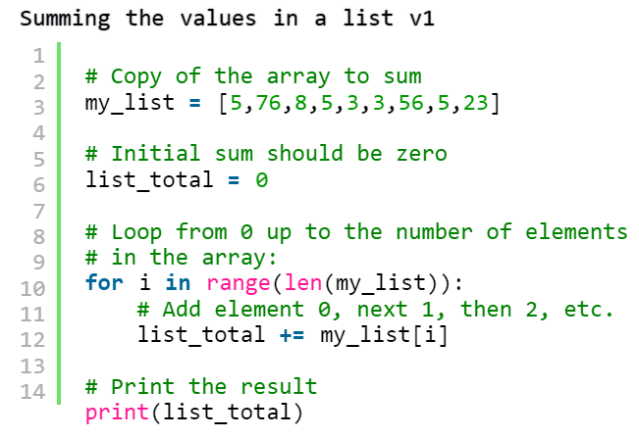

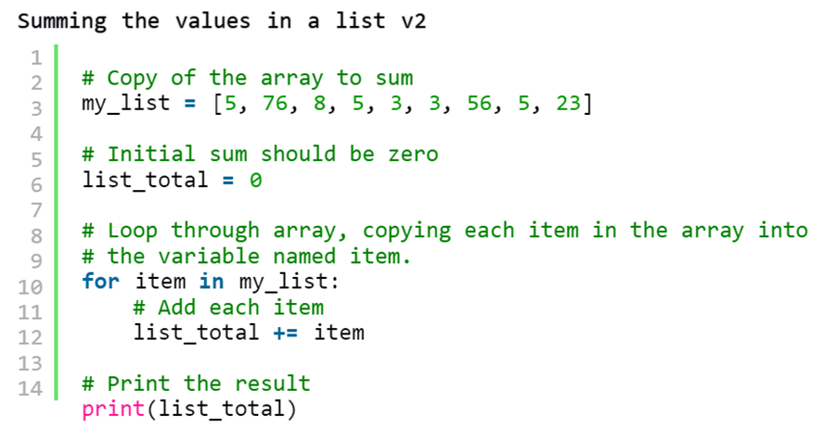

* You can also use a for loop to double every number in a list:

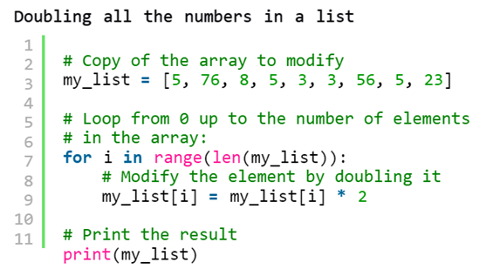

* Associative arrays are arrays which can use a different form of indexing and are created using curly braces ({}). An associative array can be created using statements such as *x = {}*, values in the array can be initialized using statements such as *x =[“fred”] = 2*, and values can be fetched from the array with indexes using statements such as *print(x[“fred”])*.
* Objects in pygame can be animated by using a loop to continually change their position. For example:

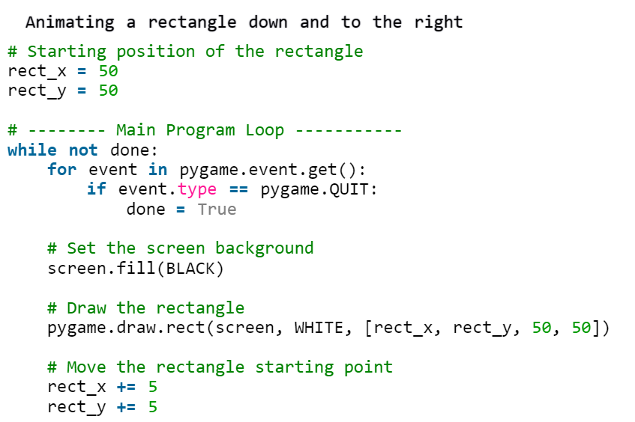

* 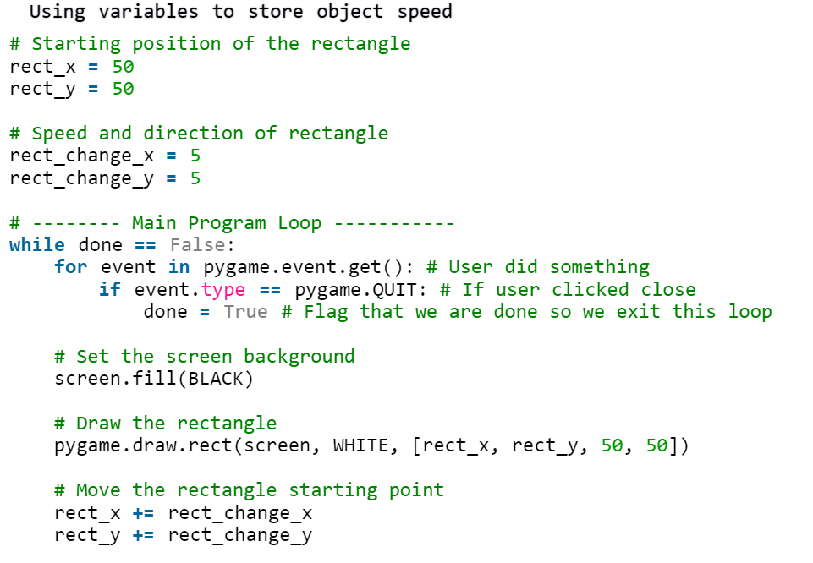Additionally, an object’s movement can be represented using a vector containing its speed and direction:
* Objects can be reflected off the boundaries of the screen using conditional statements to detect whether the object has hit one of them.

As the coordinates of the rectangle are the coordinates of its top left corner, if you want it to reflect off the bottom of the screen you need to account for the rectangle’s size when making the conditional statement (e.g. the screen in the program the example below comes from is 500 pixels high and the rectangle in said program is 50 pixels high, so when the rectangle hits the bottom of the screen its top-left corner will have a coordinate of (x, 450)):

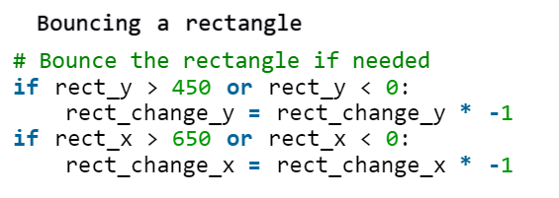

* Functions in Python usually have a comment as their first statement to explain what the function does.
* Most code and variables should be written in functions, as this makes debugging a lot easier since you only have to look through a few select lines in the code to find a problem and this only allows the program to change variables within the function they’re placed in.
* If you were to import a program by writing the program’s code into a function in another program, the program the function is written in would automatically run said function if the statement which calls it is not written . In order to make it so the program can control when the function is called, you need to get it to check the global variable *__name__*. This variable is automatically defined by Python, and will be set to the imported program’s name with two underscores on both sides of it if it’s being run. This can be implemented to make the program only call the function when requested:

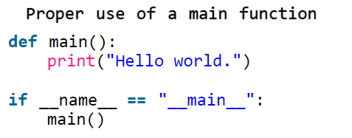

* If a global variable is not passed to a function, it cannot be edited inside the function.
* When variables defined outside a function are changed inside of it, they need to be returned and reassigned in order for the program to work with their new values outside of the function. This is because when variables are passed to a function, the variables that are edited are copies of the ones outside the function. To demonstrate this, the code on the left will print 3, whereas the code on the right will print 4:

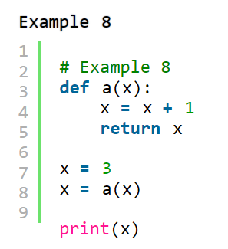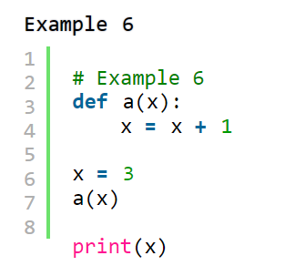

* The parameter *screen* and parameters for an object’s x and y coordinates need to be passed into any functions which draw it so Pygame knows which window to draw the object on and where to draw said object.
* The coordinates of the mouse can be obtained as a tuple using the function *pygame.mouse.get_pos()*. Code such as this should go in the ‘game logic’ part of the main program loop (the part which determines the functions of non-player objects and when they should perform their functions).
* The mouse can be hidden using *pygame.mouse.set_visible(False)*.
* One way to control an object’s movement using the keyboard is to set an initial velocity for the object when a key is pressed down, adjust the co-ordinates of the object every frame depending on said velocity, and have its velocity reset to 0 when the key is released.
* 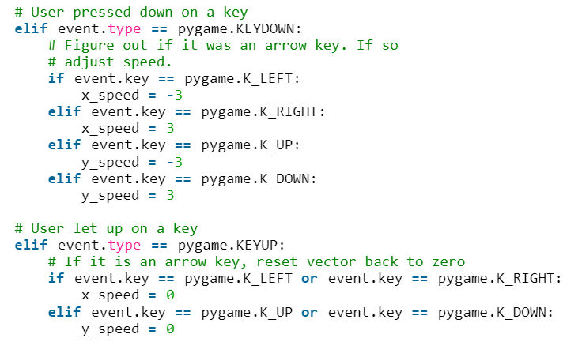To achieve this, additional events need to be added to the main game loop, those being *pygame.KEYDOWN* events (which are generated whenever a key is pressed down), and pygame.KEYUP events (which are generated whenever a key is released). These events can be implemented using the following method:
* The first table on the following webpage shows a full list of key-codes which can be used in Pygame: <https://www.pygame.org/docs/ref/key.html>
* Images can be displayed in Pygame by loading the image into a variable and using the *screen.blit()* function to display the image in the variable (e.g. *variable_name = pygame.image.load().convert, screen.blit(variable_name, [0, 0])* will display the image stored in *variable_name*, placing the top left corner of the image at coordinates (0, 0)).
* It’s important to ensure that the resolution of any images you load into the program aren’t bigger than the resolution of the Pygame window, however.
* If an image has a background containing a single colour, it can be made transparent by setting a colour key for the image (e.g. *variable_name.set_colorkey((0, 0, 0))*). Although this works for .gif and .png files, it’s not as effective for .jpg files as the algorithm which makes them smaller changes the image they contain, causing the background to contain multiple colors. As such, .png and .gif files should be used when images with transparent backgrounds are needed.
* .bmp images aren’t compressed at all, and therefore trying to make their background transparent will result in very large files.
* Graphics programs are required to convert .png files to .jpg files and vice versa, although once converted to a .jpg format an image will be altered in such a way that changing it to a .png file won’t revert said alterations.
* Much like images, sounds in pygame must be loaded using the *pygame.mixer.Sound()* function in the main program loop before they’re used. The sound can then be played using the *.play()* function.
* 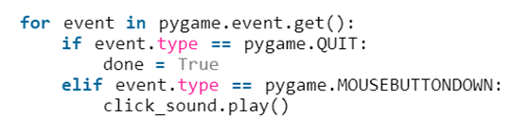Functions which play sounds should be placed inside event subroutines so they only play in certain circumstances rather than all the time. For example:
* Classes are groups of data attributes. They can be created using the following method:

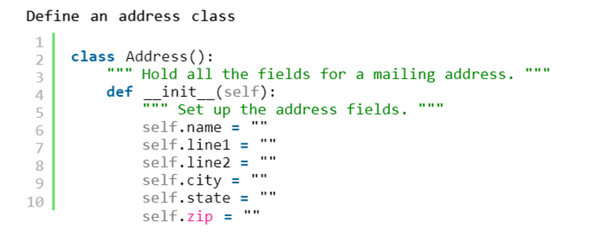

* The variables stored inside classes are known as attributes/fields.
* Class names should begin with an uppercase letter.
* *def __init__(self)* is a constructor, a special function which is run when the class is created.
* *self.* can only be used to refer to a class inside its definition.
* 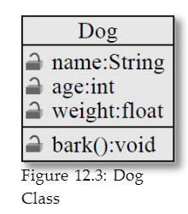Programmers often make diagrams to help visualize classes. These are known as class diagrams, and look like the following example:
* Although a class code defines a class, creating an instance of one needs to be done separately. For instance, using the class in the example above the class diagram:

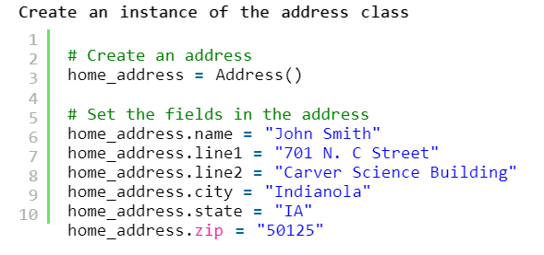

* When using classes, it’s important to specify which instance of the class you want to modify, even if there’s only one instance of it.
* Multiple instances of the same class can be created and used. For example:

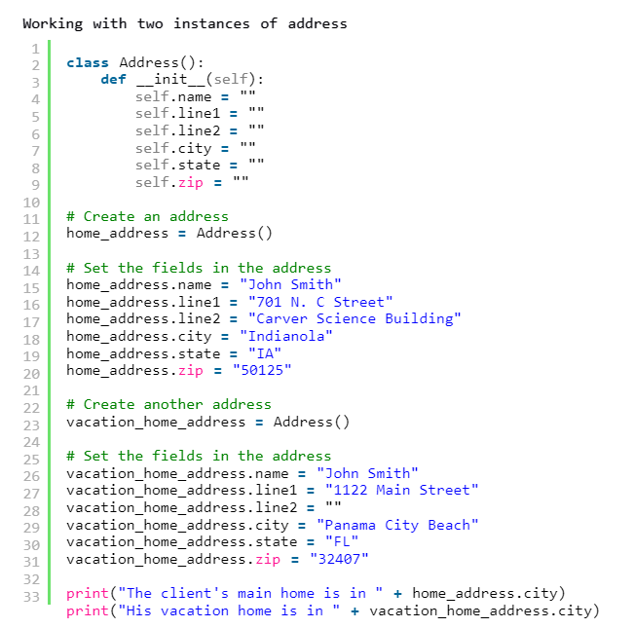

* An object is an instance of a class.
* Adding lots of data fields to a class makes it easy to pass data in and out of functions, as you don’t need to add parameters for every field to the function. For example, the following code takes an address as a parameter and prints it out on the screen:

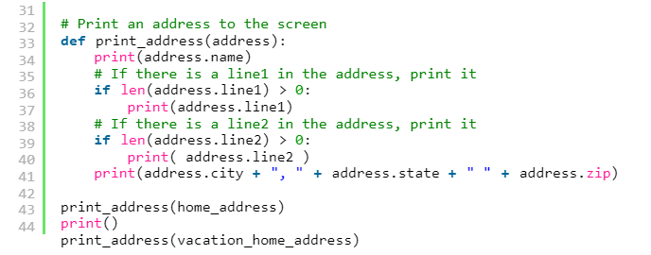

* Classes can have methods, which are functions inside of a class. The example below showcases a method for barking inside a dog class:

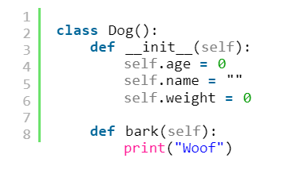

* Methods must have *self* as their first parameter, and their definitions should be at the same indent as the class’s constructor.
* Attributes should be listed before methods.
* The way methods are called is similar to the way attributes are referenced:

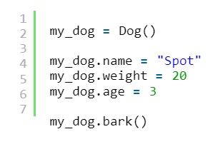

* Although *self* is always a parameter in method functions, it doesn’t need to be passed in to calls of said methods as Python assumes the first parameter references the object itself.
* 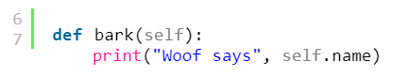Method functions can reference other attributes in their respective class using the *self* reference. For example:
* 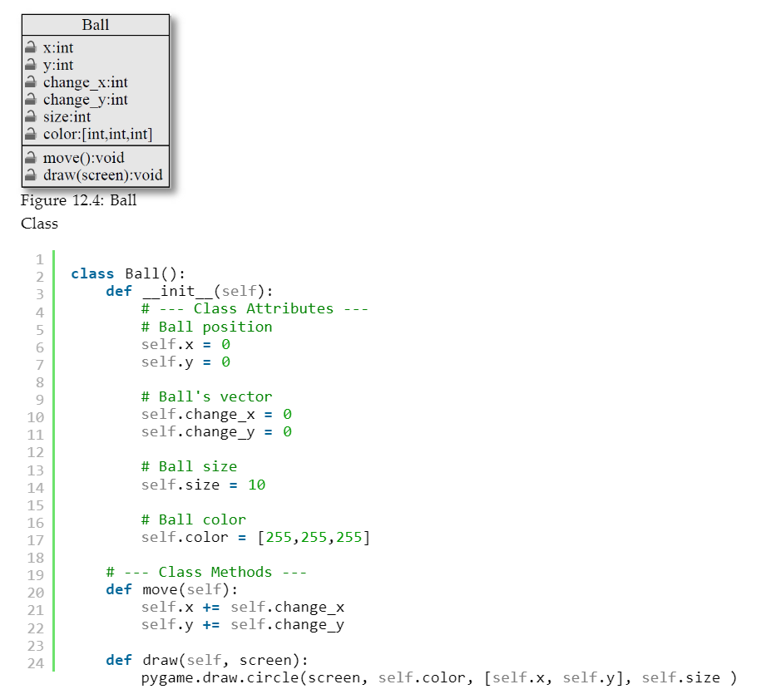An example of classes being used to create a ball in Pygame which the user can control is shown below:

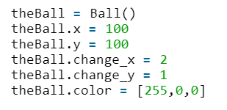

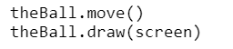

* In the above example, *theBall* stores a reference to the object rather than the object itself. As such, *new_variable = theBall* would cause *new_variable* to become another reference for the same object, having the same attributes and methods copied from *theBall*. To further demonstrate this, the following code will produce the following output:

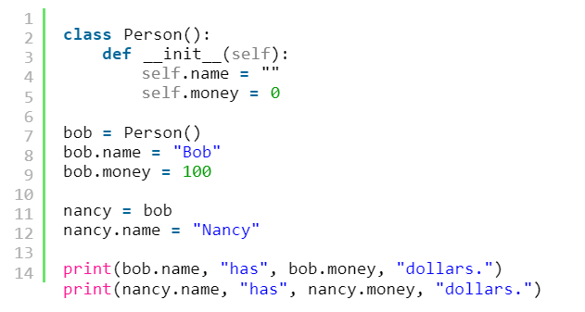



* In order to change attributes using functions, the class needs to be passed as a parameter and referenced in the function definition. For example:

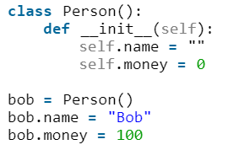

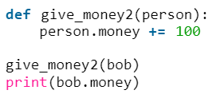

* 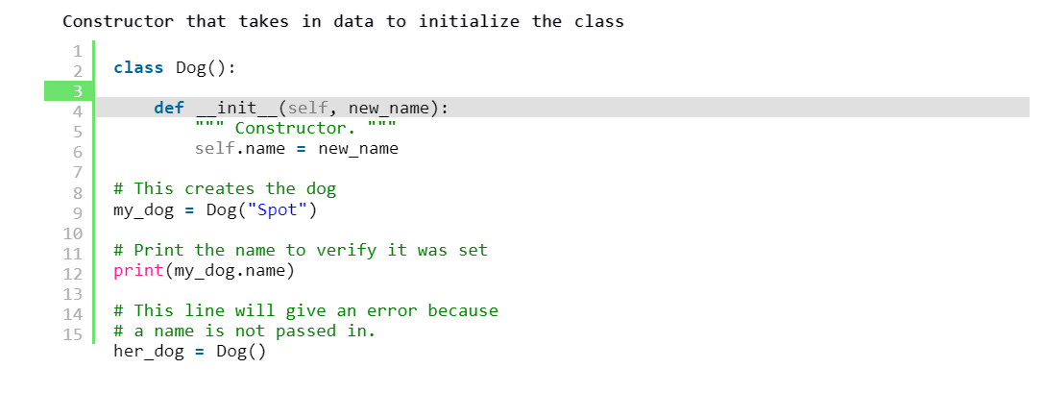If you want a class to have certain attributes set upon creation, you need to add them to the constructor function as a parameter and define the attribute as that parameter. However, doing this will mean that you have to enter what you want the attribute to be for each instance of the class you create. For example:
* 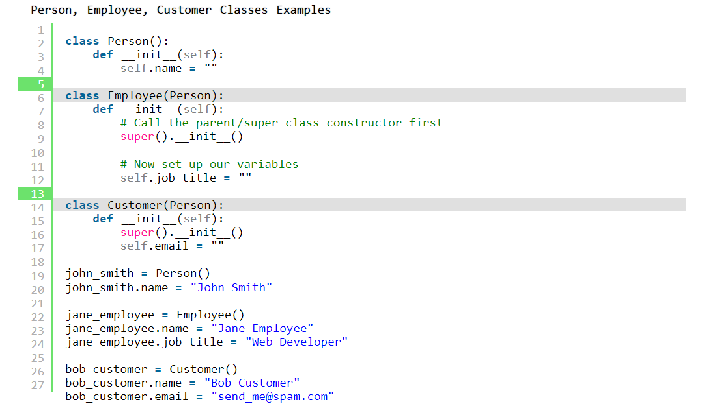Classes can inherit attributes from other classes. Classes which inherit attributes from other classes are known as child classes, whereas the classes which child classes have their attributes inherited from are known as parent classes. Here is an example of inheritance in action:
* If a parent class updates (e.g. receives new attributes), the child class(es) will receive the same updates automatically.
* There are two main types of class relationships: “is a” (e.g. Employee is a person, Dog is an animal) and “has a” (e.g. Person has a name, Dog has a breed).
* Methods in a parent class can be run through a child class using the *super().* function.
* All constructors in a child class should call the parent constructor.
* An instance variable is a class variable in which each instance of the class gets its own value, whereas a static variable is a class variable which has the same value for each instance of the class.
* 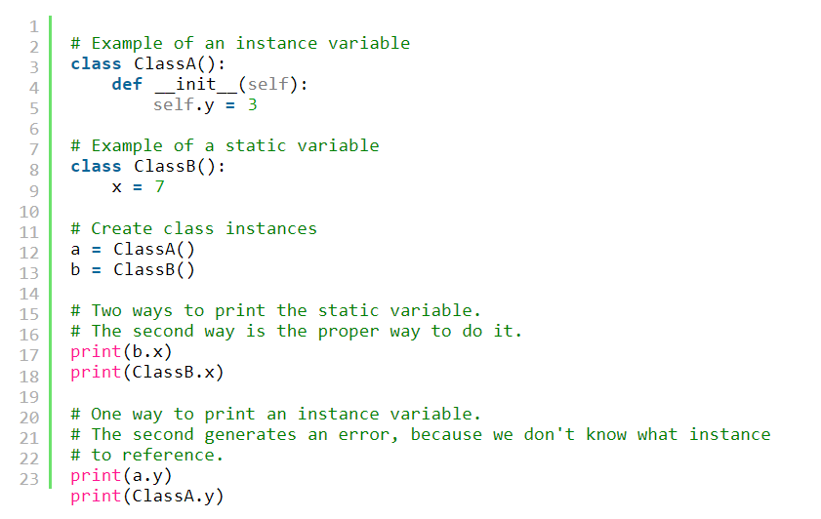Here is an example of both static and instance variables:
* It’s possible to have a static variable and an instance variable with the same name in Python, and they can be edited separately from each other:

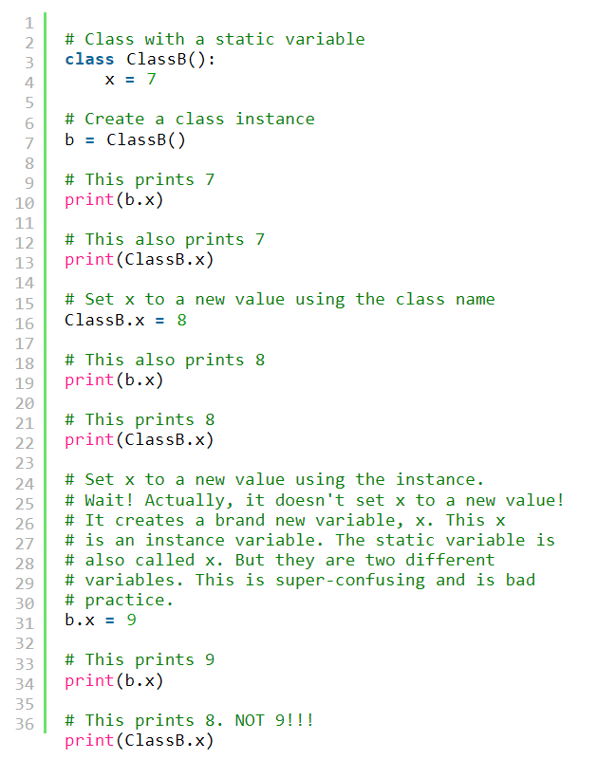

* Sprites have their own class in Pygame, which can be imported by adding it to the brackets in the class creation code (e.g. *class Block(pygame.sprite.Sprite):*).
* When using this method, the class created will be a child class of the *Sprite* class, and it’s therefore constructed by calling the parent class constructor (*super().__init__()*).
* Objects created using the *Sprite* class as a parent class should have parameters defining their colour, height, and width, along with code creating a blank image for the sprite to be drawn on (e.g. *self.image = pygame.Surface([width, height])*) and code filling it with the chosen colour (e.g. *self.image.fill(color)*).
* Sprites can be made transparent by filling the image they’re drawn on in with a colour and setting the colour key to the same colour.
* In order for a sprite to move, it needs code in its constructor to update its x and y coordinates (e.g. *self.rect = self.image.get_rect()*). *rect* is used as it represents the sprite’s dimensions, and pygame will draw the sprite wherever its x and y coordinates are.
* Pygame programs should start with *pygame.init()*, and should be followed with *screen = pygame.display.set_mode([screen_width, screen_height])* (with *screen_width* and *screen_height* being integers).
* Sprites in Pygame can be grouped using the function *pygame.sprite.Group()*. *Group* is a pre-defined class which allows the user to group objects (e.g. sprites) together. This allows sprites to be drawn or moved with a single command, and for the program to check for collisions between sprites.
* All the objects that a sprite can collide with can be represented as a list (e.g. *block_list = pygame.sprite.Group()*). The objects in the list can then be checked against the player to see if they are colliding or not (e.g. *blocks_hit_list = pygame.sprite.spritecollide(player, block_list, True)*).
* The *True* in the above code will remove any sprites which are colliding with the player from the list.
* 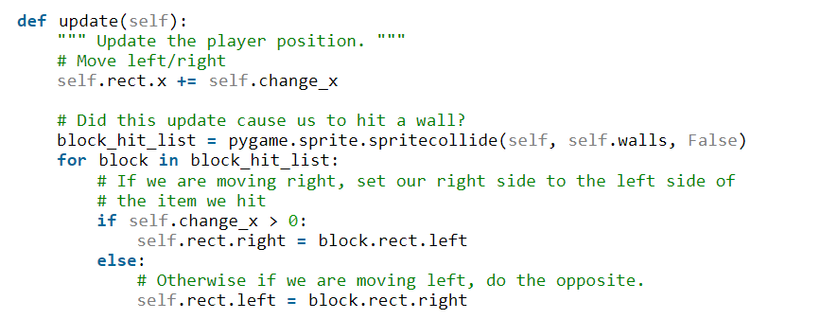Sections of ground can be implemented by adding code to keep the player next to them when they try to move through them:
* Rooms (individual sections of a large level) can be connected to each other by having each room coded as a separate object and having the room being displayed on the screen change when the player is at specific x and y coordinates in the room they’re currently traversing:

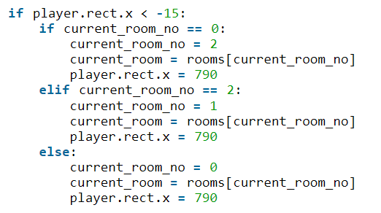

* Moving hazards could be implemented by adding to/subtracting from their coordinates until they reach a certain point, then subtracting from/adding to them respectively to make them change direction.
* The best way to draw sprites in a program is to add them to a group, and then call *.draw(screen)* on the group.
* A sprite’s *update()* function is automatically called whenever the code calls *update()* on any list the sprite is in.
* Sprites can be added to groups using the *.add()* command (e.g. *sprite_list.add(my_sprite)*).
* In order to use modules from other programs, they must be imported (e.g. *import my_functions*).
* Specific functions from modules can be imported by adding the module’s namespace to the function you wish to import (e.g. *my_functions.foo()*, with the namespace being *my_functions*).
* As functions from other programs are called as packages, it doesn’t matter if two imported programs have functions which have the same name (e.g. calling *student_functions.print_report()* and *financial_functions.print_report()* in the same program will produce different outputs).
* These functions can also be imported into the local namespace, which is more efficient if the programs you are importing don’t have the same function names:

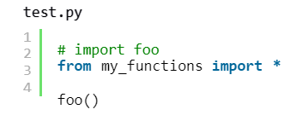

This research has given me a good idea of how the game’s level and its gameplay mechanics should be designed in order to make it enjoyable, how I could code some of its mechanics, and which parts of the Pygame library will be the most useful for the project and its purpose.

## Interviews

To get a better idea of what would make the game best fulfil its purpose, I created a series of interview questions and got friends of mine who study physics as an A Level and actively play video games, three students who study physics as a GSCE and actively play video games, and the head of the physics department at my school to answer them. My friends’ answers are represented by answer sets i) and ii), the GSCE students’ answers are represented by answer sets iii), iv) and v), and the head of the physics department’s answers are represented by answer set vi).

* In physics lessons, what method of learning do you find most effective / which teaching method do you think works best?
  + 1. Visual demonstrations.
    2. I'd most likely say where the teacher first runs us through the content of the topic and gives us examples and notes to write down, then once that's done we’re given some questions to do to grasp the concept.
    3. Practicals.
    4. Representing concepts in a visual form.
    5. In physics, I find that teaching by repeating the same content until the students understand is better than just moving on once the teacher has given everyone all the information they’ll need and coming back to it later for revision, and that interactive learning is the best way to learn.
    6. Combination of practicing questions and working through practicals.
* What forces would you want the program to showcase?
  + 1. Air resistance and friction.
    2. Gravity, momentum along with friction (the two go hand in hand), acceleration, potential energy (e.g. stuff like catapults that are under a lot of tension so when you snap the rope it sends you flying), buoyancy/elasticity (so stuff like objects that you can bounce off, with buoyancy being for anything water-related and elasticity being for everything else).

But obviously if it's to be a platforming game, objects in motion is the main thing at play, so SUVAT related forces (forces which affect an object’s motion) are a must. I would also introduce Newton’s laws as a staple, such as for every reaction there is an opposite reaction (e.g. if I push myself off of a block, that block will move the other way that I push off from).

* + 1. Newton's Third Law.
    2. Perhaps realistic water physics.
    3. Kinetic forces.
    4. Depends on the scenario. Newton’s laws of motion etc.

Weight due to gravity and possibly air resistance. Also if underwater then buoyancy effects would also need to be factored in.

* Would you want the conditions in each room to vary to demonstrate different examples of how they can affect the forces on display (e.g. underwater sections where movement is slowed but the player has buoyancy)?
  + 1. Yes, with sufficient context given (explaining how x affects y). This could be done through text boxes explaining what each room is showing the player.
    2. Set a medium for what a normal room would be like (normally in the earlier levels of the game), then introduce special elements or even powers that can manipulate the forces the game is built around to incorporate an interesting mechanic that varies with each level. It’s normally better to initially introduce each mechanic one at a time.
    3. Yes.
    4. Yes, I think this makes games more interesting.
    5. I would like the conditions to vary, as it would allow more diversity in the program and give the player more things to explore.
    6. That sounds good. Don’t forget there will also be resistive forces opposing the motion itself (i.e. in the opposite direction to your movement).
  + Do you think encouraging players to try and finish the game as quickly as possible after their first playthrough would make students take the information in more effectively due to a newfound level of engagement, or cause them to ignore the forces and physics in favour of gameplay and optimising their playthroughs?
    1. Optimisation in video games inherently leads to attempting to ‘break’ game systems and therefore I believe unless the system is 100% solid, you shouldn’t encourage that.
    2. Absolutely. Having that element always makes players come back, and the more they come back the more reinforced the learning becomes.
    3. There would inevitably be a group of people dedicated to optimizing their run times, but I believe that it is still possible to get students to focus on forces while doing so.
    4. I think it would cause them to ignore the physics, but letting the player play at their own pace and discover these different mechanics on their own would be better than them being shoved down their throat.
    5. I believe increasing such an aspect would increase user engagement, but would overall decrease the actual learning taking place. I think that a slower game based on puzzles with differing solutions (perhaps procedurally generated ones) would be more effective.
    6. Depends whether you can you assign points/score for trying to accomplish certain tasks where you need to take into account the effects of the physics.
  + What do you think would be the best way to make an educational video game?
    1. Having either a little puzzle/quiz thing at the end of an area to see if they understood or an audible description of how something works.
    2. I'd say minimise the amount it feels like an educational game - make the inclusion of the information subtle, but not so subtle they don't actually learn it. Try to avoid putting up a wall of text and getting them to figure it out through that, as a more independent way of learning would be more fun for the player in my opinion. Perhaps leave some mechanics unwritten and let the player discover them for themselves, as that element of discovery adds a lot to games from my own experience.
    3. Give people something to compete for/against, where a deeper level of knowledge on the topic results in a higher possibility for advantage (for example, a shooter game where knowledge of chemical reactions and what certain elements react to form allows players to create certain things that give them an advantage over other players).
    4. I feel like video games can only educate people on things like actual concepts that can be visualised – educative games centred around topics like maths or English would not be engaging, but ones centred around something like chemistry would be since seeing different elements combining and reacting realistically would help the player take in information more effectively.
    5. I believe an educational video game primarily needs to be fun and engaging while focusing on the educational aspect second, as this would stop the player from seeing it as a chore or wanting to rush through it without taking anything in.
    6. An educational game would need to be detailed and slow-paced. It should require a lot of time on behalf of the player to work through such a game.

These answers have allowed me to deduce the features the project will need to have in order to satisfy the needs of the end users. I think the best way to structure the game is to have a level which the user plays through that gives them a visual demonstration of the forces on display along with explanations of how they work, and to have a quiz which tests them on the topics discussed in the explanations afterwards. Although learning should be stressed as the player’s main priority, they should also be encouraged to try to complete the game as fast as possible once they’ve completed it so they feel motivated to replay it and reinforce their learning in turn. I believe that the forces I should focus on are friction, air resistance, and buoyancy, as these forces are important concepts in physics, can easily be showcased in a visual format, and can be coded with a sufficient amount of detail to illustrate the concept to the player within the time I’ve been given to make the game.

Both these interviews and my research have led me to create the following objectives:

## Objectives

My core objectives for the project are as follows:

* Create a 2D platforming game in Python which teaches the user about various forces.

1. Create the ball which the player will control.
   1. Allow the player to make the ball move left with the left arrow key or A and make the ball move right with the right arrow key or D.
      1. The player should accelerate while they hold one of the movement keys until they reach the ball’s top speed (at which point they should continuously move at that speed).
      2. When the player lets go of one of the movement keys, the ball should gradually decelerate until it comes to a stop.
      3. Additionally, the ground in the level should apply friction to the ball, decreasing its rate of acceleration and rate of deceleration along with its top speed.
   2. Allow the player to make the ball jump with the Space Bar, and make the ball accelerate toward the ground whenever it is midair.
      1. The player should only be allowed to jump while they are on the ground, and shouldn’t be able to jump multiple times in succession by holding the Space Bar.
      2. If the player was moving to the left or right before jumping, they should keep their current momentum, but should also gradually slow down while midair (representing the effects of air resistance).
      3. Furthermore, their vertical speed should stop increasing once it reaches a certain value (representing the ball’s terminal velocity).
2. Create a level in which the player descends from its top to its bottom, with wide horizontal sections to create variety so the vertical platforming doesn’t get repetitive. The horizontal sections will also make it much easier to design a fun and interesting level while demonstrating the chosen elements of physics to students.
   1. Split the level up into various rooms, with each room being connected to each other through off-screen points which, if the player comes into contact with them, will cause the room currently being displayed to change. The player’s coordinates should be updated when they touch these points so they start on the opposite side of the screen to the one they just left (e.g. if they leave a room from the right side of the screen, they should start the following room on the left side of the screen).
      1. Create subroutines containing each of the game’s rooms, running the one which corresponds to the room the player should be going to whenever they leave the screen in the room they’re currently in and updating their coordinates accordingly.
      2. Each room should have different conditions so they can display each force implemented in the game throughout its duration. The first few rooms should be plainly designed so the player can see how the extra elements in the later rooms change how the forces affect the player’s movement.
   2. Create keys which are required to unlock barriers (see below).
   3. Create barriers which can only be passed through if the player is holding a key, removing said key from the player’s inventory when the player comes into contact with them.
   4. Add hazards which if touched, force the player to restart the room they're currently in from the point they entered the room from.
      1. There should be hazards with set movement patterns (e.g. up and down, back and forth) as well as stationary ones.
   5. Create different kinds of terrain. As a general principle, terrain shouldn’t allow the player to pass through it, and should reset the player’s acceleration in the direction they were moving should they collide with the terrain as a result of said acceleration.
      1. Regular terrain should set a standard for friction. Additionally, each collision algorithm for the terrain’s sides should have the ability to be deactivated, allowing the player to pass straight through the terrain from that side.
      2. Ice terrain should have lower friction than regular terrain, giving the ball a decreased rate of acceleration and deceleration along with a lower top speed.
      3. Create ramps which affect the ball’s movement while it is travelling along their slope by slowly pulling it towards the ramp’s bottom when the player isn’t moving it themselves. Ramps should also allow the ball to move more quickly down their slope and more slowly up their slope. These features represent the effects of gravity while the ball is on an incline.
   6. Add water as a different substance for the ball to travel through. Water should increase the effect of resistant forces in both x-axis directions (representing the effects of water resistance), however it should also slow the ball’s descent while it’s midair and should allow for the ball to jump higher (representing the effects of buoyancy on the ball).
3. Create a text box system which can be used to explain the how the game works along with the forces showcased in each room.
   1. 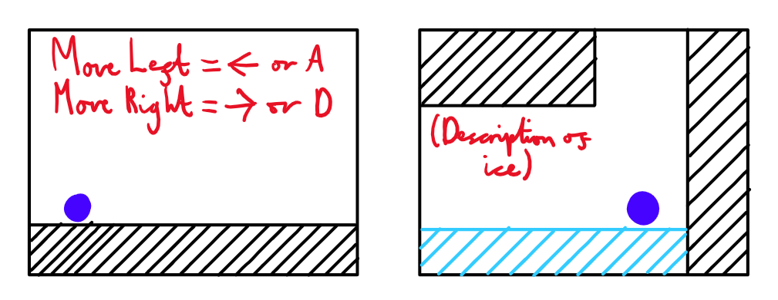The text boxes should offer explanations which are brief enough to make them fit on the screen and easy to read without being so brief that the player can’t understand the concepts being explained.For example:
4. Create a title screen which will allow the player to start the game.
5. Create a quiz which will test the player on the material they’ve learnt after they complete the level portion of the game, allowing them to progress each time they answer a question correctly.

I may try to fulfil these goals should I have time once I've fulfilled my core objectives:

1. Create a pause menu which will allow the player to restart the level.
2. Create a stopwatch which records how long the player takes to complete the game each time they play it, showing this time to them when they complete it.
   1. Create a local leaderboard which stores the player's best times for completing the level.
      1. This will require the use of a database which updates every time the level is cleared. This database could be split into the following segments:

|  |  |  |
| --- | --- | --- |
| Ranking | Initials *(3 Letters)* | Time |
| 1 | BFP | 2:50 |
| 2 | CRS | 3:29 |
| 3 | SWL | 5:17 |

If I add this, I will make the game require the player to enter their initials when they finish the level before they go back to the title screen.

1. Create an options menu which allows the player to change the resolution of the game’s display window. This options menu could be accessed from the title screen or the pause menu.

## Constraints

In order to ensure that I can create a solution which fulfils the end-user’s needs within the time given, I will have to compromise certain areas of the game so I can focus on my objectives:

* The game’s graphics will be basic, only using a variety of shapes and a crudely drawn key.
* The game won’t have any sound.
* Leaderboards (if they are coded at all) will only be stored locally (and will likely have their data deleted whenever the game is closed).
* The level design will be simplistic.
* Forces which would be harder to visually demonstrate (e.g. Newton’s second law of motion, potential energy) will not be incorporated into the game.
* The player’s control over the ball will be limited, with them only being able to move the ball left/right and make it jump.

Initial Modelling

The model below is a detailed draft of the game’s level I created as one of the first things I made relating to the project, containing diagrams of each room. This model was made before I updated my analysis to better reflect my current direction for the project, so some elements in the diagrams are outdated. These elements and my reasoning for deciding not to make them are described at the end of the model. Each diagram consists of the room’s layout and its respective number. Additionally, the key for these diagrams is as follows:

= Regular Terrain – has normal values for friction.

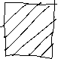

= Entry Point – connects the room the player is in to the room noted on the entry point at the entry point with the current room on it. For example:

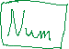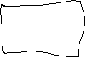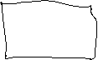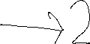

These entry points are placed in the off-screen area next to the point of the room they’re drawn in, so they can’t be seen by the player.

= One-Way Entry Point – an entry point which cannot be entered from the room its placed in. The only way to access this entry point is to go through the entry point it’s connected to.

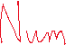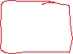

= Locked Entry Point – an entry point which requires the player to be holding a key in order to access it.

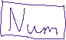

= Key – allows the player to access locked entry points.



= Ice Terrain – terrain which has lower friction than regular terrain. As such, when travelling across ice terrain the ball will have a lower top speed, and will accelerate and decelerate more slowly.

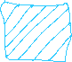

= Hazard – hazards will force the player to restart the room they are currently in the from the closest area to the entry point they entered it from in which they’d be fully visible on-screen. An arrow next to the hazard indicates that it will move in that direction until it reaches the end of the arrow, at which point it will move back to the point it started from. The hazard will continue moving between these two points until the player leaves the room.



= Water – when the ball is underwater, it will have a lower rate of acceleration and deceleration in both horizontal directions (representing water resistance). The ball will also jump higher and take longer to descend back down to the ground (representing the effects of buoyant forces on the ball). In the diagram, touching a wave of water will activate/deactivate underwater physics depending on whether the player was underwater before touching the wave.



= Rubber Terrain – terrain which has higher friction than regular terrain. As a result, when travelling across rubber terrain the ball will have a higher top speed and rate of deceleration, however its rate of acceleration will be much lower.

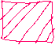

Model Diagrams

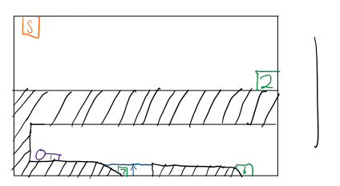

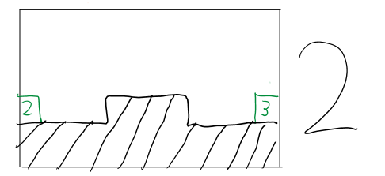This room is the starting point for the level, and gives the player space to experiment with the controls. The area below the bridge can only be accessed from the entry point in room 7, and has a semi-solid platform above the entry point to ensure that the player doesn’t accidentally go back to room 7 after picking up the key.

This is a simple horizontal segment with an elevated platform, allowing the player to learn about how the jump key functions and how the ball’s movement is affected while it’s airborne.

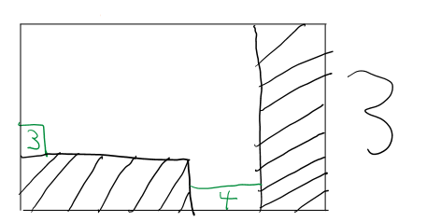

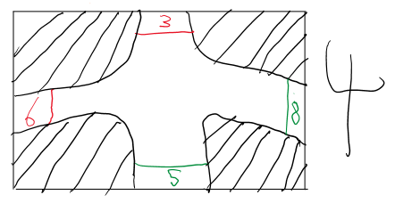This room has a vertical drop which will show the player how gravity affects the ball.

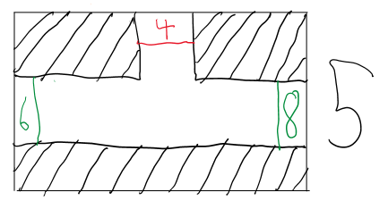This room continues the vertical drop from room 3, and shows the player that they will be returning to this room at some point later on to go from room 6 to room 8.

After concluding the vertical drop, this room gives the player the choice of going to room 8 or room 6. If they go to room 8, they will be told to follow the path starting with room 6 so they can unlock the barrier in room 8.

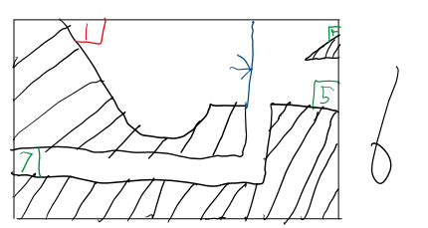

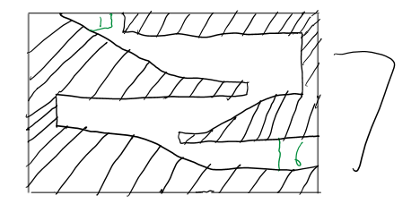When entering this room from room 5, the semi-solid terrain forces the player to take the lower path to room 7. If entering from room 1 however, the player will build speed as they go down the ramp so they can get to room 4 and make the horizontal jump from room 6 to room 8 in that room.



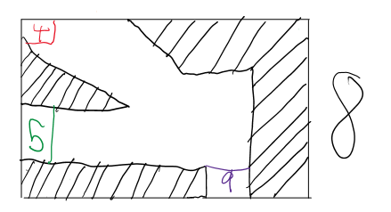This room requires the player to make a simple set of jumps to get back to room 1, demonstrating how inclines will impact the ball’s movement in the process.

This room has a locked entry point which requires the key from room 1 in order to be opened. Once the player opens this locked entry point, they can proceed to the next room.

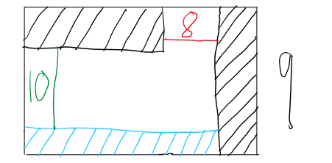

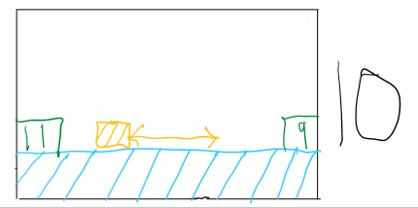This room introduces ice terrain to the player.

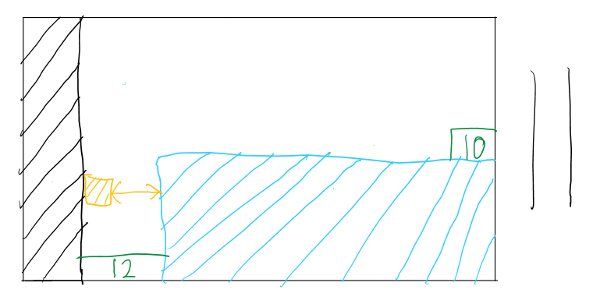This room introduces the player to hazards.

This room has a vertical drop guarded by a moving hazard.

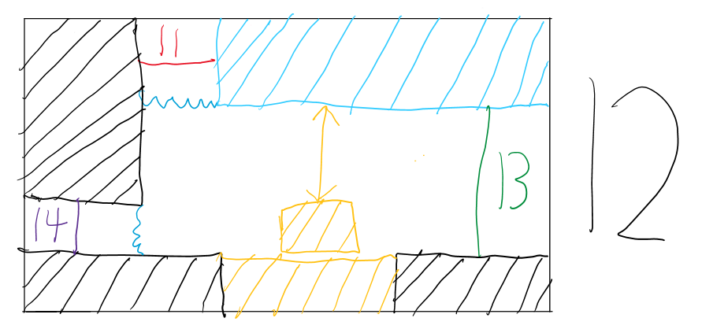

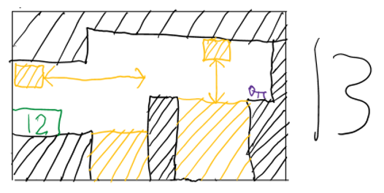This room introduces the player to water. There is a locked entry point to the left of the room which requires the player to grab a key from room 13 in order to open it.



This room requires the player to traverse it from the left side to the right side to grab the key, and then go back to the left side without touching the hazards. Although not drawn here, the room will be filled with water, so the player will have to use the ways in which it affects the player’s movement to their advantage. If the player touches any hazard while they are holding the key (including the one in the previous room), they will have to reobtain the key after they respawn.

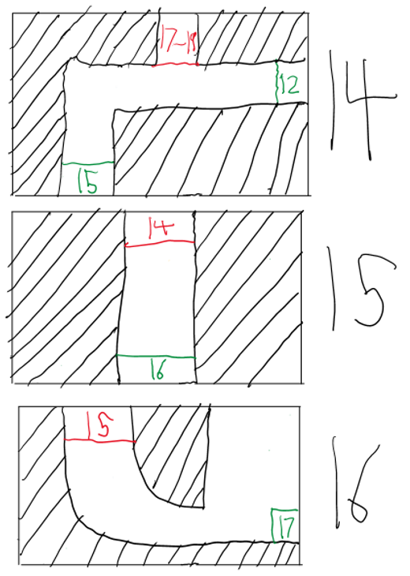





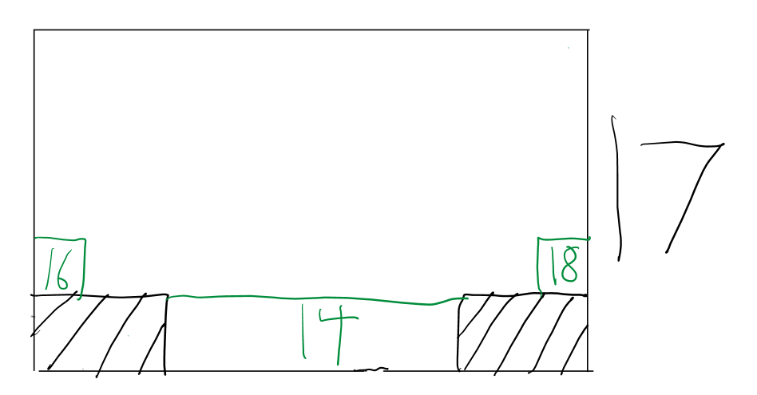These rooms collectively contain a massive drop so the player can build enough momentum for the sections following it. There is also a one-way entry point in room 14 for various entry points in the upcoming rooms (which force the player to restart the section from room 14), ensuring that the player always has enough momentum for every attempt of the following section.

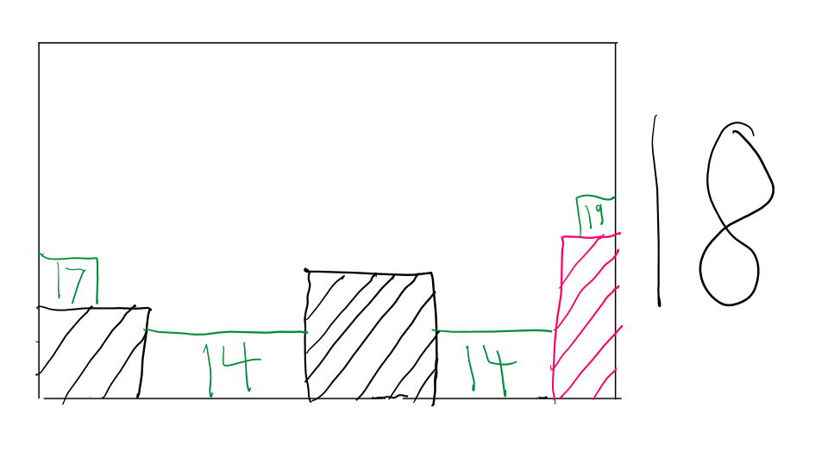

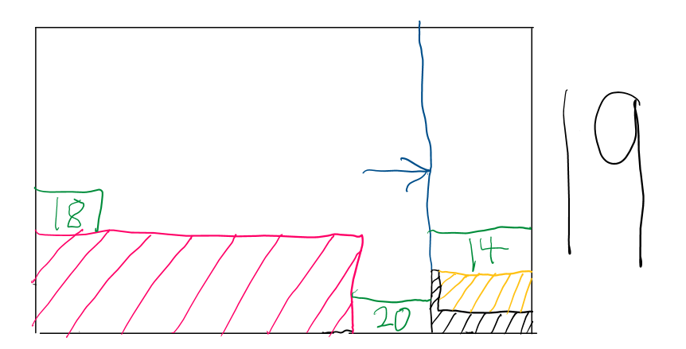

This segment of rooms consists of multiple gaps which the player has to jump across using the momentum they’ve gained from the drop beforehand. The player will be introduced to rubber terrain at the end of room 18, which will provide them with the friction they need to slow down so they can fit through the gap between the rubber and the semisolid. If the player fails to slow down enough, they will be sent back to room 14. The player won’t actually be able to touch the hazard – its purpose is to immerse the player in the game (so from the player’s point of view, there’s a visible reason they got sent back to room 14).

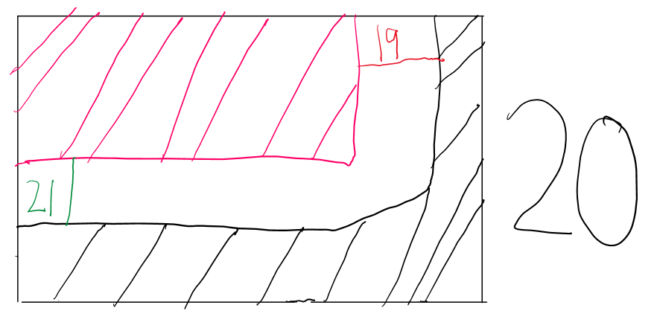

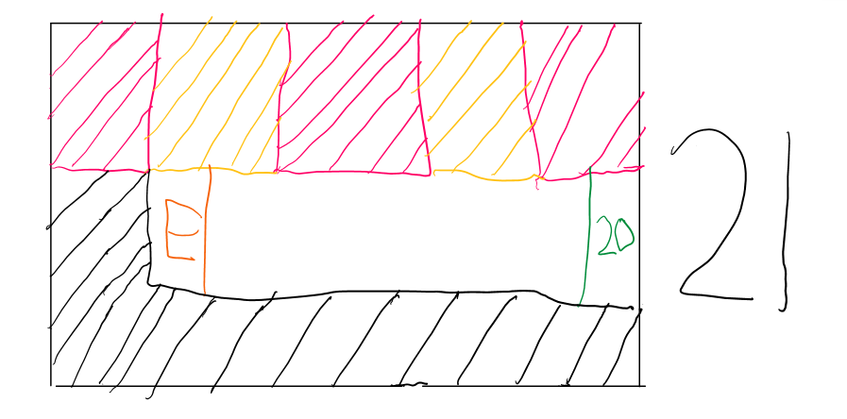

Once the player has reached room 20, all the player has to do to complete the game is move left. Once again, the hazards and rubber above the player only serve to immerse them in the experience.

Main Differences Between Model and Code

After giving the level’s design some further thought, I’ve decided that the game will have to differ from the model in certain ways to ensure that I can create a program which satisfies the needs of my end-users within the time given. With that in mind, I’ve decided on the following things:

* Rubber terrain will not be coded into the game.
* Locked entry points will be created using a physical barrier which needs to be unlocked using a key in front of a normal entry point.
* Another room will be added between rooms 3 and 4 to make the drop connecting rooms 3 and 5 larger to give the player more of a chance to see terminal velocity in action.
* Curved ramps (e.g. the one connecting room 1 and 6, the ones in room 7) will not be in the final product as trying to figure out how to code collision between them and the player proved to be very difficult, so I decided it would be better to not include them so I can focus on the objectives I created after making the model. The ramps in room 7 will instead be triangular, and the connection between room 1 and 6 will be redesigned to use regular terrain and/or triangular ramps.
* Rooms 14-22 will be replaced by a quiz which will question the player on the physics concepts they will have learnt throughout the game.

## Data Dictionary (Analysis)

I’ve created the following data dictionary to get a better understanding of the variables I’ll need to create in order to make the game:

|  |  |  |  |  |
| --- | --- | --- | --- | --- |
| Data Item | Data Type | Validation | Sample Data | Description |
| Right Acceleration | Integer | The player should only be able to affect this variable if they are pressing the right arrow key or D. | 0 | The player’s acceleration to the right. |
| Left Acceleration | Integer | The player should only be able to affect this variable if they are pressing the left arrow key or A. | 0 | The player’s acceleration to the left. |
| Up Acceleration | Integer | The player should only be able to affect this variable if they have jumped. | 0 | The player’s acceleration upwards. |
| Down Acceleration | Integer | The player should only be able to affect this variable if they have jumped, or if they have fallen off a piece of ground. | 0 | The player’s acceleration downwards. |
| Player X-Coordinate | Integer | The player should only be able to affect this variable by moving the ball left and right through the aforementioned methods (*keyinput[pygame.K_LEFT] and keyinput[pygame.K_RIGHT]*). | 0 | The x-coordinate of the top-left of the image the player character is represented by (the transparent square in which the circle is drawn). |
| Player Y-Coordinate | Integer | The player should only be able to affect this variable by jumping through the aforementioned method (*keyinput[pygame.K_SPACE]*), by moving up or down a ramp, or by moving off of a block of terrain. | 0 | The y-coordinate of the top-left of the image the player character is represented by (the transparent square in which the circle is drawn). |
| Jump | Boolean |  | True | If this variable is set to False, this means that the player is on the ground and has the ability to jump. |
| Friction | Integer |  | 1 | This value should be used to change the rate at which the player can accelerate and decelerate, along with the fastest speed at which they can move along a piece of ground. |
| Water Resistance | Integer |  | 1 | This value should also be used to change the rate at which the player can accelerate and decelerate along with the fastest speed they can move along a piece of ground, however it should only affect the player while they are underwater. |
| Buoyancy | Integer |  | 1 | This value should be used to change how high the player can jump and how quickly they fall back to the ground while midair. Like water resistance, this variable should only affect the player while they’re underwater. |
| Terrain X-Coordinate | Integer |  | 0 | The x-coordinate of the top left corner of a block of terrain. |
| Terrain Y-Coordinate | Integer |  | 0 | The y-coordinate of the top left corner of a block of terrain. |
| Terrain Width | Integer |  | 100 | The distance (in pixels) between the left and right sides of a block of terrain. |
| Terrain Height | Integer |  | 100 | The distance (in pixels) between the top and bottom sides of a block of terrain. |
| Hazard X-Coordinate | Integer |  | 100 | The x-coordinate of the top left corner of a hazard. |
| Hazard Y-Coordinate | Integer |  | 100 | The y-coordinate of the top left corner of a hazard. |
| Hazard Width | Integer |  | 200 | The distance (in pixels) between the left and right sides of a hazard. |
| Hazard Height | Integer |  | 200 | The distance between the top and bottom sides of a hazard. |
| Ramp Vertex X-Coordinate | Integer |  | 20 | The x-coordinate of one of the vertices of a triangular ramp. Each ramp will have three vertices. |
| Ramp Vertex Y-Coordinate | Integer |  | 50 | The y-coordinate of one of the vertices of a triangular ramp. Each ramp will have three vertices. |
| Key X-Coordinate | Integer |  | 300 | The x-coordinate of the top left corner of the image keys will be represented by. |
| Key Y-Coordinate | Integer |  | 300 | The y-coordinate of the top left corner of the image keys will be represented by. |
| Water X-Coordinate | Integer |  | 200 | The x-coordinate of the top left corner of a body of water. |
| Water Y-Coordinate | Integer |  | 200 | The y-coordinate of the top left corner of a body of water. |
| Water Width | Integer |  | 300 | The distance (in pixels) between the left and right sides of a body of water. |
| Water Height | Integer |  | 300 | The distance (in pixels) between the top and bottom sides of a body of water. |
| Barrier X-Coordinate | Integer |  | 300 | The x-coordinate of the top left coordinate of a locked barrier. |
| Barrier Y-Coordinate | Integer |  | 300 | The y-coordinate of the top left coordinate of a locked barrier. |
| Barrier Width | Integer |  | 50 | The distance (in pixels) between the left and right sides of a locked barrier. |
| Barrier Height | Integer |  | 50 | The distance (in pixels) between the top and bottom sides of a locked barrier. |
| Hazard Boundary X-Coordinate | Integer |  | 300 | The x-coordinate at which a moving hazard should change directions and move back towards its starting point. Once said hazard reaches its starting point, it should move towards its boundary again. |
| Hazard Boundary Y-Coordinate | Integer |  | 300 | The y-coordinate at which a moving hazard should change directions and move back towards its starting point. Once said hazard reaches its starting point, it should move towards its boundary again. |
| Key in Player Inventory | Boolean |  | False | If the player is holding a key, this variable should be set to True, allowing the player to remove locked barriers from the screen. |
| Game Loop Toggle | Boolean |  | False | While this variable is set to False, the loop the game is stored in should be executed continuously. |
| Reset X-Coordinate | Integer |  | 25 | The x-coordinate the player’s x-coordinate should be set to when they come into contact with a hazard. |
| Reset Y-Coordinate | Integer |  | 25 | The y-coordinate the player’s y-coordinate should be set to when they come into contact with a hazard. |

# Design

## Top-Down Diagram

To get an idea of the processes the game will need to execute and the events which should trigger them, I’ve created the following top-down diagram:

1

Run Program



Load Title Screen



Render Current Room

Collision Detection

Receive Player Inputs



Render Room Layout

Right Arrow / D

Space Bar

Left Arrow / A



Move Right



Render Player

Move Left



Accelerate to the Left

Accelerate to the Right



Start Game (if on Title Screen)

Jump (if not on Title Screen)

Check For Key Collision



Check For Lock Collision



Check For Terrain Collision

Check For Hazard Collision

Check For Water Collision

Check For Room Border Collision

Check For Ramp Collision



Stop Player From Moving Through Terrain



Stop Player From Moving Through Ramp

Slow Player’s Movement + Allow Them to Jump Higher

Move Player Back to Beginning of Room

Add Key To Inventory



Set Current Room to Room next to Screen Border the Player Has Passed Through in the Room they’re Traversing



Remove Lock From Screen (If Player has a Key)

Stop Player From Moving Through Terrain (If Player doesn’t have key)

If on Ramp Incline, Gradually Send Player Down Ramp while Player is not Pressing a Movement Key

## 

## IPSO Chart

To develop the idea of the processes the game will need further, I created the following IPSO chart:

|  |  |  |
| --- | --- | --- |
| IPSO | Program Section | Item |
| Input | Getting directional inputs from the keyboard | If the player is holding the right/left arrow key or D/A, then set the *right*/*left* variables to True. |
|  | Checking whether the Space Bar has been pressed while the player is on the ground or while the player is on the title screen | Set the *jump* variable to Truewhenever the player is on the ground.  When the player presses the Space Bar while they are on the ground, this variable should be set to *False* and their acceleration on the y-axis should be set to a specific negative value. |
| Processing | Changing the player’s speed depending on which movement keys are being held and the value the player’s acceleration is currently set to | If D or the right arrow key is being pressed, add a small value to the player’s acceleration to the right until it reaches a set limit (at which point it should continue moving at the speed set by said limit assuming the key continues to be held down).  If A or the left arrow key is being pressed, subtract a small value from the player’s acceleration to the left until it reaches a set limit (at which point it should continue moving at the speed set by said limit assuming the key continues to be held down). |
|  | Making the player slow down when a movement key is released | If D or the right arrow key / A or the left arrow key is released after being held down, set *right*/*left* to *False* and gradually take away/add a small value to the player’s acceleration to the right / acceleration to the left until it returns to 0 respectively. |
|  | Making the player continuously accelerate downwards until their acceleration reaches a specific value (which represents the ball’s terminal velocity) whenever they are midair | If *jump* is set to False, add a small value to the player’s vertical acceleration until it reaches a set limit. |
|  | While the player is on top of a slope, making the player automatically accelerate down its incline while they aren’t pressing any of the movement keys, with the rate at which they accelerate at depending on said slope’s steepness | If the player is on top of a ramp and not pressing any of the movement keys, add/subtract a value multiplied by the ramp’s steepness onto their acceleration to the right / acceleration to the left depending on the whether the ramp’s incline ascends to the left/right respectively until they leave it. |
|  | Changing the maximum speed the player can move at if they are on top of an incline depending on its steepness and direction | If the player is on a ramp, they should be able to move at a greater maximum speed down the incline and a lower maximum speed up the incline. The amount by which this maximum speed is greater/lower than the maximum speed the player can travel at along terrain with no incline will be determined by the ramp’s steepness. |
|  | Setting the friction value used in calculations involving the player’s speed to reflect the terrain they’re currently on top of | When the player touches the top surface of a block of a terrain, change the value of friction affecting the player’s movement to the value associated with the block of terrain. |
|  | Making the player gradually slow down when they are moving in a horizontal direction while midair | If *jump* is set to Fals*e* and the player’s acceleration to the left/acceleration to the right is not equal to 0, add an incredibly small value to their acceleration to the left/subtract an incredibly small value from their acceleration to the right until the respective acceleration has a value of 0. |
|  | Changing how quickly the ball can move to the left and right along with the rate at which the ball accelerates downwards while midair when it moves between land and water | If the player is underwater, slow down their acceleration in both horizontal directions and downwards (which in turn allows the ball to jump higher). |
| Storage | Storing keys in the player’s inventory when they are picked up and removing them from the player’s inventory when they are used | If the player collides with a key, set *player.keyhold* to True.  If the player collides with a locked barrier while holding a key, set *player.keyhold* to False. |
|  | Storing the room the player is currently traversing in a variable so said room can be generated and the points at which the player can leave the screen (and change the room being displayed on the screen) can be determined | Store the identifier of the room the player is currently traversing in *player.room*.  If the player’s coordinates go beyond the screen’s border, change the room being displayed to the one next to the border that was just crossed and store its identifier in *player.room*. |
|  | Storing the coordinates of the player | Store the player’s x-coordinate in *player.x* and their y-coordinate in *player.y*. |
|  | Storing the player’s acceleration to the right, left, and in both vertical directions in three separate variables | Store the player’s acceleration to the left in *lacc*, a variable which can only have values equal to or below 0.  Store the player’s acceleration to the right in *racc*, a variable which can only have values equal to or above 0.  Store the player’s acceleration on the y-axis in y*acc*, a variable in which a positive value means that the ball is moving downward and a negative value means that the ball is moving upward.  *Note: Acceleration to the right and acceleration to the left need to be stored in two separate variables, as if they are stored in the same variable, if the horizontal acceleration goes below 0 as a result of the player slowing down after moving to the right the player will start accelerating to the left (and vice versa). As the player will never need to slow down to a complete stop on the y-axis however, their acceleration on that axis can be stored in a single variable. |
| Output | Changing the player’s co-ordinates depending on the values of each acceleration value at a set interval | Add the player’s acceleration to the left and their acceleration to the right to their x-coordinate and their vertical acceleration to their y-coordinate every second.  As a negative value will be stored in *lacc* and *yacc* if the player is moving left or upward respectively, the player’s acceleration will never have to be subtracted from their coordinates. |
|  | Updating the player’s co-ordinates so they don’t move through pieces of terrain | If the player is colliding with terrain, the player should be placed to the side of the surface of the terrain they collided with. |
|  | Allowing the player to pass through a block of terrain if the collision algorithm for the side of the terrain the player is colliding with has been deactivated | If one of the terrain’s side collision variables is set to *False*, allow the player to move through the terrain block from the variable’s respective side. |
|  | Generating the title screen and starting the game when the player presses the Space Bar | When the program starts running, load the title screen.  If the player presses the Space Bar while on the title screen, generate the player and the first room of the game’s level. |
|  | Changing the room being displayed on the screen when the player leaves the one they’re currently in | If the player is outside the border of the game’s window, the screen should be changed to match the layout of the room next to the border of the room the player just left. |
|  | Resetting the player’s position when they collide with a hazard | If the player is colliding with a hazard, they should move to the closest point to the point they entered the room currently being displayed from at which the entire ball would be on-screen. |
|  | Making moving hazards move between their boundaries while they’re on-screen | If a hazard is at its starting point and the limit of the space it can move in is to its right, it should move right until it collides with that boundary, at which point it should move left again until it returns to its starting point. This process will repeat until the player leaves the room. |
|  | Removing keys from the screen when the player collides with them | If the player collides with a key, remove it from the screen. |
|  | Removing locked barriers from the screen when the player collides with them while holding a key (and colliding with locked barriers like they would with terrain if they aren’t holding one) | If the player collides with a locked barrier and *player.keyhold* is set to True, remove the barrier from the screen and allow the player to pass through the space it took up.  If the player collides with a locked barrier and *player.keyhold* is set to False, place the player next to the surface of the barrier they are colliding with. |

## Data Dictionary (Design)

Building on the data dictionary I made in my analysis, I decided to create an updated version of it with a clearer vision for the variables that the game will need, along with the type of variable that each of these variables should be.

|  |  |  |  |  |
| --- | --- | --- | --- | --- |
| Data Item | Data Type | Validation | Sample Data | Description |
| Player X-Coordinate | Real | The player should only be able to affect this variable if *right* or *left* are set to True (see Right Key Pressed and Left Key Pressed respectively). | 50.0 | The x-coordinate of the top-left corner of the image the player character is represented by (the transparent square in which the circle is drawn). |
| Player Y-Coordinate | Real | The player should only be able to affect this variable by jumping, by moving up or down a ramp, or by falling off a piece of ground. | 50.0 | The y-coordinate of the top-left corner of the image the player character is represented by (the transparent square in which the circle is drawn). |
| Jump | Boolean | The player should only be able to affect this variable by setting *keyinput[pygame.K_SPACE]* to True by pressing the Space Bar, and should only be able to jump once for each press of the Space Bar. When *jump_buffer* is set to True (which will happen whenever the Space Bar is pressed), the player will not be able to jump again until its value has returned to False (which will happen when the player releases the Space Bar). | True | If this variable is set to False, this means that the player is on the ground and has the ability to jump. |
| Left Acceleration | Real | The player should only be able to affect this variable if *left* is set to True (see Left Key Pressed). | -8.2 | The player’s acceleration to the left. This variable should only be able to have values below or equal to 0, and the smaller the value is the faster the ball should move to the left. |
| Right Acceleration | Real | The player should only be able to affect this variable if *right* is set to True (see Right Key Pressed). | 9.3 | The player’s acceleration to the right. This variable should only be able to have values above or equal to 0, and the larger the value is the faster the ball should move to the right. |
| Y-Axis Acceleration | Real | The player should only be able to affect this variable by jumping, by moving up or down a ramp, or by falling off a piece of ground. | 16.1 | The player’s acceleration on the y-axis (upwards and downwards). A negative value will indicate that the player is moving upwards, while a positive value will indicate that the player is moving downwards. |
| Object Visibility Toggle | Boolean |  | True | Indicates whether an object should be drawn onto the screen in a given room. |
| Terrain X-Coordinate | Real |  | 0.0 | The x-coordinate of the top left corner of a block of terrain. |
| Terrain Y-Coordinate | Real |  | 400.0 | The y-coordinate of the top left corner of a block of terrain. |
| Terrain Width | Real |  | 300.0 | The distance (in pixels) between the left and right sides of a block of terrain. |
| Terrain Height | Real |  | 250.0 | The distance (in pixels) between the top and bottom sides of a block of terrain. |
| Friction | Real |  | 0.125 | This value should be used to change the rate at which the player can accelerate and decelerate on the x-axis, along with the fastest speed they can move at along a piece of ground. |
| Hazard X-Coordinate | Real |  | 150.0 | The x-coordinate of the top left corner of a hazard. |
| Hazard Y-Coordinate | Real |  | 50.0 | The y-coordinate of the top left corner of a hazard. |
| Hazard Width | Real |  | 75.0 | The distance (in pixels) between the left and right sides of a hazard. |
| Hazard Height | Real |  | 75.0 | The distance (in pixels) between the top and bottom sides of a hazard. |
| Hazard Boundary | Real |  | 159.0 | The x/y coordinate at which a moving hazard should change directions and move back towards its starting point. Once said hazard reaches its starting point, it should move towards its boundary again.  As hazards can only move on one axis, the type of coordinate stored in this variable will depend on the direction the hazard travels in (e.g. if it travels to the right, the value will be an x-coordinate). |
| Reset X-Coordinate | Real |  | 25.0 | The x-coordinate the player’s x-coordinate should be set to when they come into contact with a hazard. |
| Reset Y-Coordinate | Real |  | 25.0 | The y-coordinate the player’s y-coordinate should be set to when they come into contact with a hazard. |
| Ramp Vertex X-Coordinate | Real |  | 80.0 | The x-coordinate of a vertex of a triangular ramp. Each ramp will have three vertices. |
| Ramp Vertex Y-Coordinate | Real |  | 40.0 | The y-coordinate of a vertex of a triangular ramp. Each ramp will have three vertices. |
| Incline Movement Modifier | Real |  | 1.5 | The value which should be multiplied to the player’s top speed, rate of acceleration, and rate of deceleration in a given direction to reflect the steepness of a ramp in said direction (with a value higher than 1 indicating that the ramp’s incline descends in the respective direction and a value lower than 1 indicating that the ramp’s incline ascends in the respective direction). |
| Key X-Coordinate | Real |  | 75.0 | The x-coordinate of the top left corner of the image keys will be represented by. |
| Key Y-Coordinate | Real |  | 89.0 | The y-coordinate of the top left corner of the image keys will be represented by. |
| Water X-Coordinate | Real |  | 38.0 | The x-coordinate of the top left corner of a body of water. |
| Water Y-Coordinate | Real |  | 57.0 | The y-coordinate of the top left corner of a body of water. |
| Water Width | Real |  | 160.0 | The distance (in pixels) between the left and right sides of a body of water. |
| Water Height | Real |  | 275.0 | The distance (in pixels) between the top and bottom sides of a body of water. |
| Water Resistance | Real |  | 0.375 | While the player is underwater, this value should be used to change the rate at which the player can accelerate and decelerate in both horizontal directions, along with the fastest speed at which they can move along a piece of ground. |
| Buoyancy | Real |  | 2.5 | While the player is underwater, this value should be used to change how high the player jumps and how quickly they fall back to the ground while midair. |
| Barrier X-Coordinate | Real |  | 557.0 | The x-coordinate of the top left corner of a locked barrier. |
| Barrier Y-Coordinate | Real |  | 246.0 | The y-coordinate of the top left corner of a locked barrier. |
| Barrier Width | Real |  | 50.0 | The distance (in pixels) between the left and right sides of a locked barrier. |
| Barrier Height | Real |  | 50.0 | The distance (in pixels) between the top and bottom sides of a locked barrier. |
| Ground in Range of Player | Boolean |  | True | Indicates whether there are any blocks of terrain or ramps near the player, being set to True if there are.  If this variable is set to False, the player should fall until they collide with a ramp or a block of terrain with the collision algorithm for its top side active. |
| Player Room | String |  | “title” | Stores the room the player is in so the program knows which objects to draw onto the screen and where the player can leave the screen (and which rooms the program should draw along with where the player should be drawn when they do so). |
| Key in Player Inventory | Boolean |  | False | If the player is holding a key, this variable should be set to True, allowing the player to remove locked barriers from the screen. |
| Slowing Algorithm Toggle | Boolean |  | True | When set to True, this variable will activate the slowing algorithm respective to the direction the player was travelling in. |
| Game Loop Toggle | Boolean |  | False | While this variable is set to False, the loop the game is stored in should be executed continuously. |
| Right Key Pressed | Boolean |  | True |  |
| Left Key Pressed | Boolean |  | True |  |

## Program Structure

**Sidenote**: All bullet points have numbers written next to them indicating the number of the line the pseudocode is written on. This has been done instead of using numbered bullet points as bullet points with numbers that have more than one digit cause the bullet point to be shifted to the right enough to make the indentation of the pseudocode unclear. Additionally, code relating to Pygame (e.g. functions such as *pygame.init()*) has been written as if it were being written in Python to make it easier to write and understand.

* IMPORT pygame
* DEFINE main():



* pygame.init()



* screen_x 🡨 700
* screen_y 🡨 500



* gamekey 🡨 pygame.image.load(“key.png”).convert()
* WHITE 🡨 (255, 255, 255)



* BLACK 🡨 (0, 0, 0)
* W_BLUE 🡨 (92, 112, 247)



* I_BLUE 🡨 (0, 205, 255)
* RED 🡨 (255, 0, 0)
* YELLOW 🡨 (255, 222, 0)



* PURPLE 🡨 (162, 0, 255)
* gamekey.set_colorkey(WHITE)
* pygame.display.set_caption(“Introduction to Forces”)



* ground1 🡨 Terrain(x, y, width, height, top_collision, bottom_collision, right_collision, left_collision)
* ground2 🡨 Terrain(x, y, width, height, top_collision, bottom_collision, right_collision, left_collision)



* ground3 🡨 Terrain(x, y, width, height, top_collision, bottom_collision, right_collision, left_collision)



* ground4 🡨 Terrain(x, y, width, height, top_collision, bottom_collision, right_collision, left_collision)



* key 🡨 Key(x, y)
* lock 🡨 Lock(x, y, width, height)



* hazard1 🡨 Hazard(x, y, width, height, initial_direction)
* hazard2 🡨 Hazard(x, y, width, height, initial_direction)



* hazard3 🡨 Hazard(x, y, width, height, initial_direction)
* hazard4 🡨 Hazard(x, y, width, height, initial_direction)



* done 🡨 FALSE



* room 🡨 "title"
* clock 🡨 pygame.time.Clock()



* xspawn 🡨 0
* yspawn 🡨 0
* rslow 🡨 FALSE



* lslow 🡨 FALSE
* rar 🡨 FALSE



* lar 🡨 FALSE



* right 🡨 FALSE
* left 🡨 FALSE
* jump_buffer 🡨 FALSE




* WHILE done == FALSE:
* clock.tick(60)
* keyinput 🡨 pygame.key.get_pressed()
* IF event.type == pygame.QUIT OR keyinput[pygame.K_ESCAPE]:



* done 🡨 TRUE



* main()



* pygame.quit()

The main program of the game will be contained inside a while loop, which will be nested inside a function that is run at the start of the program’s execution. Before the loop is run, all of the variables and objects used in the game will be instantiated, along with the image used to represent keys. The *done* variablewill keep the game’s code looping until it’s set to True (which happens when the window is closed or when the escape key is pressed), at which point the loop will stop being executed, in turn causing the main function’s execution to complete and running the function *pygame.quit()* (which closes the program).

The *pygame.time.Clock()* and *clock.tick(60)* functionslimit the rate at which the screen is updated to 60 times every second, which will allow for the program to run at a high speed without taking up too many of the computer’s resources.

**Sidenote:** The purposes of each parameter used in the objects above will be explained when I go over their respective object.

## Algorithms

**Sidenote:** All algorithms involving the player’s movement are explained using code for movement to the right. The code is exactly the same for movement to the left, but with variables referring to movement to the right (e.g. *player.racc*, which refers to acceleration to the right) being swapped with variables referring to movement to the left (e.g. *player.racc* corresponds with *player.lacc* (acceleration to the left)), and addition operations being replaced with subtraction operations (and vice versa).

Speed Algorithm (Objective 1ai)

* IF player.jump == TRUE:



* keyinput 🡨 pygame.key.get_pressed()



* IF keyinput[pygame.K_RIGHT] OR keyinput[pygame.K_d]:
* IF left == FALSE AND lslow == FALSE AND lar == FALSE AND player.rm != 0:
* right 🡨 TRUE
* IF player.lidle < 0:



* player.lidle 🡨 player.lidle + (player.lm * 0.05)
* player.calcXSpeed(player.lidle)
* ELSE:
* player.lidle 🡨 0.0



* IF player.lidle == 0.0 AND player.room != "title":



* IF rslow == FALSE:
* player.calcXSpeed(player.racc)



* IF player.racc < ((40.0 * player.f * water.r) * player.rm) AND player.jump == TRUE:
* player.racc 🡨 player.racc + ((0.2 * player.f * water.r) * player.rm)



* IF player.racc > (((40.0 * player.f * water.r) * player.rm) + 1) AND player.jump == TRUE:



* rslow 🡨 TRUE



* change 🡨 TRUE
* IF player.racc <= ((40.0 * player.f * water.r) * player.rm) AND rslow == True:



* rslow 🡨 FALSE
* IF change == TRUE:



* player.racc 🡨 ((40.0 * player.f * water.r) * player.rm)



* change 🡨 FALSE



Line 1: Makes sure that the player is on the ground before processing inputs.

Lines 2-3: Processes inputs from the keyboard, activating the speed algorithm if either the right arrow key or D is being pressed.

Line 4: Makes sure that the player is not moving left nor slowing down from moving left, and that they have the ability to move right on the terrain they’re on top of before allowing them to do so.

Line 5: Sets *right* to True, which will stop the algorithm for movement to the left from being triggered.

Lines 6-10: If the player is accelerating to the left as a result of being pulled down a slope while not pressing the movement keys, said acceleration will be gradually reduced to 0, and the player’s position will be constantly updated by calling *player.calcXSpeed()* (see Class Diagrams) while this happens. This is to make sure that the player is completely stationary before any acceleration to the right is applied.

Line 11: Ensures that the type of acceleration mentioned above has been cancelled out and that the player is not on the title screen before allowing them to move right.

Lines 12-13: Ensures that the slowing algorithm for movement to the right is not active before activating a class method which will add the player’s current acceleration to the right to their x-coordinate.

Lines 14-15: Adds a constant value to the player’s acceleration to the right, which is calculated by multiplying 0.2 by the steepness of the ground (when moving to the right) and the friction being applied by the ground they’re currently on top of. This value will then be added to the player’s position on the x-axis by calling the class method on line 13.

Line 14 establishes a top speed for the player which is calculated using the same method as above, but with 40 instead of 0.2.

Lines 16-18: If the player moves from one segment of terrain to a flatter one, the player’s acceleration to the right will be gradually decreased until it’s lower than the new terrain’s top speed added to one. In addition, *change* is set to True, allowing for the code in lines 21-23 to be activated if the player continues to hold the right arrow key or D.

Lines 19-23: Allows the player to stop the slowing algorithm midway through its execution and continue accelerating. If *change* is set toTrue, the player’s acceleration to the right is set to match the top speed of the terrain the player is currently on top of.

Main Slowing Algorithm (Objective 1aii)

* IF event.type == pygame.KEYUP:



* IF event.key == pygame.K_RIGHT OR event.key == pygame.K_d:
* right 🡨 FALSE
* IF room != "title" AND player.jump == TRUE:
* IF rslow == FALSE:



* player.racc 🡨 player.racc / 1.5
* rslow 🡨 TRUE
* IF rslow == TRUE:
* player.calcXSpeed(player.racc)
* player.racc 🡨 player.racc - ((0.25 * player.f) / player.rm)




* IF player.racc < player.ridle AND rslow == TRUE:



* rslow 🡨 FALSE
* player.racc 🡨 player.ridle

Lines 1-7: Checks to see if any of the right movement keys have been released, setting *right* to False and activating the slowing algorithm if this is the case. In order to make the ball’s deceleration gradual without it taking too much time to come to a stop, the player’s acceleration to the right is divided by 1.5.

Lines 9-15: Continually decreases the player’s acceleration to the right by the result of 0.25 multiplied by the terrain’s friction and divided by the terrain’s steepness when moving to the right, updating the player’s position every time a subtraction takes place.

Once the player’s voluntary acceleration to the right is smaller than their idle acceleration to the right (movement which would happen without the player pressing anything due to the ball being on a slope), the player’s acceleration to the right will be set to said idle acceleration’s value and *rslow* will be set to False, halting the execution of the slowing algorithm.

Air Resistance Algorithm (Objective 1bi)

* IF player.jump == FALSE AND rar == FALSE:
* IF player.racc > 0.0:
* rar 🡨 TRUE



* IF player.ridle > 0.0:
* rar 🡨 TRUE
* IF rar == TRUE:



* IF player.racc > 0:
* player.calcXSpeed(player.racc)
* player.racc 🡨 player.racc - 0.01



* IF player.ridle > 0:
* player.calcXSpeed(player.ridle)



* player.ridle 🡨 player.ridle - 0.01
* rslow 🡨 FALSE







* IF (rar == TRUE OR lar == TRUE) AND player.jump == TRUE:
* IF player.lacc < 0.0 AND left == FALSE:
* lslow 🡨 TRUE



* IF player.racc > 0.0 AND right == FALSE:



* rslow 🡨 TRUE
* lar 🡨 FALSE



* rar 🡨 FALSE



Lines 1-14: Activates the air resistance algorithm if the player is airborne, which will continually subtract the player’s current acceleration to the right (both idle and voluntary) by 0.01 and update their position accordingly until both forms of acceleration are equal to or below 0.

Lines 16-22: Deactivates the air resistance algorithm when the ball hits the ground. If no directional input is being received from the keyboard, the slowing algorithm respective to the direction the player is travelling in will be activated.

Idle Acceleration Algorithm (Objective 2eiii)

**Sidenote:** Idle acceleration refers to acceleration which happens while the ball is on an incline due to the force of gravity.

* IF player.rm - 1 > 0:



* IF rtemp == player.rm AND player.lacc == 0.0 AND left == FALSE AND player.jump == TRUE:
* IF player.ridle < player.rm * 5:
* player.ridle 🡨 player.ridle + (player.rm * 0.01)
* IF right == FALSE AND rslow == FALSE:
* player.calcXSpeed(player.ridle)
* player.racc 🡨 player.ridle



* IF player.racc < player.ridle AND rslow == TRUE:
* rslow 🡨 FALSE
* player.racc 🡨 player.ridle
* ELSE:
* IF player.ridle > 0:
* player.ridle 🡨 player.ridle - (player.rm * 0.01)
* IF right == FALSE OR left == TRUE:



* player.racc 🡨 player.ridle
* player.calcXSpeed(player.ridle)
* ELSE:



* player.ridle 🡨 0



* IF lacc < 0 AND right == FALSE:



* player.racc 🡨 0



* IF (rtemp < 1 AND player.rm > 1) OR (rtemp > 1 AND player.rm < 1) AND player.rm != 1:



* IF player.ridle > 0:



* player.ridle 🡨 player.ridle - (player.rm * 0.01)
* player.calcXSpeed(player.ridle)



* ELSE:
* player.ridle 🡨 0
* IF left == FALSE AND right == FALSE:



* player.racc 🡨 0
* rtemp 🡨 player.rm



Lines 1-10: If the ball is on top of a slope on which moving to the right would cause the player to move down the slope, is not moving left in any fashion, and the player’s idle acceleration to the right is equal to 0 (see Lines 24-32), the ball’s idle acceleration to the right will be gradually increased by the result of 0.01 multiplied by the steepness of the incline (which is stored in *player.rm*). The player’s idle acceleration to the right will stop increasing once its value is greater than the slope’s steepness multiplied by 5.

Lines 12-19: If the player moves to terrain which doesn’t fulfil the conditions mentioned in the first sentence of the paragraph above, their idle acceleration to the right will gradually decrease until it reaches 0. If the player presses the right arrow key or D during this process, the idle acceleration to the right will stop being added to the player’s x-coordinates and the ball will start accelerating from the speed it was travelling at while the idle acceleration was decreasing.

Lines 21-22: Ensures that the idle acceleration to the right does not affect the ball while it is travelling in the opposite direction.

Lines 24-32: When the player moves from one incline to another with a gradient that has the opposite sign (for example, from a slope with a gradient of 1 to a slope with a gradient of -1), these lines of code will carry over the player’s idle acceleration, slowly reducing it back to 0 before the idle acceleration applied by the other ramp takes effect. This is done by storing the previous ramp’s steepness in the temporary variable *rtemp*, which gets updated to match the current ramp’s steepness once the aforementioned process has completed. Once the value stored in *rtemp* is equal to the one stored in *player.rm*, lines 1-10 start applying idle acceleration to the player.

Jumping + Collision Algorithms (1b + 2e)

* IF player.jump == TRUE:
* keyinput 🡨 pygame.key.get_pressed()
* IF keyinput[pygame.K_SPACE]:



* IF player.room == "title":
* room1()
* player.x 🡨 25



* player.y 🡨 25



* player.jump 🡨 FALSE



* ELSE:
* IF player.jump == TRUE and jump_buffer == FALSE:
* player.ychange 🡨 -10 * player.bm



* player.calcYSpeed(player.ychange)



* player.jump 🡨 FALSE
* jump_buffer 🡨 TRUE



* IF event.type == pygame.KEYUP:
* IF event.key == pygame.K_SPACE:
* jump_buffer 🡨 FALSE
* IF player.jump == FALSE:



* IF player.ychange < 15:
* player.calcYSpeed(player.ychange)
* player.ychange 🡨 player.ychange + 0.5



* IF player.room != "title":
* ground1.TerrainCollision()
* ground2.TerrainCollision()
* ground3.TerrainCollision()



* ground4.TerrainCollision()
* IF ground1.ground == FALSE and ground2.ground == FALSE and ground3.ground == FALSE and ground4.ground == FALSE:
* player.jump 🡨 FALSE
* IF player.room == "1":
* IF player.x < 25:
* player.x 🡨 25



* player.lacc 🡨 0.0
* IF player.x > 700:
* room2()
* player.x 🡨 0

Lines 1-18: Allows the player to jump if the Space Bar is pressed (unless they are on the title screen, in which case it will start the game). If the ball is on the ground when the Space Bar is pressed (indicated by *player.jump* equalling True), -10 will be multiplied by a modifier representing buoyancy (which will be higher than 1 if the ball is underwater) and added to the player’s position on the y-axis (see Class Diagrams). Additionally, *jump_buffer* will be set to True, preventing the jump algorithm being activated until it returns to False (which will happen when the player lets go of the Space Bar).

Line 20-23: If *player.jump* is set to False, the player’s acceleration along the y-axis will be increased by increments of 0.5 until it reaches 15, which represents the ball’s terminal velocity.

Lines 25-31: Checks the room of the game the player is currently in and establishes the correct collision protocols. The way these protocols will work is explained in more detail in the Class Diagrams part of this section. If the player is not above any terrain, *player.jump* will be set to False, causing them to fall until they collide with another piece of terrain. There will be more instances of the *Terrain* class and other objects the player can interact with in the game itself (e.g. hazards, ramps, keys), however I’ve only included references to the first four *Terrain* objects here to make the algorithms easier to present.

Lines 33-39: Updates the screen’s borders depending on the room the player is currently in, either stopping them from passing through a border or changing the room being displayed when they do (and updating their coordinates so they start the next room on the opposite side of the screen to the one they left through to enter it).

Drawing Algorithm (Objective 2ai)

* DEFINE draw():



* IF player.room == "title":
* screen.fill(BLACK)
* font 🡨 pygame.font.SysFont('Calibri', 50, FALSE, FALSE)
* text 🡨 font.render("NEA Project", TRUE, (0, 0, 255))
* screen.blit(text, [230, 200])



* font 🡨 pygame.font.SysFont('Times New Roman', 25, FALSE, FALSE)
* text 🡨 font.render("Press the Space Bar to play!", TRUE, (45, 45, 112))
* screen.blit(text, [210, 350])



* font 🡨 pygame.font.SysFont('Calibri', 37, FALSE, FALSE)
* pygame.display.flip()
* ELSE:



* screen.fill(WHITE)
* IF ground1.active == TRUE:



* pygame.draw.rect(screen, ground1.c, [ground1.x, ground1.y, ground1.w, ground1.h])



* IF ground2.active == TRUE:
* pygame.draw.rect(screen, ground2.c, [ground2.x, ground2.y, ground2.w, ground2.h])



* IF ground3.active == TRUE:



* pygame.draw.rect(screen, ground3.c, [ground3.x, ground3.y, ground3.w, ground3.h])



* IF ground4.active == TRUE:
* pygame.draw.rect(screen, ground4.c, [ground4.x, ground4.y, ground4.w, ground4.h])



* pygame.draw.circle(screen, player.color, [player.x, player.y], player.center, player.radius)



Lines 3-12: Draws the game’s title screen by clearing the background (with the screen being completely black afterwards), then creating and placing text onto it. While on this screen, the player will not be able to control the ball as it hasn’t been drawn yet. Pressing the Space Bar will allow the player to start the game.

Lines 14-23: Draws the room the player is currently in. This algorithm will run in the following order.

1. The background will be cleared (with the screen being completely white afterwards).
2. Each object will be checked to see whether it should be active in the current room, and drawn if this is the case.
3. The text will be rendered onto the screen. Text boxes will be empty when they aren’t required for a room, but they will always be rendered regardless.
4. The player will be drawn on the screen.

*pygame.display.flip()* only needs to be used after rendering the title screen, as the player’s speed algorithm will naturally update the screen’s display and the title screen is the only part of the game where the player is not drawn or controllable.

## Class Diagrams

The Player class will be the main class of the program. Along with constant values representing the ball’s radius, center, and color, the class will also have variables representing the ball’s position on both the x and y axis, which will be updated whenever the ball accelerates in a given direction using the following class methods:

* DEFINE calcXSpeed(self, xchange):
* self.x 🡨 self.x + xchange
* pygame.display.flip()



* DEFINE calcYSpeed(self, ychange):
* self.y 🡨 self.y + (ychange / player.bm)



* pygame.display.flip()



**Sidenote:** *player.bm* refers to the buoyant forces acting on the player. If the player isn’t underwater this value will be set to 1, otherwise it will be set to a value above 1. This will make the player jump higher (and by extension, make them take longer to fall back down to the ground) than they would on land.

*xchange* and *ychange* are calculated using the speed and jumping algorithms respectively (see Algorithms).

The game will revolve around how each object interacts with the Player class. Most objects will have methods which detect whether the player is overlapping with their respective object, affecting the game in a related way if this is the case:

* Hazards: When the player collides with a hazard, the player will be sent back to a checkpoint. Checkpoints can be the closest point on-screen to the point the player entered the room from, or the point where the player picked up a key.
* Locks: If the player collides with a lock while holding a key, the lock will disappear and the key will be removed from the player’s inventory, allowing them to pass through the area it took up. If the player isn’t holding a key however, the player will collide with the lock as if it were a regular piece of terrain.
* Keys: When the player collides with a key, it will be added to the player’s inventory.
* Water: While the player is inside a body of water, it will alter the player’s physics so they jump higher, fall down to the ground slower, and move more slowly to the left and right.

The pseudocode for all of these collision algorithms is shown below, with each collision algorithm being listed in the same order as the objects are above:

* DEFINE HazardCollision(self):



* IF self.x - player.radius <= player.x <= self.x + self.w + player.radius AND self.y - player.radius <= player.y <= self.y + self.h + player.radius AND self.active == True:
* player.x 🡨 x_spawn
* player.y 🡨 y_spawn
* player.racc 🡨 0



* player.lacc 🡨 0
* player.ridle 🡨 0
* player.lidle 🡨 0



* player.ychange 🡨 0.0



* DEFINE LockCollision(self):
* IF self.locked == TRUE AND self.active == TRUE AND self.x - player.radius <= player.x <= self.x + self.w + player.radius AND self.y - player.radius <= player.y <= self.y + self.h + player.radius:
* IF player.racc > 0 AND player.x < self.x + self.w AND self.y < player.y < self.y + self.h:



* IF player.keyhold == TRUE:
* self.locked 🡨 FALSE
* player.keyhold 🡨 FALSE



* ELSE:
* player.x 🡨 self.x - player.radius
* player.racc 🡨 0.0



* player.ridle 🡨 0.0
* ELIF player.lacc < 0 AND self.x < player.x AND self.y < player.y < self.y + self.h:



* IF player.keyhold == True:



* self.locked 🡨 False



* player.keyhold 🡨 False
* ELSE:



* player.x 🡨 self.x + self.w + player.radius



* player.lacc 🡨 0.0



* player.lidle 🡨 0.0



* DEFINE Pickup(self):



* IF self.x - player.hitbox <= player.x <= self.x + self.w + player.hitbox AND self.y - player.hitbox <= player.y <= self.y + self.h + player.hitbox:



* player.keyhold 🡨 TRUE







* DEFINE WaterCollision(self):



* IF self.active == True AND self.x - player.radius <= player.x <= self.x + self.w + player.radius AND self.y - player.radius <= player.y <= self.y + self.h + player.radius:



* IF player.bm == 1:



* c 🡨 0
* WHILE c < 5:



* player.ychange 🡨 player.ychange - (player.ychange * 0.05)
* c 🡨 c + 1



* player.bm 🡨 2.5
* player.wr 🡨 0.375



* ELSE:
* IF player.bm == 2.5:



* player.ychange 🡨 player.ychange / 2.5
* player.bm 🡨 1



* player.wr 🡨 1

Hazards will also have a method which allows them to move by checking their current direction and moving them by a specified number of coordinates in said direction, along with a method which checks whether the hazard has reached the start or end of its limited movement range (reversing the direction of its movement if this is the case):

* DEFINE HazardMove(self, movement):
* IF self.c_d == "Right":
* self.x 🡨 self.x + movement



* pygame.display.flip()
* ELIF self.c_d == "Left":
* self.x 🡨 self.x - movement
* pygame.display.flip()
* ELIF self.c_d == "Up":
* self.y 🡨 self.y - movement



* pygame.display.flip()
* ELIF self.c_d == "Down":



* self.y 🡨 self.y + movement
* pygame.display.flip()








* DEFINE BoundaryCheck(self):



* IF self.i_d == "Up":
* IF self.y <= self.eyp:



* self.c_d 🡨 "Down"
* IF self.i_d == "Down":



* IF self.y >= self.eyp:



* self.c_d 🡨 "Up"
* IF self.i_d == "Right":
* IF self.x >= self.exp:



* self.c_d 🡨 "Left"
* IF self.i_d == "Left":



* IF self.x <= self.exp:
* self.c_d 🡨 "Right"



* IF self.x == self.sxp AND self.y == self.syp:



* self.c_d 🡨 self.i_d



**Note:** *i_d* refers to the direction the hazard initially moves in, whereas *c_d* refers to the direction the hazard is currently moving in. This distinction needs to be made so the hazard will traverse its movement range correctly.

Text boxes are different to the other objects in the game in the sense that they won’t interact with the player at all. Each text box will be displayed by rendering the text in each box through Pygame and placing these renders onto the screen as images.

* DEFINE Write(self):
* self.font 🡨 pygame.font.SysFont(self.f, self.s, self.b, self.i)



* self.box 🡨 self.font.render(f"{self.t}", self.aa, self.c)
* screen.blit(self.box, [self.x, self.y])

Terrain is much more complex than the aforementioned classes, as there are four different types of collision which could occur depending on the surface of the terrain the ball collides with and the direction it’s travelling in. These will all be accounted for using a subroutine which detects the player’s position in relation to the terrain on-screen, using attributes from the Player class related to their movement to find out what type of collision is taking place and how to deal with it. If the player is within range of a piece of terrain, its *ground* attribute will be set to True, and likewise if the player goes outside its range the attribute will be set to False. If the *ground* attribute is set to False for all pieces of terrain in the room, the Player’s *jump* attribute will be set to False and they will begin falling (see Jumping + Collision Algorithm).

* DEFINE TerrainCollision(self):



* IF (self.x - player.radius <= player.x <= self.x + self.w + player.radius AND self.y - player.radius <= player.y <= self.y + self.h + player.radius) AND self.active == TRUE:
* self.ground 🡨 TRUE
* IF player.ychange >= 0.0 AND self.us == FALSE AND player.y < self.y:
* IF self.x - player.radius <= player.x <= self.x + self.w + player.radius:
* player.y 🡨 self.y - player.radius
* player.f 🡨 self.f



* player.jump 🡨 TRUE
* player.lm 🡨 1
* player.rm 🡨 1
* player.ychange 🡨 0.0
* ELIF player.ychange < 0 AND player.y > self.y + self.h AND self.ds == FALSE:
* player.y 🡨 self.y + self.h + player.radius



* player.ychange 🡨 0.0
* ELIF player.racc > 0 AND player.x < self.x + self.w AND self.y < player.y < self.y + self.h AND self.ls == FALSE:
* player.x 🡨 self.x - player.radius



* player.racc 🡨 0.0
* player.ridle 🡨 0.0
* IF player.jump == FALSE:



* self.ground = FALSE



* ELIF player.lacc < 0 AND self.x < player.x AND self.y < player.y < self.y + self.h AND self.rs == FALSE:



* player.x 🡨 self.x + self.w + player.radius



* player.lacc 🡨 0.0



* player.lidle 🡨 0.0



* IF player.jump == FALSE:



* self.ground 🡨 FALSE



* ELSE:
* self.ground 🡨 FALSE



The collision for ramps will work in a very similar way, however collision for the hypotenuse of the ramp will be coded using the equation of a line, with the y-intercept being where the line would intersect the left side of the screen. The player will collide with the ramp’s edges and the areas close to them differently depending on whether the ramp is next to a piece of terrain or not. Additionally, the x and y coordinates used for the boundaries in the collision algorithm will be in different places in the inequalities depending on the direction the incline of the ramp ascends in (although this isn’t shown in the psuedocode).

* IF (self.x1 - player.radius <= player.x <= self.x3 + player.radius AND self.y1 - player.radius <= player.y <= self.y3 + player.radius):



* self.ground 🡨 True
* IF player.ychange < 0.0 AND player.y > self.y3:



* player.y 🡨 self.y3 + player.radius
* player.ychange 🡨 0.0



* IF player.ychange > 0 AND player.y < self.y3 AND player.y > ((player.x * self.g) + self.yi) - (player.radius):
* IF player.x > self.x1:



* player.y 🡨 ((player.x * self.g) + self.yi) - (player.radius + (self.g // 1) * 10)



* player.jump 🡨 True
* player.ychange 🡨 0.0
* player.lm 🡨 self.lm



* player.rm 🡨 self.rm



* ELIF player.x < self.x1:
* IF self.lntg == True:
* player.y 🡨 self.y1 - player.radius



* player.jump 🡨 True
* player.lm 🡨 1



* player.rm 🡨 1
* player.ychange 🡨 0.0



* ELSE:



* player.y 🡨 ((player.x * self.g) + self.yi) - (player.radius + (self.g // 1) * 10)
* player.jump 🡨 True



* player.lm 🡨 self.lm
* player.rm 🡨 self.rm



* player.ychange 🡨 0.0
* IF player.ychange == 0 AND player.jump == TRUE AND player.y != ((player.x * self.g) + self.yi) - (player.radius + (self.g // 1) * 10):



* IF player.x > self.x1:
* player.y 🡨 ((player.x * self.g) + self.yi) - (player.radius + (self.g // 1) * 10)



* player.jump 🡨 TRUE



* player.lm 🡨 self.lm



* player.rm 🡨 self.rm



* player.ychange 🡨 0.0



* ELIF player.x < self.x1:
* IF self.lntg == TRUE:



* player.y 🡨 self.y1 - player.radius
* player.jump 🡨 TRUE
* player.lm 🡨 1



* player.rm 🡨 1
* player.ychange 🡨 0.0
* ELSE:



* player.y 🡨 ((player.x * self.g) + self.yi) - (player.radius + (self.g // 1) * 10)
* player.jump 🡨 TRUE
* player.lm 🡨 self.lm
* player.rm 🡨 self.rm



* player.ychange 🡨 0.0
* IF player.x > self.x3:
* IF self.rntg == True:



* player.y 🡨 self.y3 - player.radius
* player.jump 🡨 TRUE
* player.lm 🡨 1



* player.rm 🡨 1
* player.ychange 🡨 0.0



* ELSE:
* player.y 🡨 ((player.x * self.g) + self.yi) - (player.radius + (self.g // 1) * 10)



* player.jump 🡨 True
* player.lm 🡨 self.lm
* player.rm 🡨 self.rm



* player.ychange 🡨 0.0
* IF self.y3 <= player.y <= self.y1 AND player.x < self.x3 AND player.lacc < 0.0:
* player.x 🡨 self.x3 + player.radius
* player.lacc 🡨 0.0



* ELSE:
* self.ground 🡨 FALSE

Finally, each non-player object will have a method which redefines its attributes. These methods will be called when the game needs to change the room being displayed on the screen as a result of the player leaving the screen’s borders. If an object is not needed in a room, its *active* attribute will be set to False and it won’t be drawn.

* DEFINE example_room():
* water.Redefine(0, 0, 700, 500)



* ground1.Redefine(0, 0, 100, 350, BLACK, FALSE, FALSE, FALSE, FALSE, 0.25)
* ground2.Redefine(300, 0, 400, 151, BLACK, FALSE, FALSE, FALSE, FALSE, 0.25)
* ground3.Redefine(0, 450, 350, 100, BLACK, FALSE, FALSE, FALSE, FALSE, 0.25)



* ground4.Redefine(450, 450, 250, 100, BLACK, FALSE, FALSE, FALSE, FALSE, 0.25)
* lock.Redefine(0, 350, 50, 100)
* hazard1.Redefine(375, 400, 50, 50, "Up", 1, 375, 150)



* hazard2.Redefine(350, 450, 100, 100, "Up", 0, 350, 450)
* water.active 🡨 TRUE
* ground1.active 🡨 TRUE



* ground2.active 🡨 TRUE
* ground3.active 🡨 TRUE



* ground4.active 🡨 TRUE
* ground5.active 🡨 FALSE



* ground6.active 🡨 FALSE
* ground7.active 🡨 FALSE



* ground8.active 🡨 FALSE
* ramp1.active 🡨 FALSE



* ramp2.active 🡨 FALSE
* ramp3.active 🡨 FALSE
* key.active 🡨 FALSE
* hazard1.active 🡨 TRUE



* hazard2.active 🡨 TRUE
* lock.active 🡨 TRUE
* textbox1.Redefine("While underwater, the ball's movement is more restricted.", TRUE, WHITE, 310, 10, "Calibri", 12, FALSE, FALSE)



* textbox2.Redefine("Although the ball sinks since it has higher density than the water,", TRUE, WHITE, 310, 27, "Calibri", 12, FALSE, FALSE)



* textbox3.Redefine("there is a force pushing against the one which causes it to sink.", TRUE, WHITE, 310, 45, "Calibri", 12, FALSE, FALSE)



* textbox4.Redefine("This upward force is the object's buoyancy.", TRUE, WHITE, 310, 70, "Calibri", 12, FALSE, FALSE)



* textbox5.Redefine("Jumping will provide the force required for the total upward force to outweigh", TRUE, WHITE, 310, 87, "Calibri", 12, FALSE, FALSE)



* textbox6.Redefine("the total downward force, making the ball rise to the surface for a bit", TRUE, WHITE, 310, 105, "Calibri", 12, FALSE, FALSE)



* textbox7.Redefine("until the force of gravity causes it to sink again.", TRUE, WHITE, 310, 122, "Calibri", 12, FALSE, FALSE)



* textbox8.Redefine("", TRUE, BLACK, 210, 50, "Calibri", 25, FALSE, FALSE)



* textbox9.Redefine("", TRUE, BLACK, 210, 50, "Calibri", 25, FALSE, FALSE)



* textbox10.Redefine("", TRUE, BLACK, 210, 50, "Calibri", 25, FALSE, FALSE)
* player.room 🡨 "14"



As a sidenote, text boxes will not have an *active* attribute – if a text box isn’t needed in a room, its *text* attribute will simply be empty. Furthermore, the text placed in each text box may differ depending on whether the player is holding a key or not.

## Interface

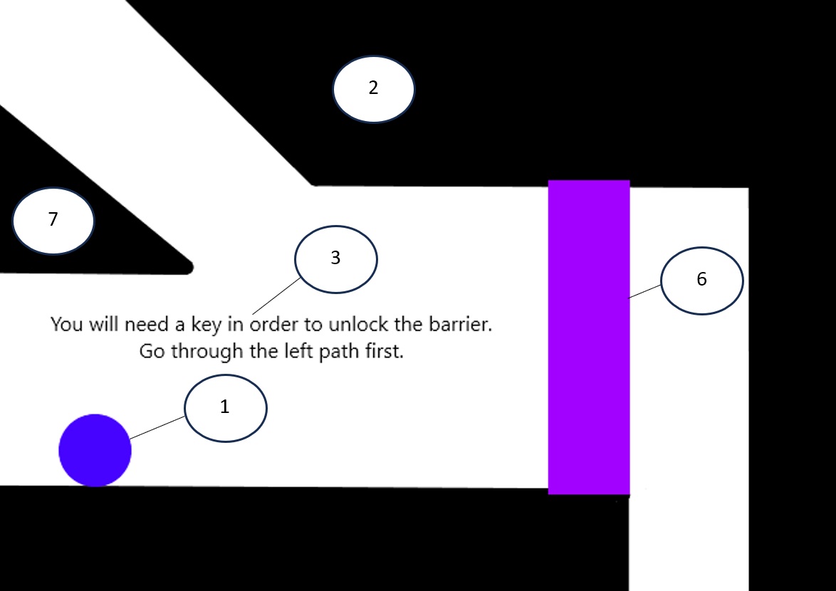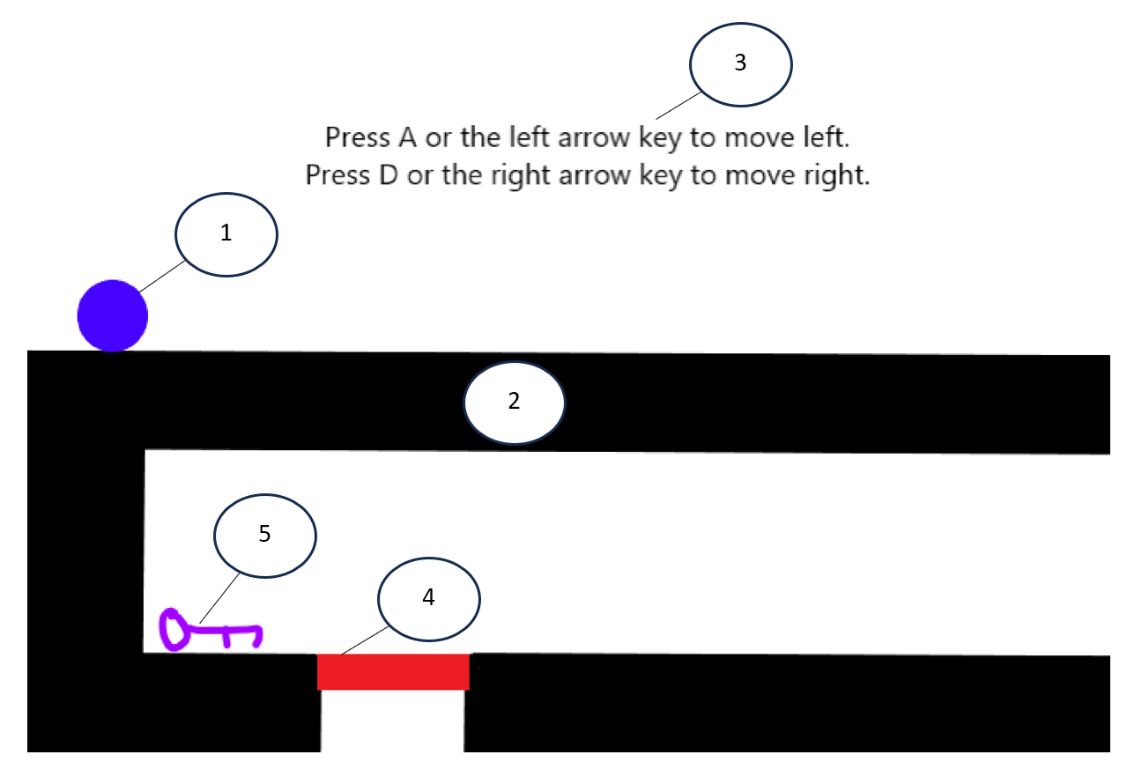To demonstrate how the game’s interface will look, I’ve created the following diagrams. Each diagram is annotated with numbers corresponding to descriptions below the diagrams which explain what each object represents. These diagrams collectively showcase each individual element of the game, and represent what the first, ninth, tenth, and fourteen rooms of the game will look like respectively.

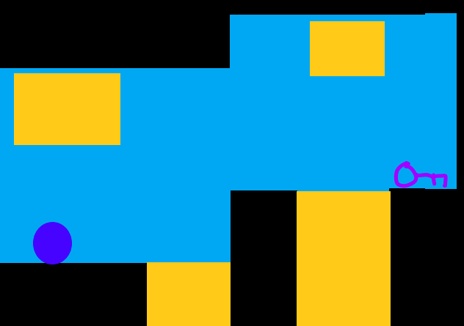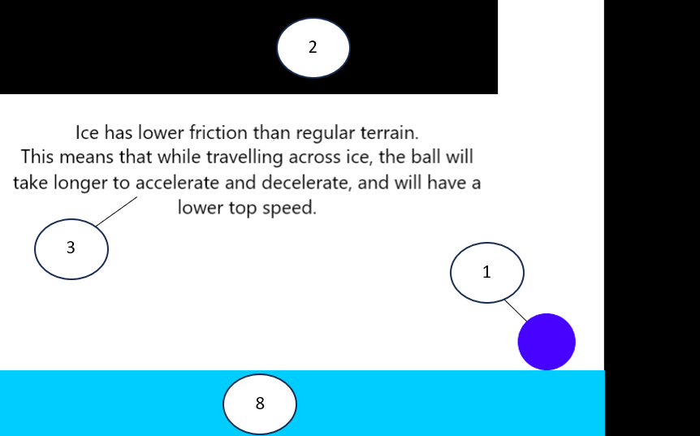

Hazards will move you

back to the beginning of

the room when you

collide with them.

1: The ball the player controls. The player can make the ball move left and right with the left arrow key / A and the right arrow key / D respectively, and can make it jump whenever it is on the ground using the Space Bar.

2: Terrain which, when the player collides with it, will reset their acceleration in the direction they collided with the terrain with to zero (e.g. if they were moving left and into a block of terrain, their acceleration to the left would be set to 0). Certain terrain blocks will only interact with the player from specific sides of their surface.

3: Text boxes which describe the forces being showcased and the game’s mechanics in detail so the player can understand what each part of the game is meant to represent and how to progress through the game.

4: Semisolids, which will interact with the player in the same way that regular terrain does when the player collides with them from one of its sides, but will allow the player to pass straight through them if they collide with them from any of their other sides.

5: Keys which will be added to the player’s inventory when they are collided with. If a player has a key in their inventory, they can unlock locked barriers by moving into them, which removes the key from their inventory and the barrier from the screen (in turn allowing them to pass through the area the barrier was taking up).

6: Locked barriers which interact with the player in the same way that regular terrain does when the player comes into contact with them if they don’t have a key in their inventory. If the player does have a key when colliding with the locked barrier however, it will be removed from the screen, and the player will be able to pass through the area it took up.

7: Ramps which will move the player towards the bottom of their slope while the player is on top of said slope and not pressing any of the movement keys. If the player tries to move using the movement keys, they will move more slowly up the slope and more quickly down it. The degree which the player’s movement speed is more quick/slow than it is when they’re travelling across flat terrain depends on the steepness of the slope.

8: Ice terrain, which has a lower amount of friction than regular terrain, but otherwise functions identically to regular terrain. This lower amount of friction means that when the player is travelling across it, they will take more time to accelerate and decelerate, and will have a lower top speed.

9: Hazards which when collided with, send the player back to the coordinates of the last checkpoint they passed. Checkpoints can either be the closest on-screen point to the point the player entered the room from, or where they picked up a key. The one below the marker will be stationary, the one above it will move down (and then up once it reaches the end of its movement range), and the one to the left of it will move right (and then left once it reaches the end of its movement range).

10: Water which hinders the player’s movement on the x-axis, representing water resistance, and hinders their acceleration downwards (which in turn allows them to jump higher), representing buoyancy.

## Hardware and Data Security

The game will be programmed in Thonny, and will be saved as a Python file. This means that the program should be able to be executed by any Python interpreter, and should therefore be able to run on all hardware which supports a Python interpreter.

The attributes of the non-player objects in the game will all be encapsulated, meaning they can only be affected by their own methods. The player will only be able to control when these methods are called themselves by moving the ball to certain coordinates (e.g. making the ball collide with terrain, moving the ball past a screen border). As for the player object itself, the player will be able to access methods related to their acceleration by pressing the right arrow key / D to move right, the left arrow key / A to move left, or the Space Bar to jump. By using the *pygame.key.get_pressed* function, I can ensure that these methods can only be accessed using the aforementioned keys, and can only be accessed using the keyboard. As the player can access these methods directly, by extension they will be able to control the values of the *jump* attribute (which will represent whether they can make the ball jump), along with the *racc* attribute (which will represent acceleration to the right), the *lacc* attribute (which will represent acceleration to the left), and the *ychange* attribute (which will represent acceleration on the y-axis) to a certain extent. That being said, the player will not be able to see the values of these attributes (nor the values of any of the attributes in the game and how any of the methods perform their function for that matter), as all of the data they will need to play the game will be provided to them by the game’s interface (see Interface).

# Technical Solution

## Complete Code Listing

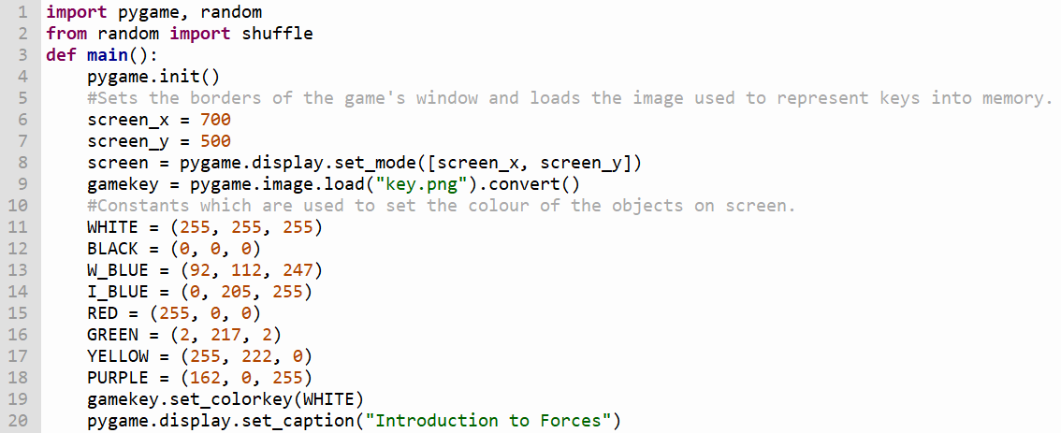

The *main* function contains all of the game’s elements, and is run at the beginning of the program’s execution. This function has a while loop containing the game itself, which stops looping when the player either presses the escape key or closes the game’s window. The function’s execution stops once the loop’s execution has completed, which in turn causes the program to stop running.

The code below the *main* function initialises the window for the game, loads the image of the key bundled with the program into the program's memory and sets the values of each of the colour constants.

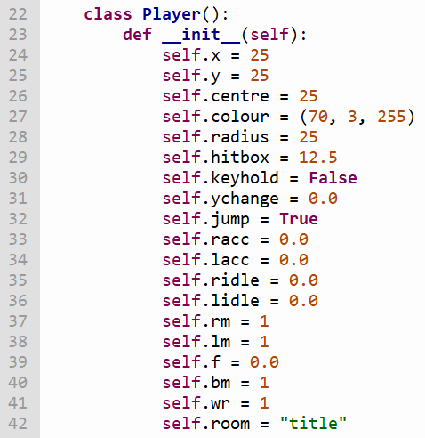

The player character is a circle drawn using Pygame’s built-in *draw.circle()* function. This function draws a rectangular image of a circle with a transparent background, meaning that the ball’s actual size is not how it appears on-screen.

The Player class contains many attributes, all of which are explained below:

* *self.x* – the x-coordinate of the top left corner of the image of the circle.
* *self.y* - the y-coordinate of the top left corner of the image of the circle.
* *self.centre* - the centre of the circle itself.
* *self.radius* - the radius of the circle itself.
* *self.hitbox* - the area outside of the circle’s centre which should be accounted for in operations where the player is colliding with certain objects (e.g. keys, hazards).
* *self.keyhold* - if the player has a key in their inventory, this attribute will be set to True. This attribute is checked when the player collides with a locked barrier.
* *self.ychange* - this value is used in calculations involving the player's movement on the y-axis.
* *self.jump* - determines whether the ball is on the ground. If this attribute is set to True, the player is allowed to jump.
* *self.racc/lacc* - represents the player's acceleration to the right/left as a result of one of the keys which control the player’s movement in that respective direction being pressed.
* *self.ridle/lidle* - represents the player's acceleration to the right/left respectively as a result of the pull of gravity while they are on an incline and not pressing any of the movement keys.
* *self.rm/lm* - the value which the player's acceleration to the right/left respectively should be multiplied by when the player is on an incline. This value will be set to 1 when the ball is on flat terrain, and the lower/higher than 1 the value is, the more/less steep the incline is in that direction respectively.
* *self.f* - represents the friction applied to the ball during movement. The higher the value is, the higher the ball’s top speed and rate of acceleration/deceleration will be.
* *self.bm* - changes how high the marble jumps and how quickly it falls back down to the ground, representing the effects of buoyant forces on the ball.
* *self.wr* - represents the resistive forces applied to the ball as a result of it travelling through water. While the ball is underwater this attribute’s value will be set to 0.375, and while the ball is on land it will be set to 1.
* 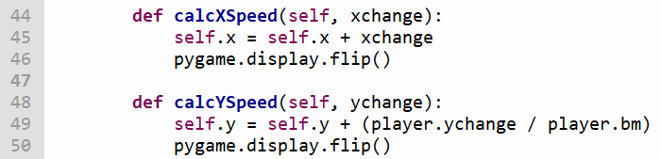*self.room* - the room the player is currently in. This attribute changes whenever the player moves between rooms.

These methods change the player's coordinates whenever they are moving along the axis dedicated to the respective method.

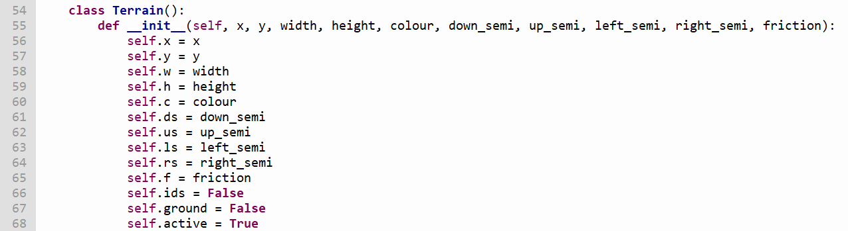

The terrain class’s attributes are explained below:

* *self.x* -the x-coordinate of the top left corner of the terrain.
* *self.y* - the y-coordinate of the top left corner of the terrain*.*
* *self.w* - the distance (in pixels) between the left side and the right side of the terrain.
* *self.h* - the distance (in pixels) between the top and the bottom of the terrain.
* *self.c* – the colour of the terrain.
* *self.ds/us/ls/rs* - deactivates the collision subroutine for the bottom/top/left/right sides of the terrain respectively, allowing the player to pass straight through it from that side.
* *self.ids* - only lets the player pass through the terrain if they aren't pressing any of the movement keys or jumping. This attribute is used in the fifth room to demonstrate how gravity will affect the ball while it is on an incline.
* *self.ground* - set to True when the player is close to the terrain. If this variable is False for all terrain and ramp objects, the player will start falling.
* *self.active* - determines whether the terrain should be drawn onto the screen when one of the room subroutines is called.

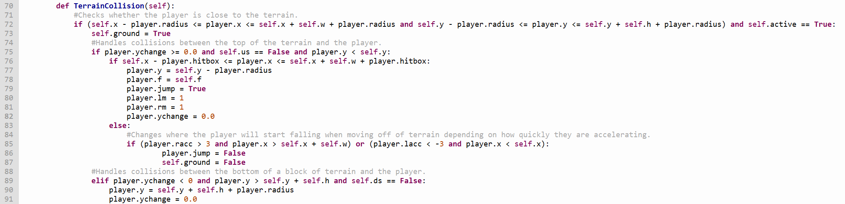

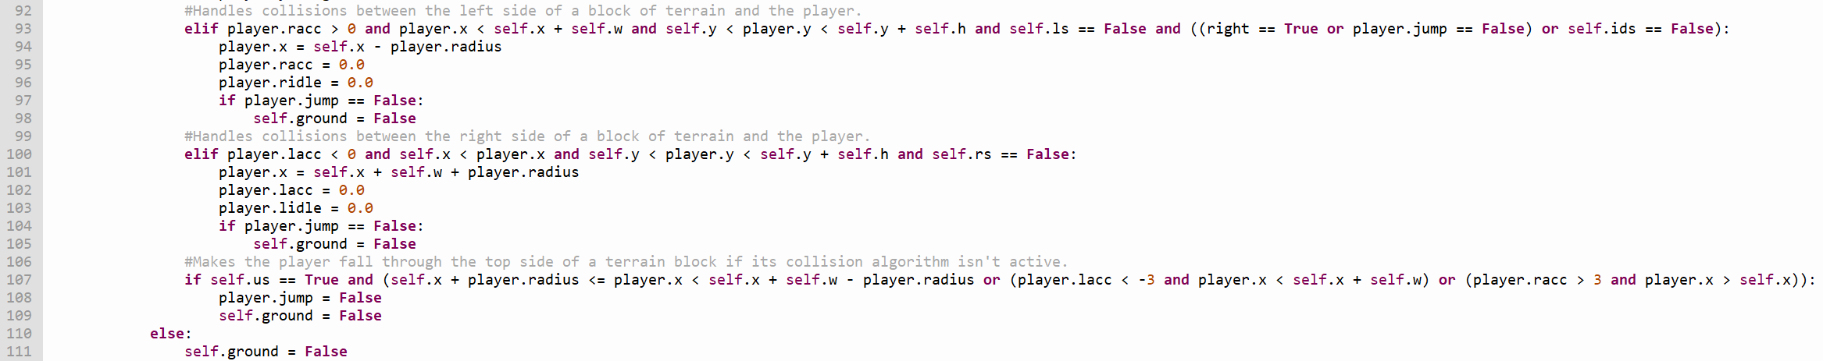

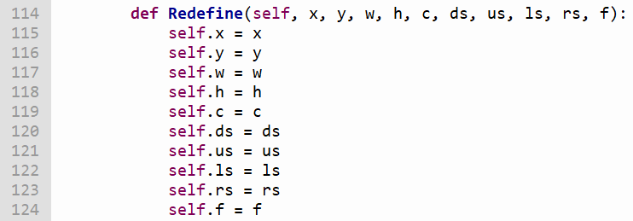This method checks whether the player is overlapping any piece of terrain. If this is the case, their acceleration in the direction they were moving towards the terrain in will be reset to zero, and they will be placed next to the side of the terrain they collided with.

The method above allows each attribute of a terrain object to be changed to fit the layout of whichever room the player is in.

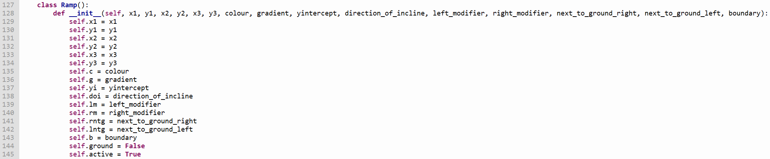Every object (other than text boxes and the player) has a *Redefine* subroutine so their attributes can be changed between rooms.

Ramps are pieces of terrain which are right-angle triangles instead of rectangles. When the player is on top of the hypotenuse of the ramp, they will slowly accelerate towards its bottom while none of the movement keys are being pressed, and will move more quickly when moving down the slope and more slowly when moving up the slope. Ramps have the following attributes:

* *self.x(1/2/3)/y(1/2/3)* - determines the first, second, and third points on the screen respectively where each vertex of the ramp should be drawn.
* *self.c* – the colour of the ramp.
* *self.g* – the gradient of the ramp’s hypotenuse.
* *self.yi* - the y-coordinate where the ramp's incline would intersect with the left border of the game's window.
* *self.doi* - the direction the ramp's incline ascends in.
* *self.lm/rm* - the value which the player's acceleration to the left/right respectively should be multiplied by when the player is on an incline. This value will be set to 1 when the ball is on flat terrain, and the lower/higher than 1 the value is, the more/less steep the incline is in that direction respectively.
* *self.rntg/lntg* - set to True if the right/left side of the ramp respectively is next to a piece of terrain, in which case the range of coordinates the ramp's collision algorithm can affect will be adjusted to account for the terrain.
* *self.b* - changes the coordinates where the ramp's collision algorithm can have an effect on the player.
* *self.ground* - set to True when the player is close to the ramp. If this variable is False for all terrain and ramp objects, the player will start falling.
* 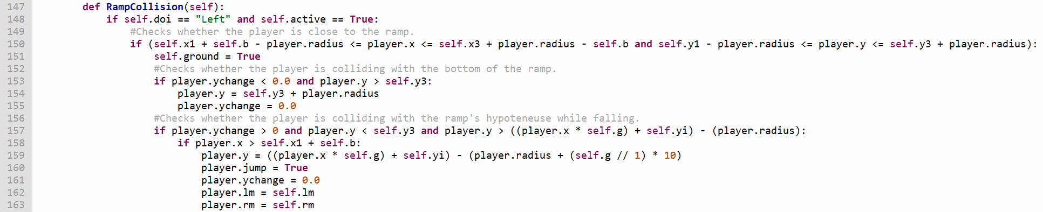*self.active* - determines whether the ramp object should be drawn onto the screen when one of the room subroutines is called.

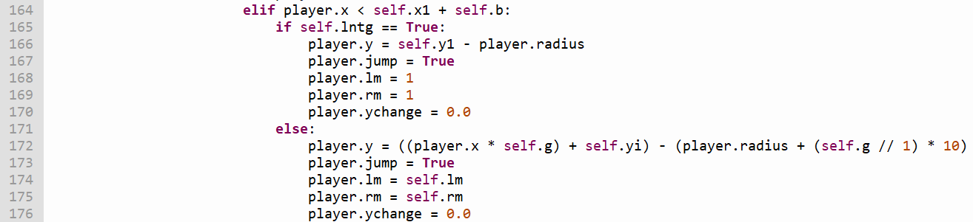

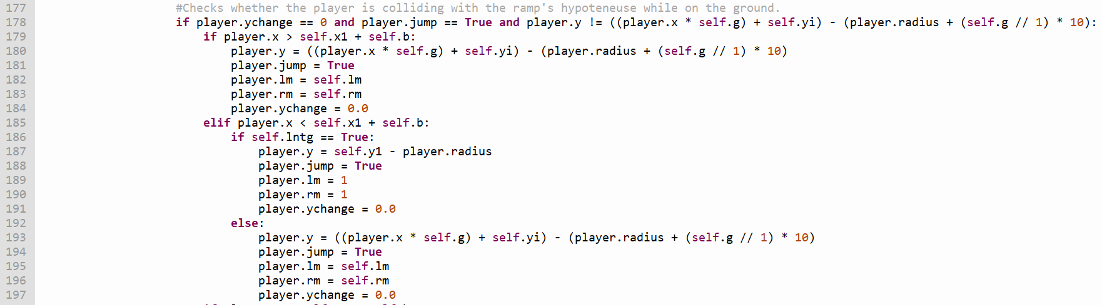

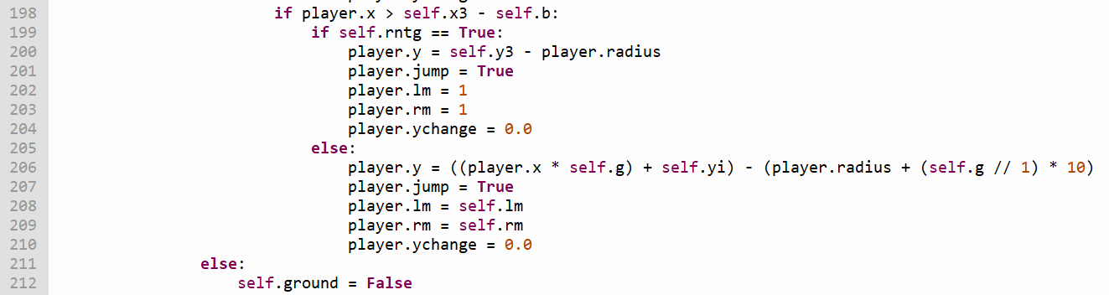

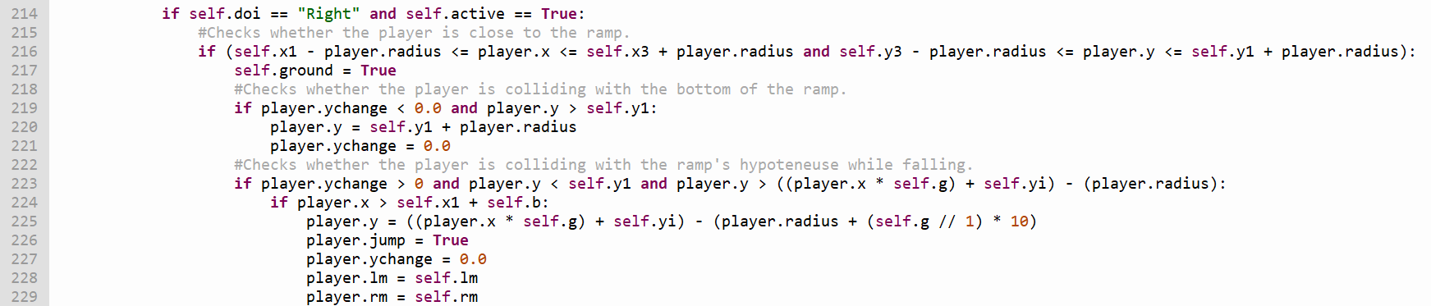

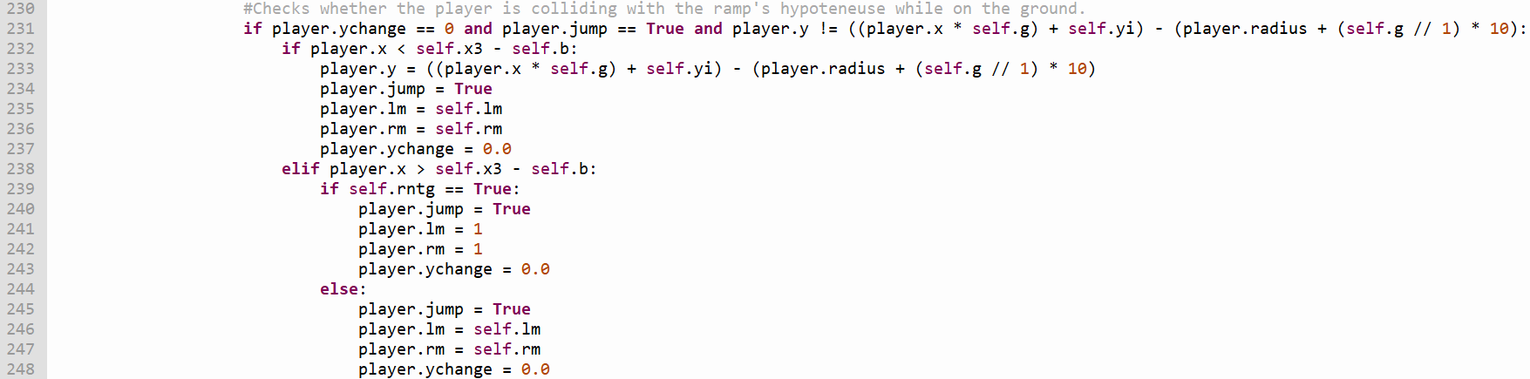

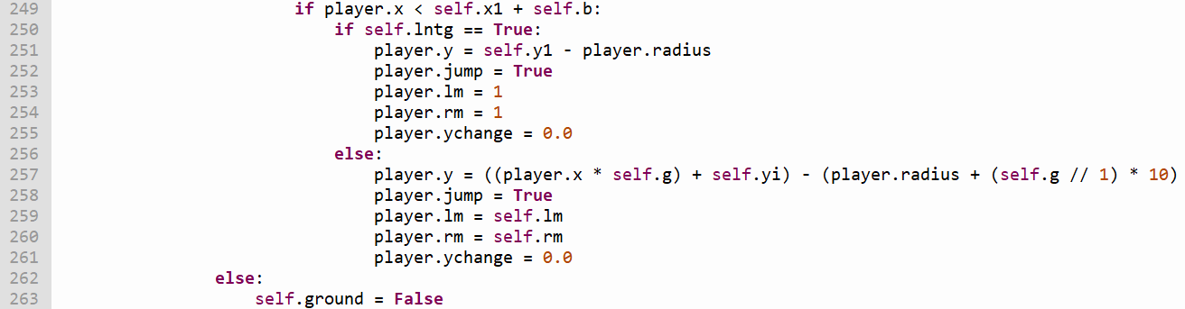

This method detects whether the player is colliding with any of the ramps, placing the player next to the surface of the ramp they collided with and cancelling their acceleration in the direction they were moving towards the ramp in if so.

The collision algorithm used to handle collisions between the player and a ramp depends on the direction the ramp’s incline ascends in (indicated by *self.doi*).

Collision for the top part of the ramp (its hypotenuse) is determined using the mathematical equation of a line.

If the player is on top of a ramp, they will gradually accelerate down the ramp while they aren’t pressing any of the movement keys (representing the effect of gravity pulling the ball down the ramp), will move slower up the ramp, and will move faster down the ramp.

Furthermore, the *x* and *y* attributes used to set boundaries for the collision algorithm will be in different places depending on the direction the ramp's incline ascends in.

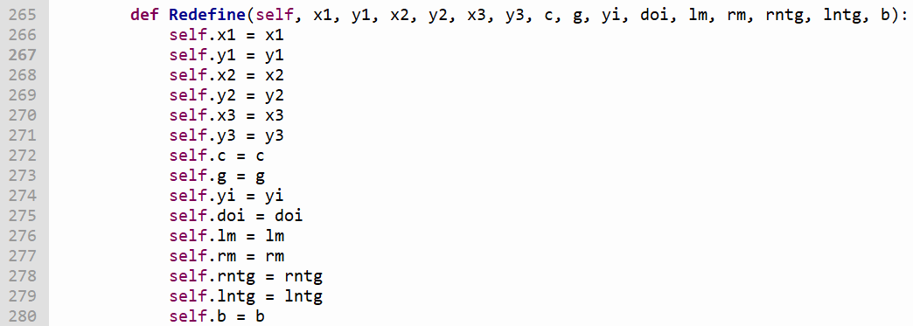

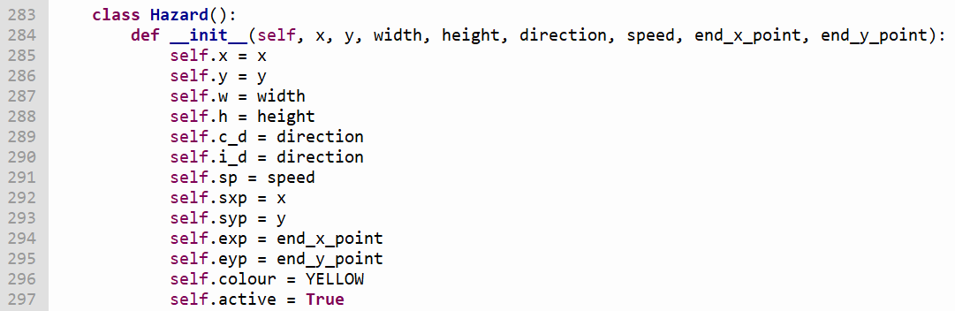The method above allows each attribute of a ramp object to be changed to fit the layout of whichever room the player is in.

Hazards are objects which will send the player back to a certain x and y coordinate when they collide with them. Hazards can be stationary, or can move back and forth between two sets of coordinates. Hazards have the following attributes:

* *self.x* - the x-coordinate of the top left corner of the hazard.
* *self.y* - the y-coordinate of the top left corner of the hazard.
* *self.w* - the distance (in pixels) between the left side and the right side of the hazard.
* *self.h* – the distance (in pixels) between the top and the bottom of the hazard.
* *self.c_d/i_d* - the direction the hazard is currently travelling in / initially started travelling in respectively.
* *self.sp* - the speed at which the hazard is moving.
* *self.sxp/syp* - the x and y coordinates that the hazard starts at respectively. This attribute also determines the point at which the hazard should change directions if it is moving in the direction opposite to the one it was initially moving in.
* *self.exp/eyp* - the x and y coordinates of the point at which the hazard changes directions if it’s moving in the same direction as the one it moves in initially respectively.
* *self.colour* - the colour of the hazard.
* *self.active* - determines whether the hazard should be drawn onto the screen when one of the room subroutines is called.

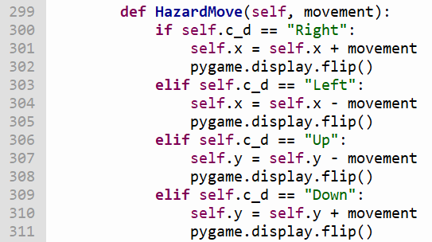

This method checks the direction the hazard should currently be moving in, then moves it in that direction by the number of coordinates specified by *movement*.

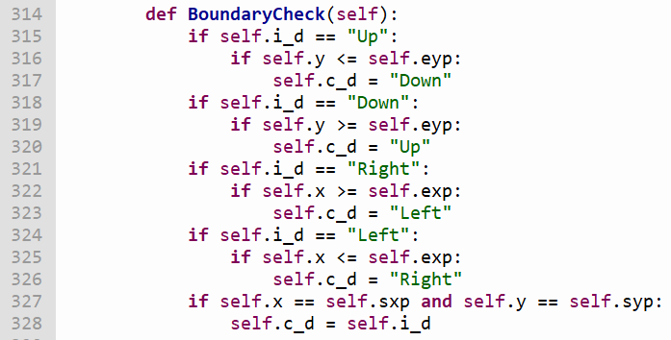

This method checks whether the hazard has reached either boundary of the area it is allowed to move in, reversing its direction of movement if so.

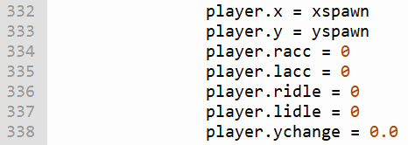

This method checks whether the player has collided with a hazard, placing them at the coordinates specified by *xspawn* and *yspawn* and cancelling all of their acceleration if this is the case.

Collision subroutines for certain objects (e.g. hazards, keys) will use the player's *hitbox* attribute to determine whether collisions are taking place rather than its *radius* attribute.

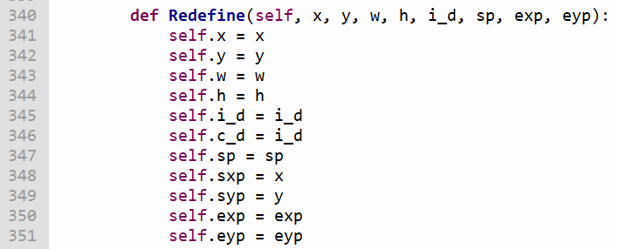

The method above allows each attribute of a hazard object to be changed to fit the layout of whichever room the player is in.

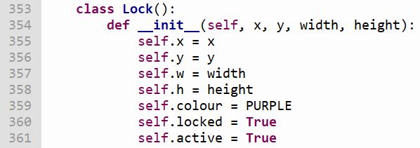

Locks are barriers which will interact with the player differently depending on whether the player is holding a key or not when they collide with them. If the player is not holding a key when they collide with a lock, the lock will interact with the player in the same way that *Terrain* objects would. If the player is holding a key when this happens however, the lock will be removed from the screen, the key will be removed from the player’s inventory, and the player will be able to pass through the area the lock was taking up.

Locks have the following attributes:

* *self.x* - the x-coordinate of the top left corner of the lock.
* *self.y* - the y-coordinate of the top left corner of the lock.
* *self.w* - the distance (in pixels) between the left side and the right side of the lock.
* *self.h* - the distance (in pixels) between the top and the bottom of the lock.
* *self.colour* – the colour of the lock.
* *self.locked* – if this attribute is set to True, the lock will be drawn on-screen and the player will be able to collide with it. If this attribute is set to False however (which happens when the player collides with it while holding a key), the lock will be removed from the screen and the player will be able to pass through it.
* *self.active* – determines whether the lock should be drawn onto the screen when one of the room subroutines is called. The difference between this attribute and *self.locked* is that while the value of *self.locked* is changed when the player interacts with the lock the attribute is part of, the value of *self.active* is changed when the player moves between rooms.

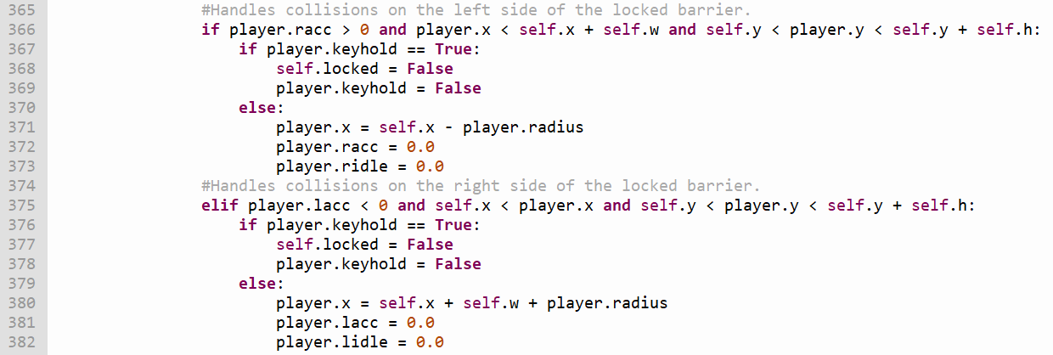

If the player is holding a key when they collide with a lock, this method will remove the key from the player's inventory and the lock from the screen, allowing the player to pass through the area the lock took up.

If the player doesn't have a key in their inventory, the method will instead make the player interact with the lock as if it were a terrain object.

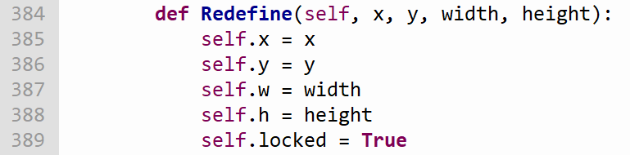

The method above allows each attribute of a lock object to be changed to fit the layout of whichever room the player is in.

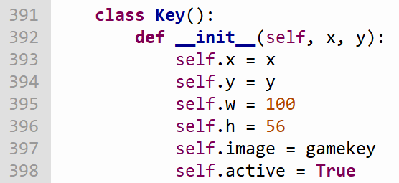

Keys are objects which can be picked up by the player, and are used to unlock locks (allowing the player to pass through the area the lock was taking up). Keys have the following attributes:

* *self.x* - the top-left corner of the image of the key.
* *self.y* - the top-left corner of the image of the key.
* *self.w* - the distance (in pixels) between the left side and the right side of the image of the key.
* *self.h* - the height (in pixels) between the top and the bottom of the image of the key.
* *self.image* - the image of the key itself. This image is loaded into the program’s memory at the beginning of its execution.
* *self.active* – determines whether the key object should be drawn onto the screen when one of the room subroutines is called.

If the player comes into contact with a key, this method will set the player’s *keyhold* attribute to True. This will allow the player to pass through locks and remove them from the screen when they come into contact with them.

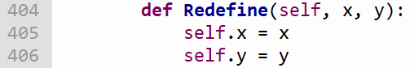

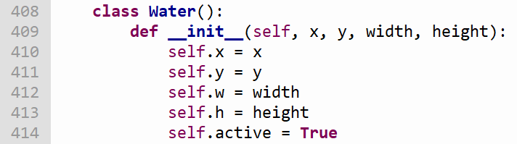The method above allows each attribute of a key object to be changed to fit the layout of whichever room the player is in.

Water will restrict the player’s movement on the x-axis, make them fall to the ground more slowly and allow them to jump higher while the player is inside it. Water uses the following attributes:

* *self.x* - the x-coordinate of the top left corner of the water object.
* *self.y* - the y-coordinate of the top left corner of the water object.
* *self.w* - the distance (in pixels) between the left side and the right side of the water object.
* *self.h* - the distance (in pixels) between the top and the bottom of the water object.
* 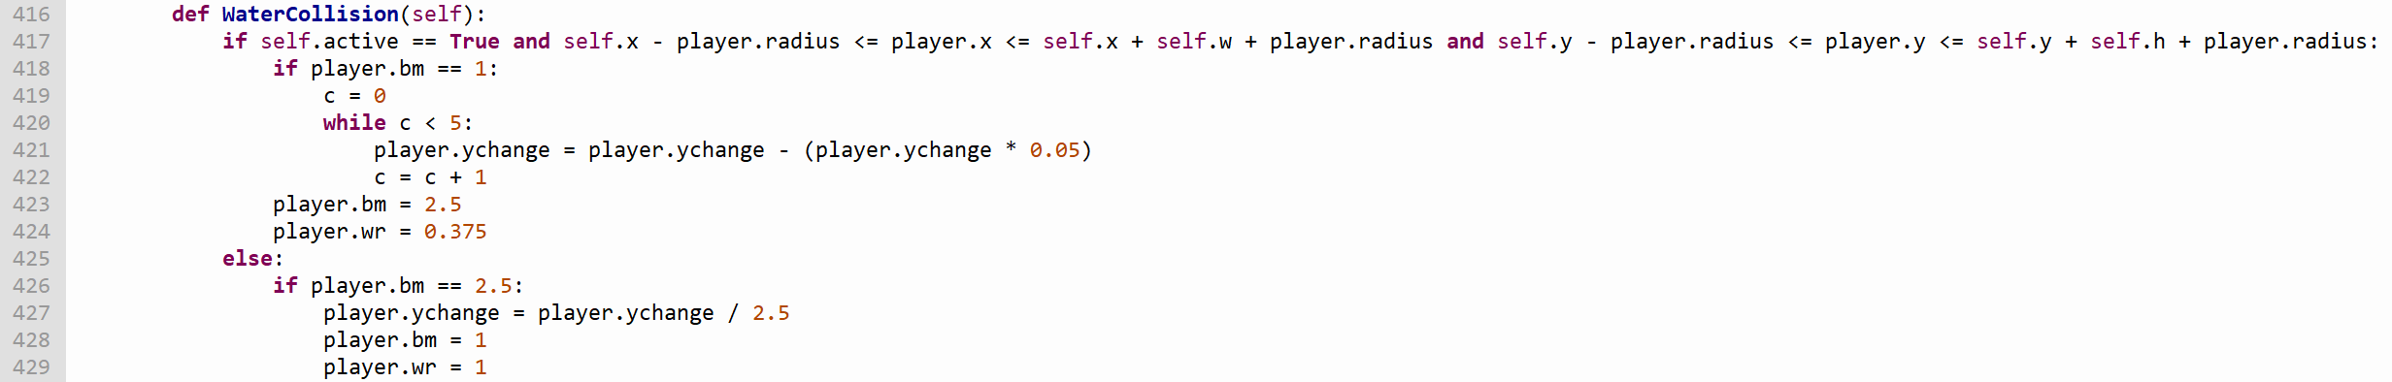*self.active* - determines whether the water object should be drawn onto the screen when one of the room subroutines is called.

When the player enters a body of water, this method will first gradually slow their acceleration on the y-axis down for a few seconds (representing how an object denser than water will slowly sink when it first enters a body of water). Then, the player’s *bm* and *wr* attributes will be changed so the player jumps higher and descends slower while midair (representing the effects of buoyant forces) and moves more slowly along the x-axis (representing the effects of water resistance) respectively.

When the player leaves the body of water, their acceleration along the y-axis will instantly be divided by 2.5 (stopping their speed from suddenly increasing when they leave it) and their *bm* and *wr* attributes will return to their original values.

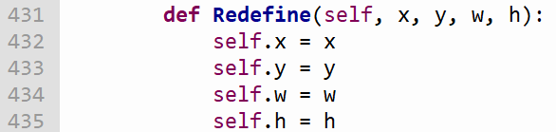

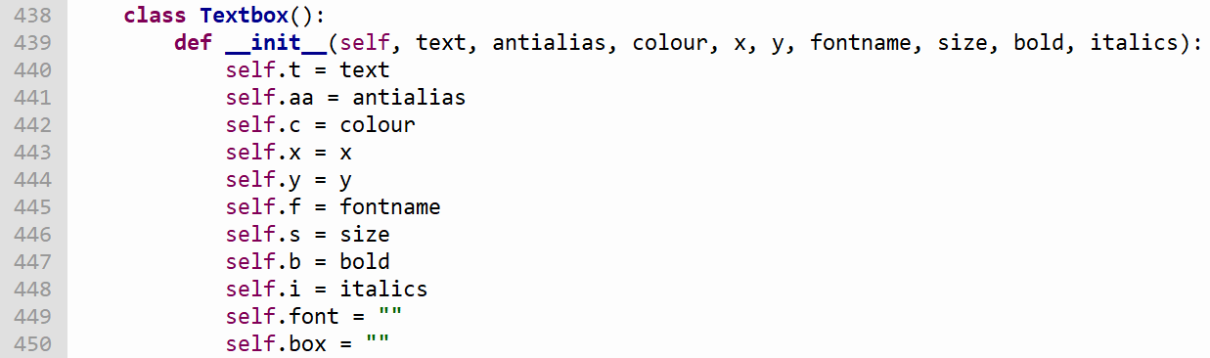The method above allows the attributes of a water object to be changed to fit the layout of whichever room the player is currently in.

Text boxes are images with a transparent background that contain text explaining how the forces and elements of the game work. They have the following attributes:

* *self.t* - the text which is to be displayed on-screen.
* *self.aa* - whether the text in the text box should be anti-aliased or not.
* *self.c* - the colour the text should be rendered in.
* *self.x* - the x-coordinate of the top left corner of the image the text is displayed in.
* *self.y* - the y-coordinate of the top left corner of the image the text is displayed in.
* *self.f* ­- the name of the font the text should be written in.
* *self.s* - the size of the text.
* *self.b* - whether the text should be in bold or not.
* *self.i* - whether the text should be in italics or not.
* *self.font* - used to create the text box itself when rendering it onto the screen.
* *self.box* - used to render the text box as an image so it can be displayed on the screen.

Unlike most other objects, text boxes don’t have an *active* attribute – instead, if a text box isn’t required in a room its *text* attribute will be left empty.

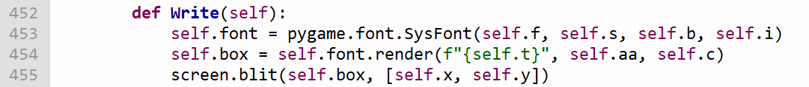

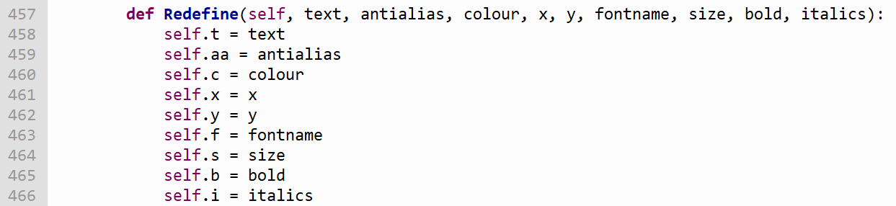This method renders its respective text box into Pygame and places it on the screen at the given coordinates as an image.

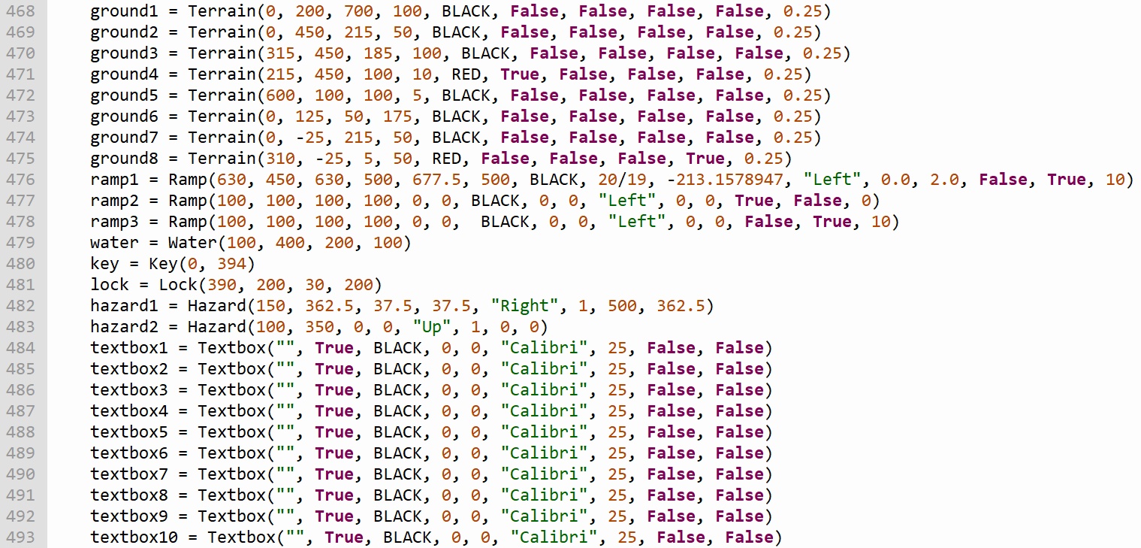The method above is used to change the attributes of each text box object so they give the player information relating to the room they are currently traversing (e.g. how certain elements of the game work, the forces elements of the game represent).

The statements above create all of the objects used in the game before it starts. Each class is given as many associated objects as necessary (e.g. room 8 requires there to be 8 *Terrain* objects on the screen, and as this is the largest requirement of *Terrain* objects for any room in the game, 8 *Terrain* objects are created).

The following subroutines redefine the attributes of each object to create the structure of each of the game's respective rooms. When the player moves between rooms, the subroutine dedicated to the room they are moving to is executed.

When a room subroutine finishes arranging the objects into the respective room's structure, the player's *room* attribute is set to the number of the room they moved to. This value is used to determine which borders of the screen the player should be able to leave the screen through and which room the program should display when the player leaves the screen through a given border.

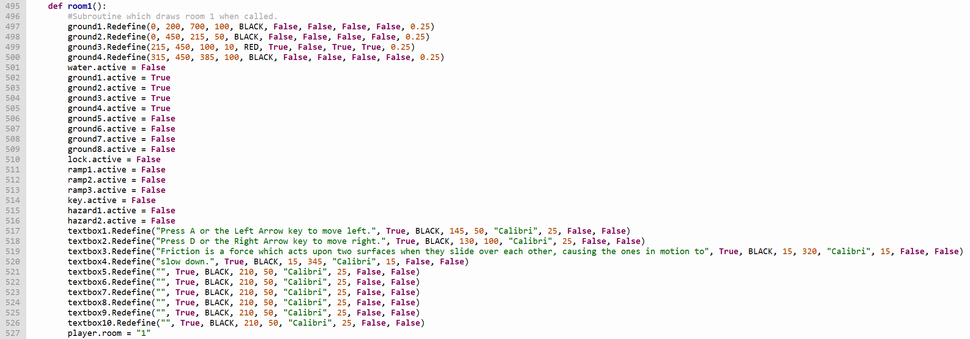

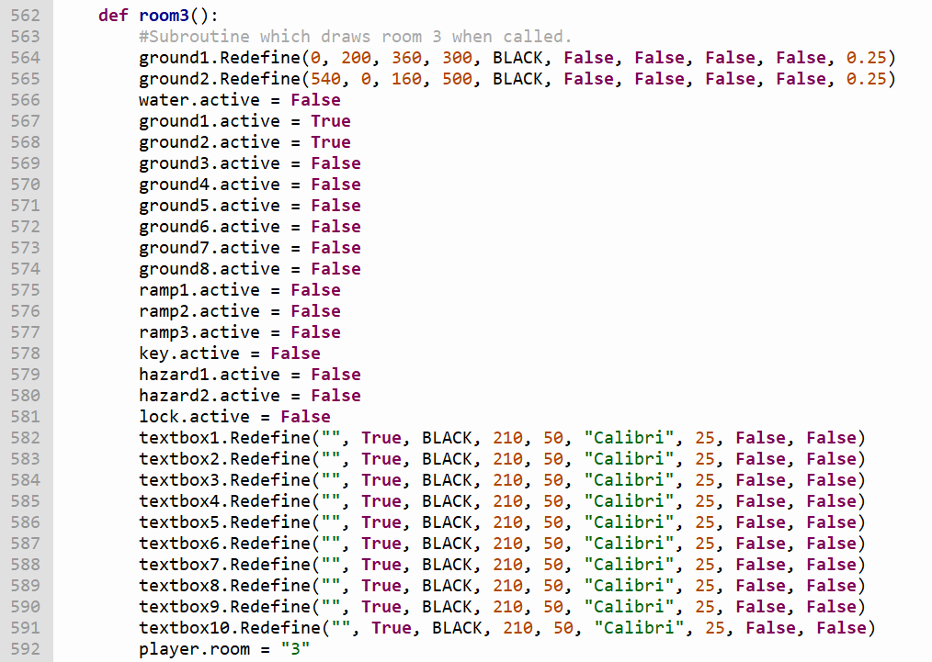 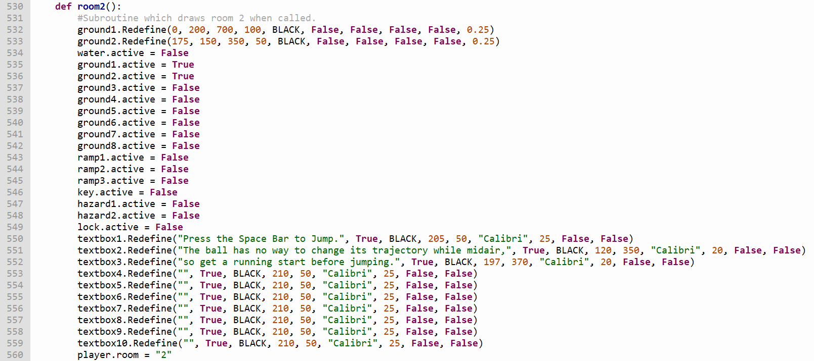

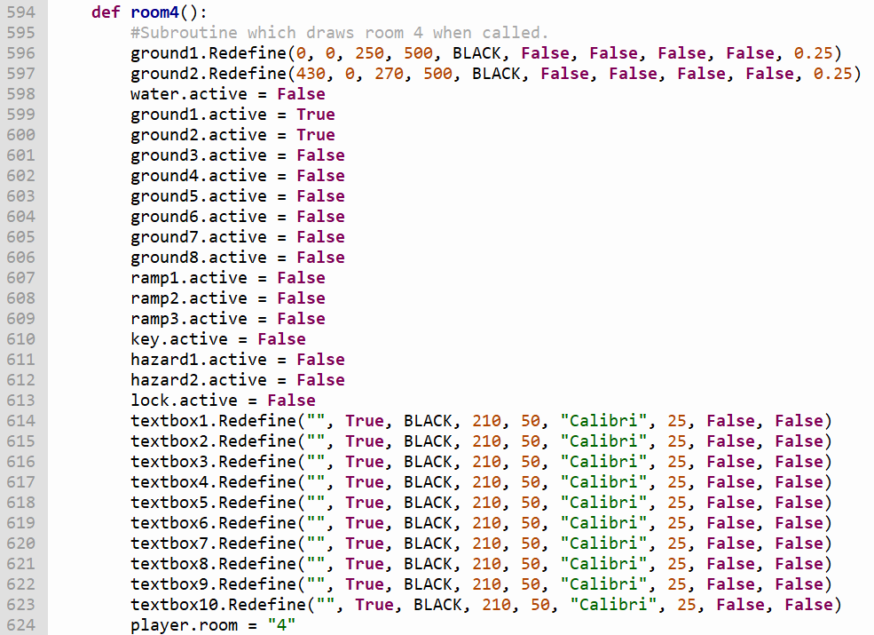

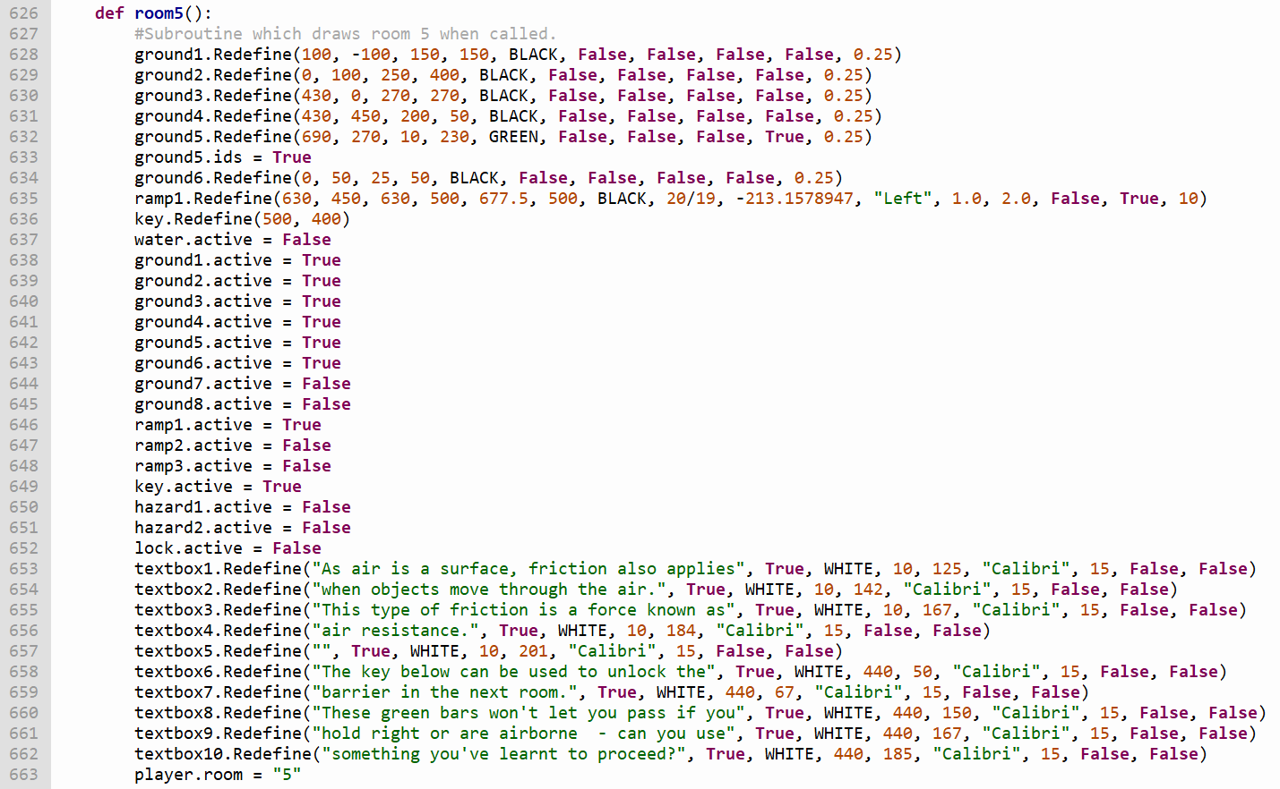

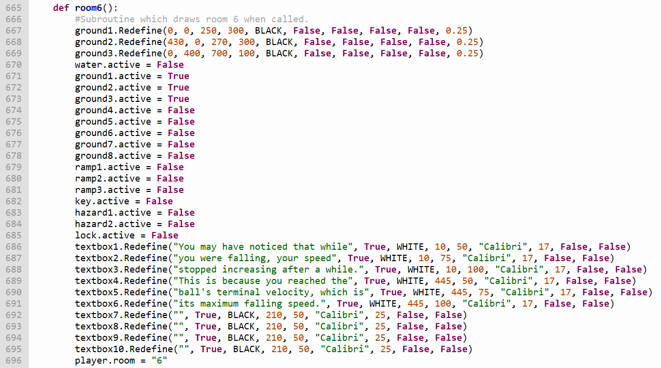

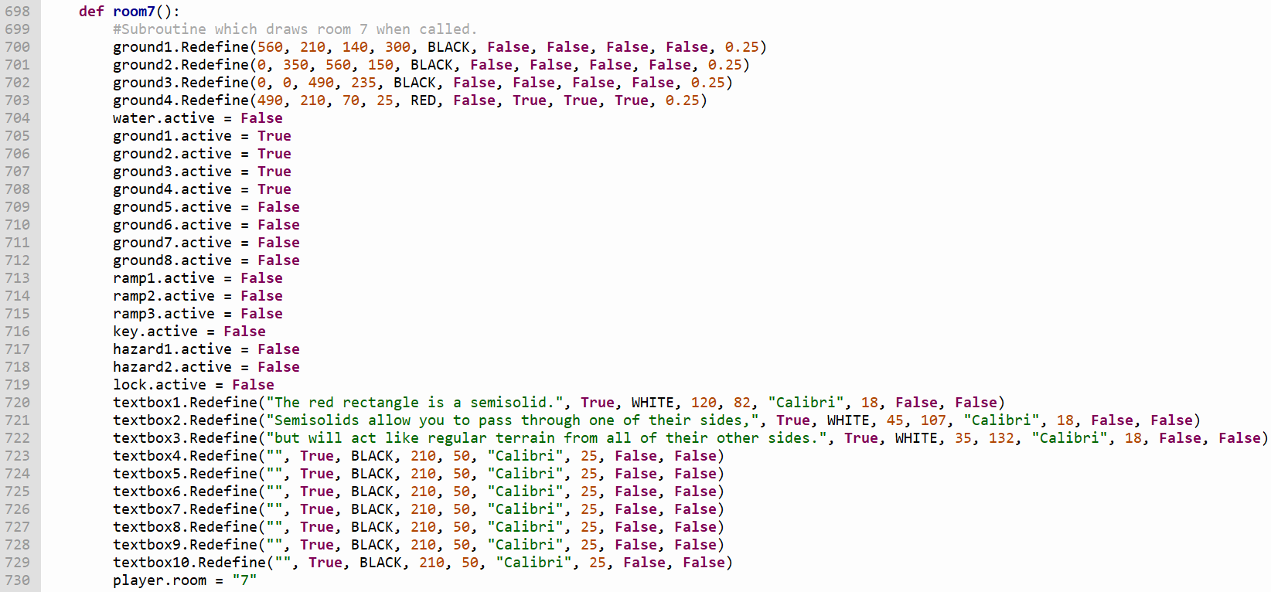

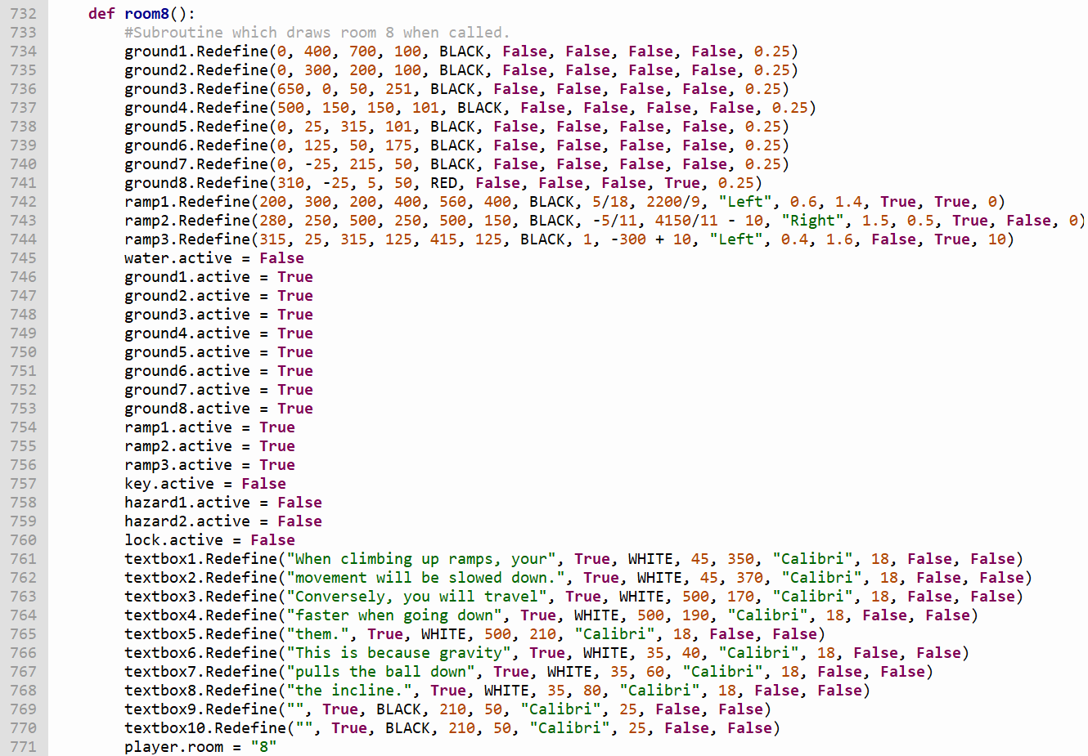

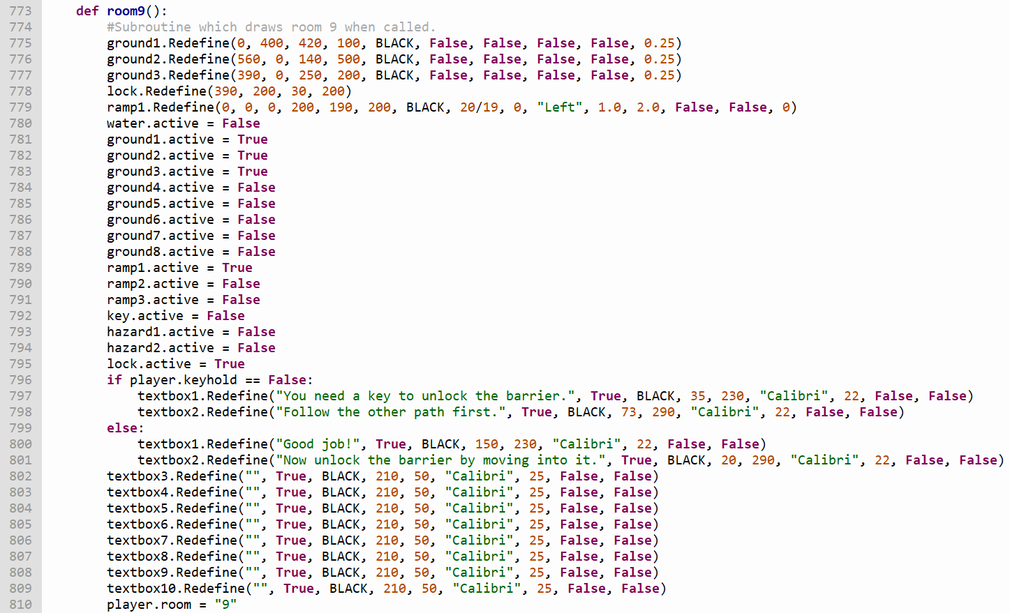

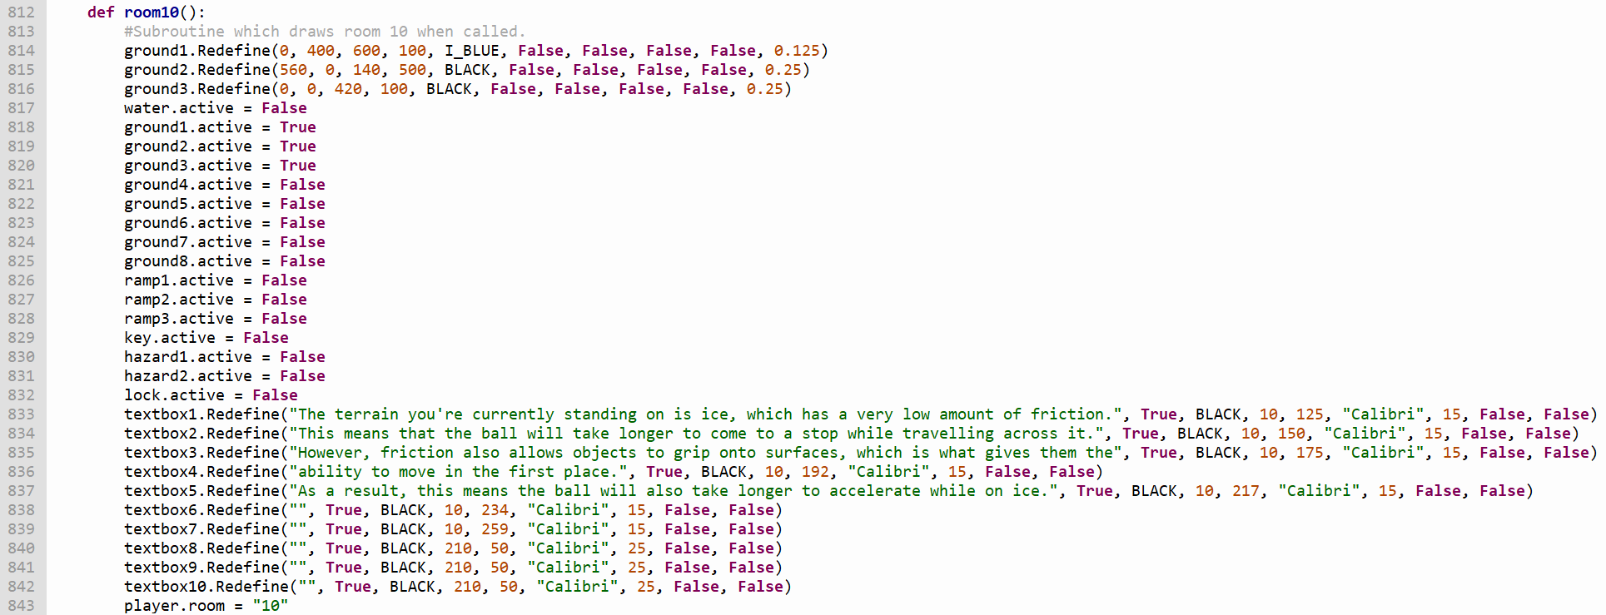The selection statement in this room subroutine changes what the text boxes in the room say depending on whether the player is holding a key when they enter the room.

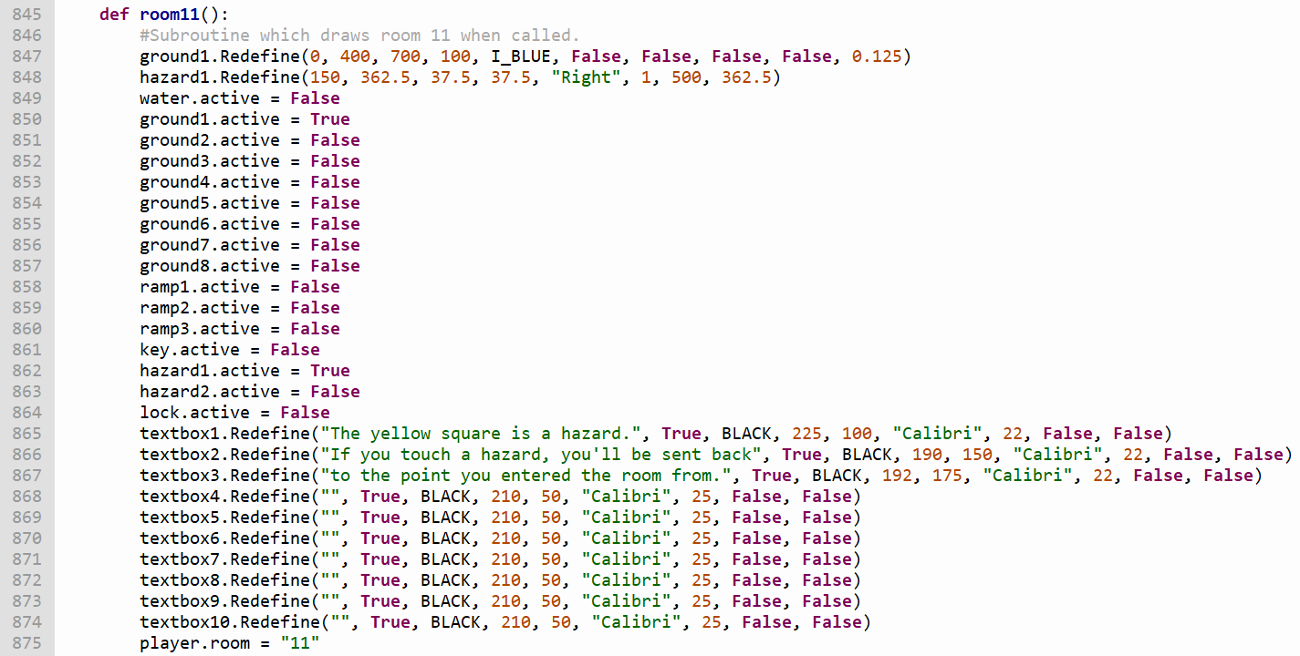

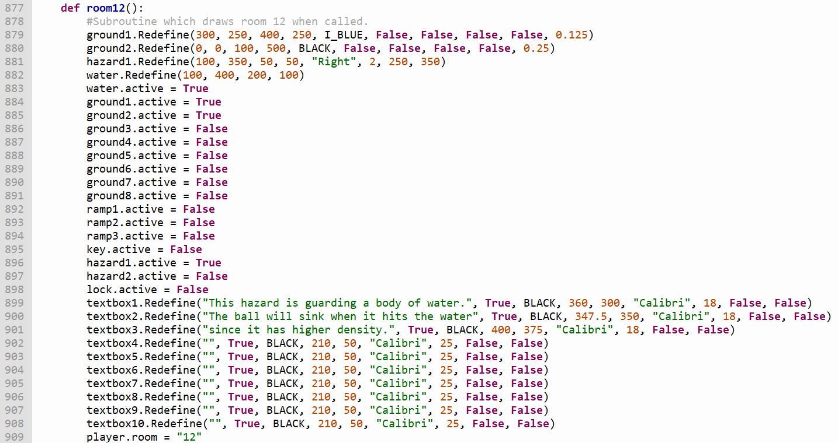

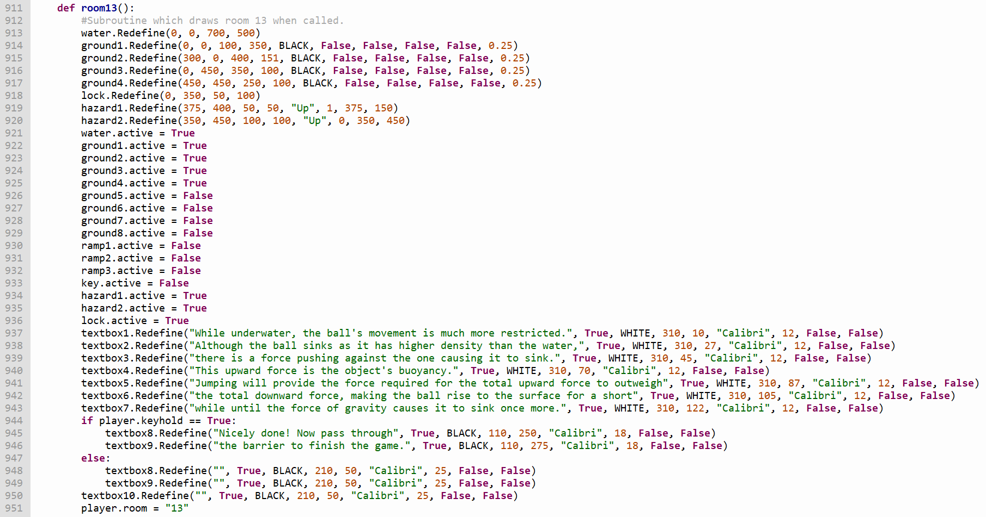

Additional text will be displayed on the screen if the player is holding a key when they enter room 13.

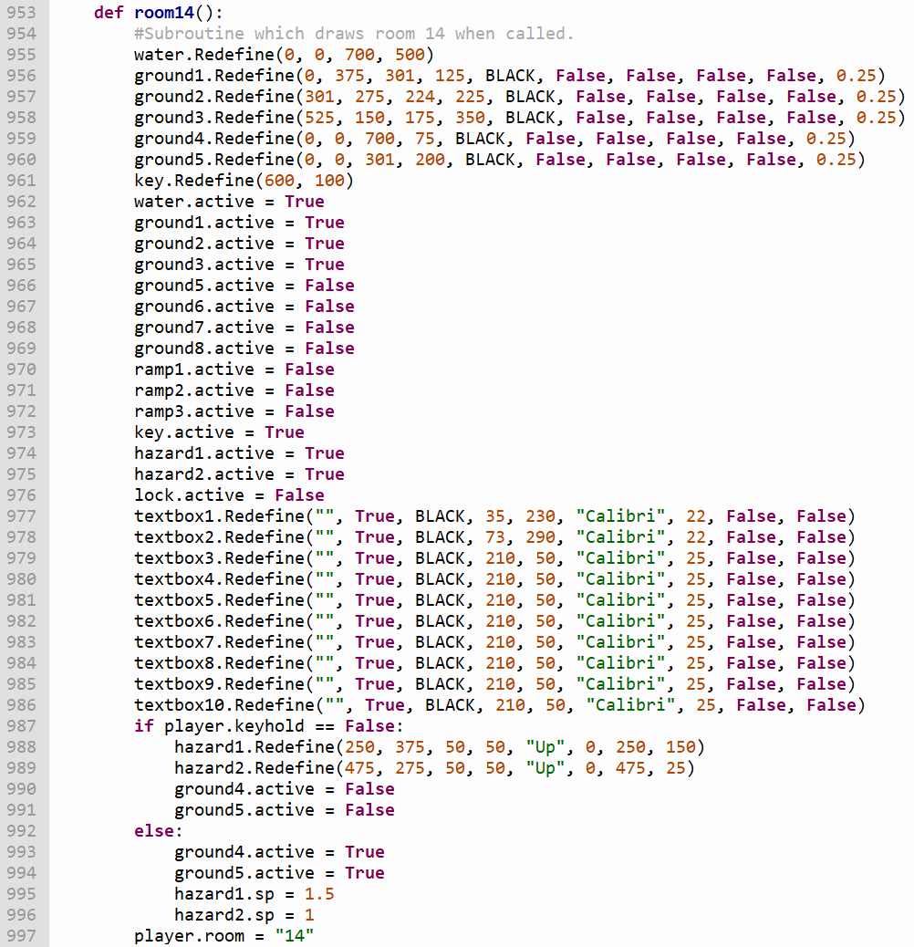

When the player grabs the key inside the room above, the *speed* attributes of the hazards will be updated so they can move.

.

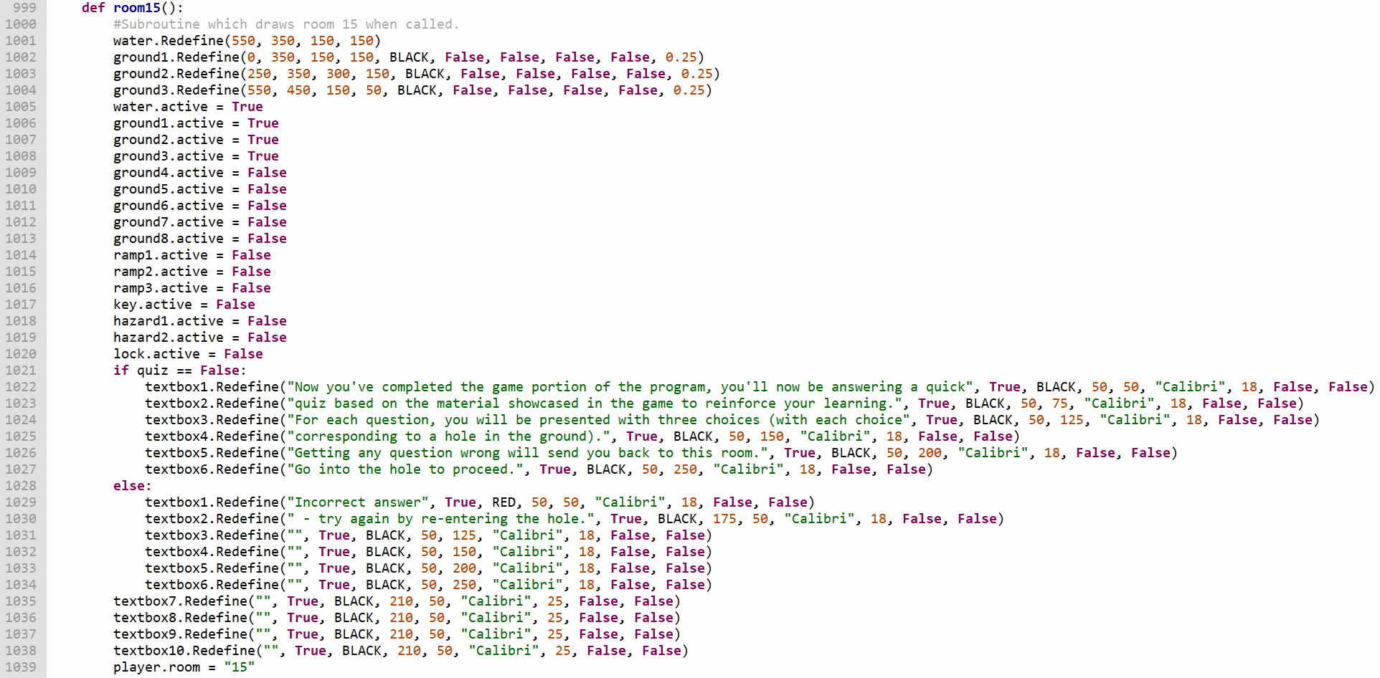

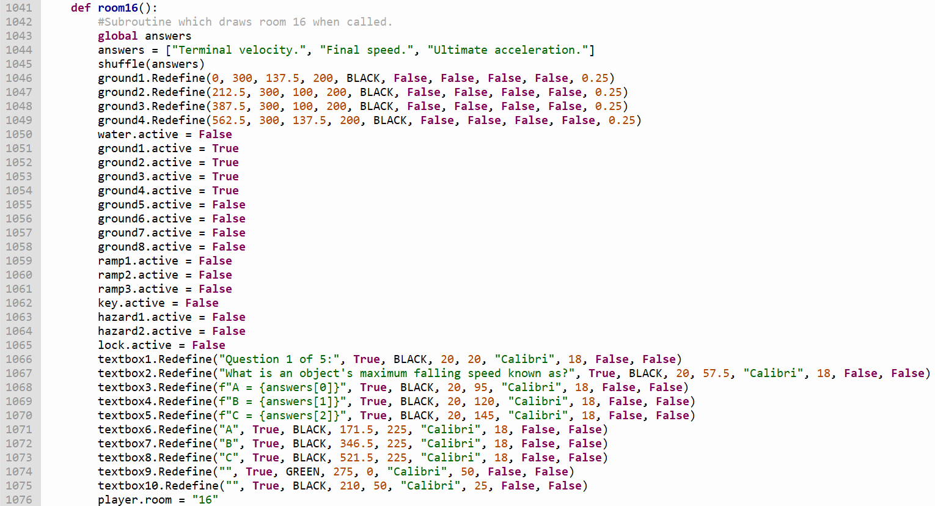The *quiz* variable in the room subroutine above signifies that the player has passed through the room containing the first question of the quiz when it’s set to True. The text displayed in this room depends on the value of this variable.

The *answers* list contains the selection of answers the player can choose from to answer a given question. This list is shuffled into a random order every time the player enters the room to make sure that they can only get the question right by knowing the answer rather than by remembering which hole it’s associated with.

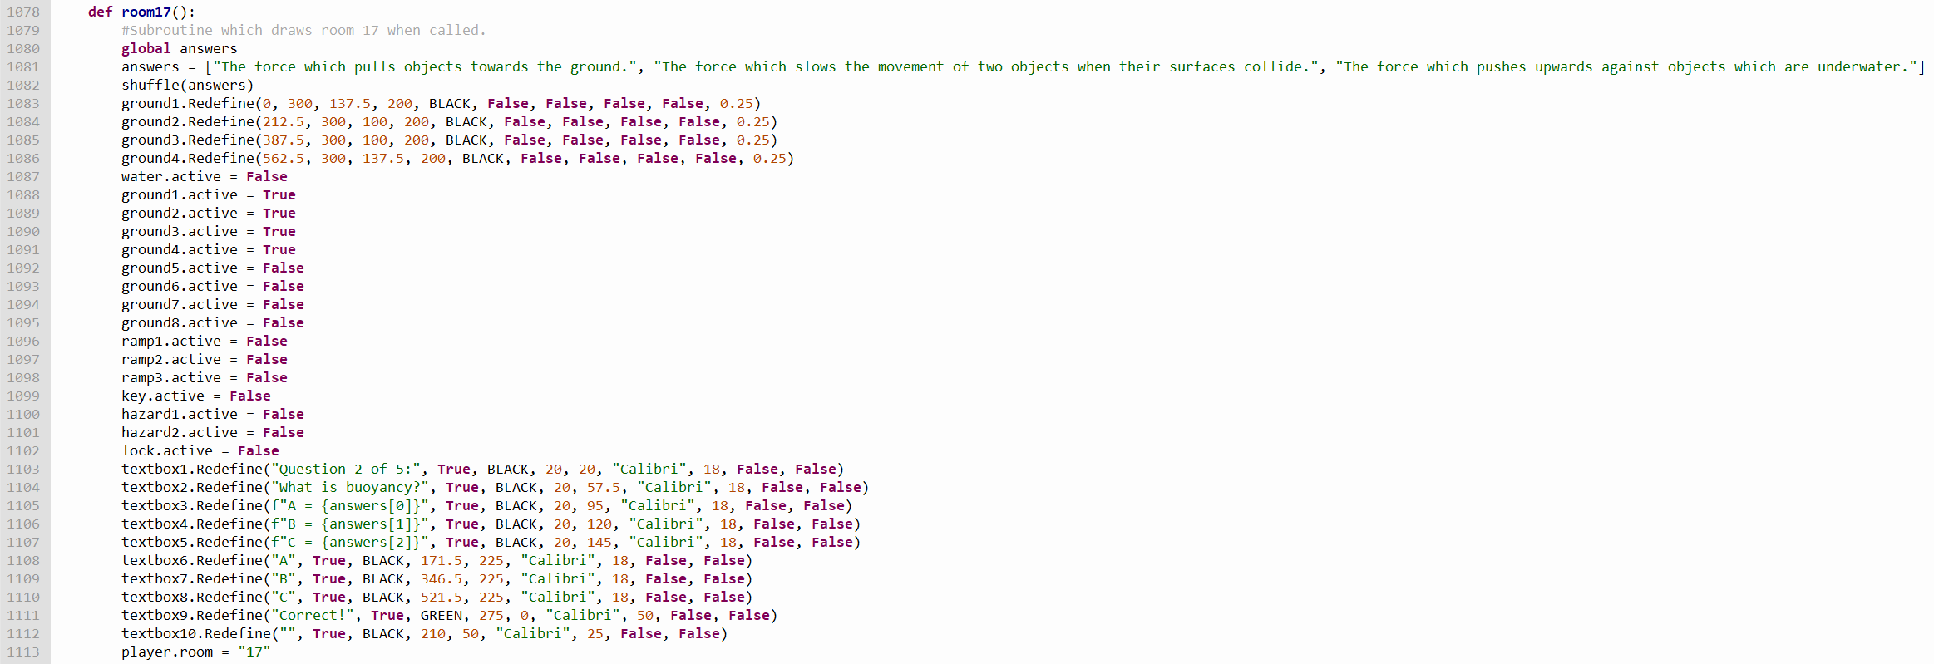

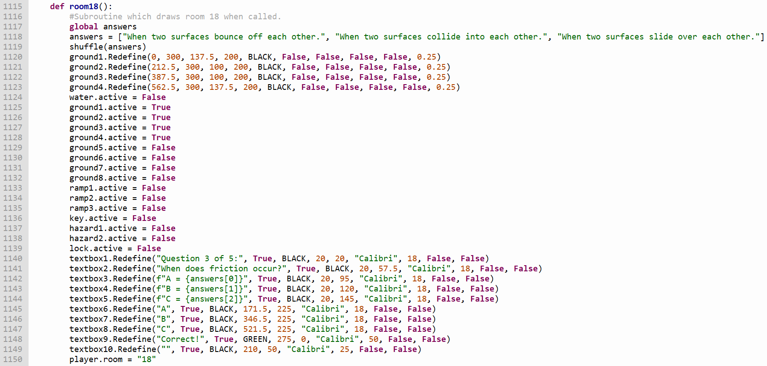

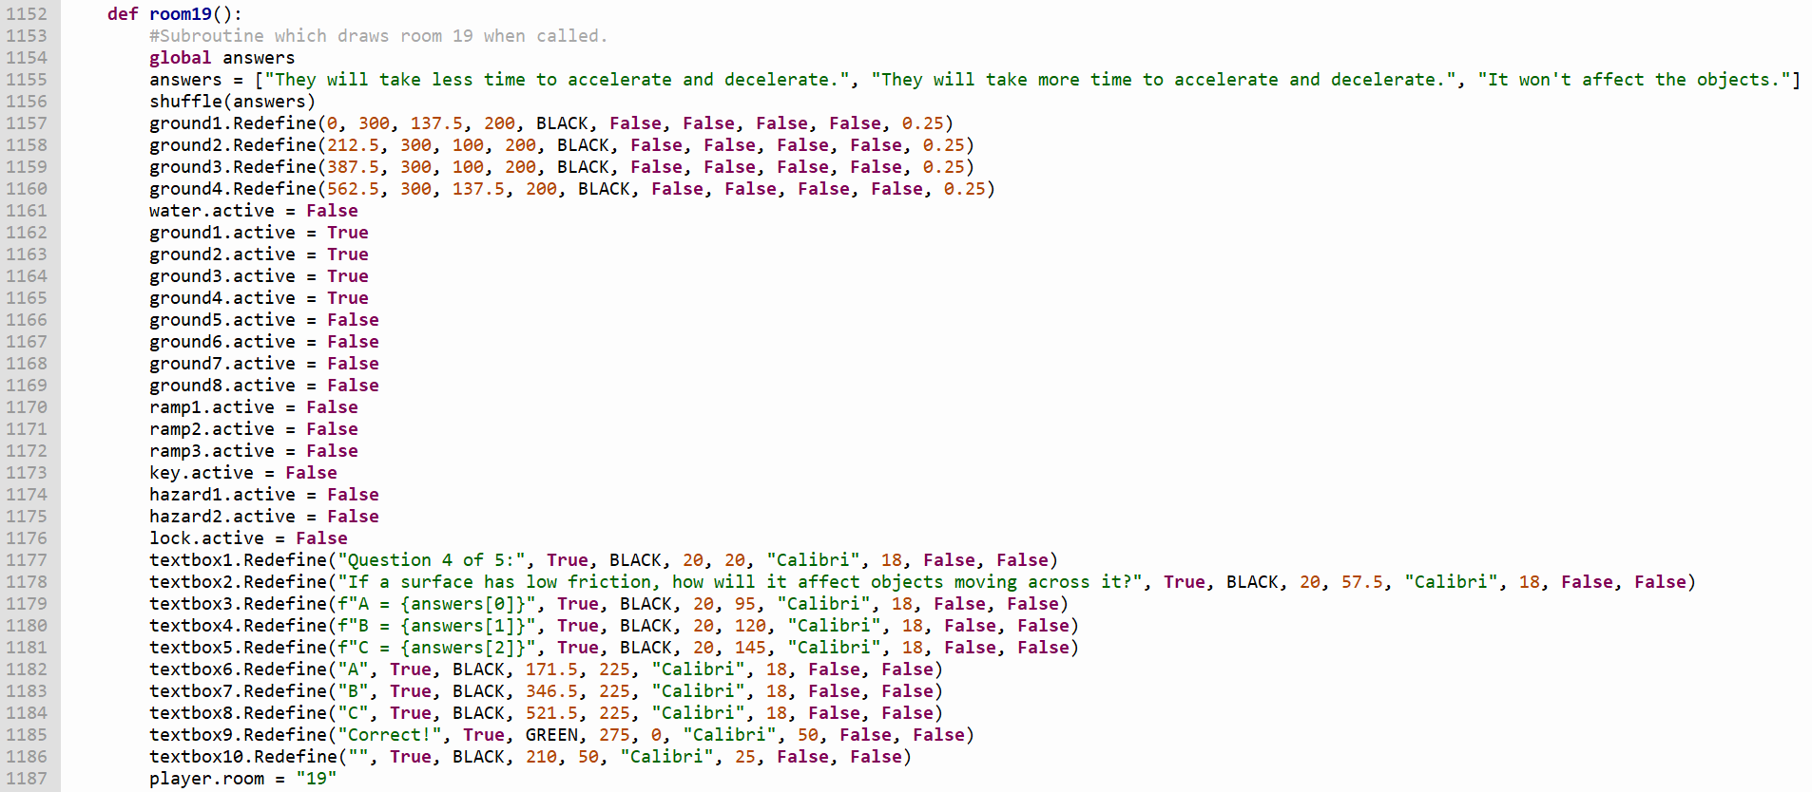

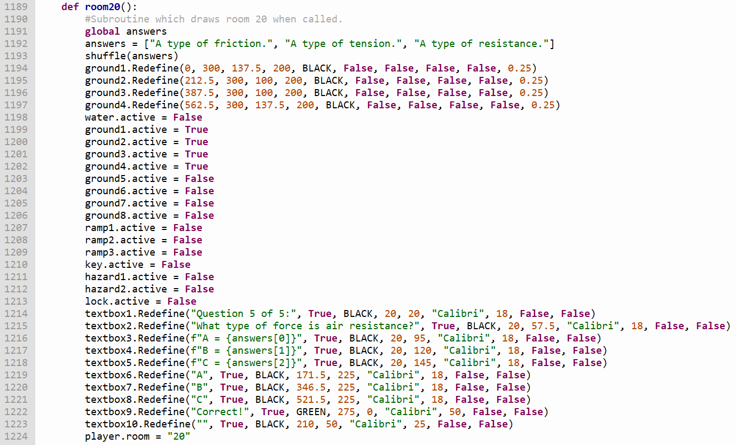

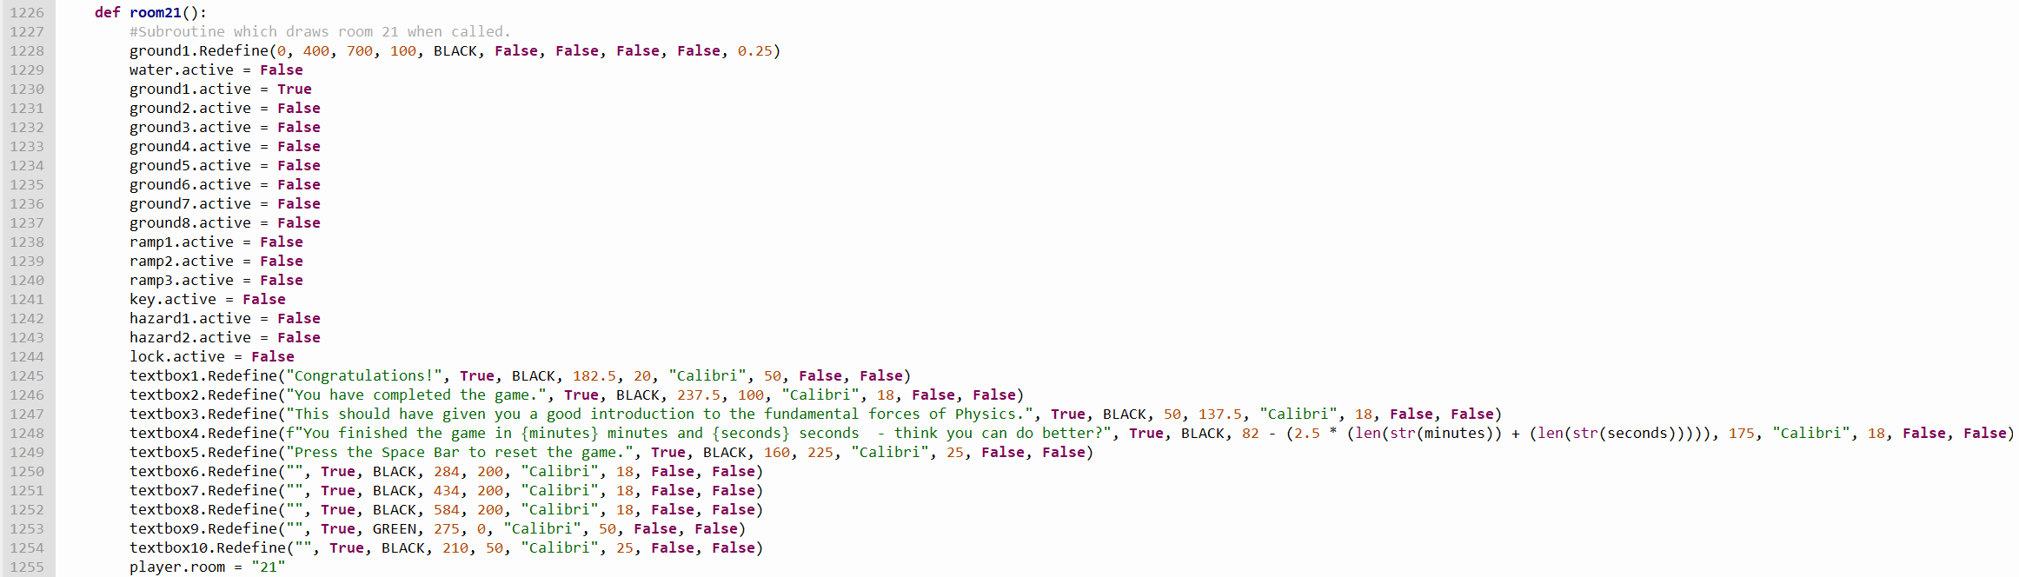

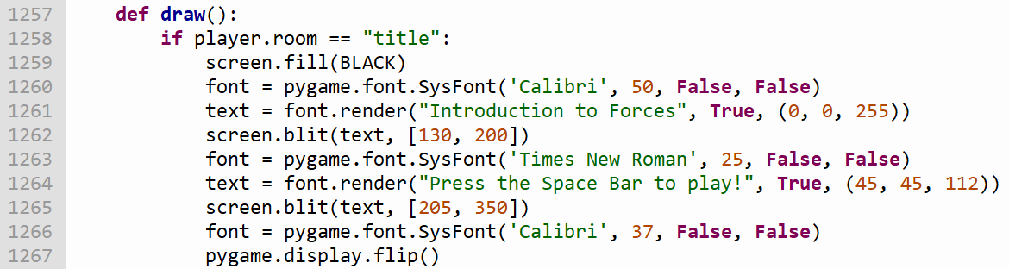The player finishes the game when they reach room 21. Once they enter this room, they will be shown the amount of time they took to complete the game in minutes and seconds.

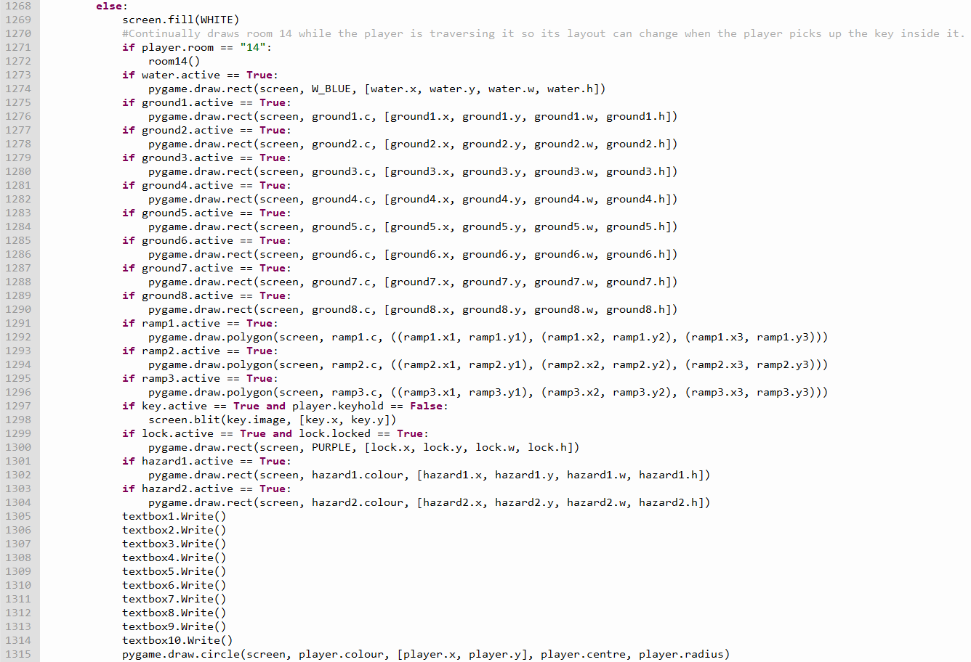

If the player is not on the title screen, this subroutine draws the objects inside the room the player is currently in onto the screen. Otherwise, the subroutine will draw the title screen itself.

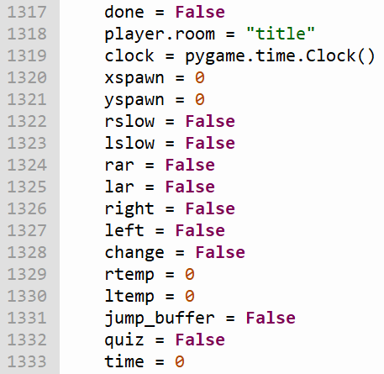

The variables above are used for the following functions:

* *done* - keeps the game’s loop running while it’s set to False. Once it’s changed to True, the loop will finish its execution, in turn finishing the *main* function’s execution and causing the game to close.
* *player.room* - the room the player is currently in.
* *clock* - used to set the game’s frame rate.
* *rslow*/*lslow* - activates the slowing algorithm for acceleration to the right/left respectively while set to True.
* *right*/*left* ­- prevents the player from moving to the left/right while holding either of the right/left movement keys respectively.
* *change* - when the player moves from one piece of terrain to one with a less steep incline at a speed higher than the maximum speed they’re allowed to move at on the second piece of terrain, they will slow down until their speed is lower than the maximum allocated to the second piece of terrain, at which point this variable will set their speed in that direction to said maximum.
* *rtemp*/*ltemp* ­- used when the player moves from one ramp to one with an incline that ascends in the opposite direction, cancelling the idle acceleration applied by the previous ramp before allowing the idle acceleration applied by the new ramp to take effect.
* *jump_buffer* - prevents the player from jumping more than once for each press of the Space Bar.
* *quiz* - this variable is set to True when the player starts the quiz, changing the text in the text boxes in the room before.
* 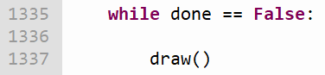*time* - records the time the player takes to complete the game in seconds. This time is converted to minutes and seconds when the player completes the game.

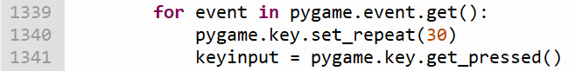

This for loop generates *pygame.KEYDOWN* events (satisfying the conditions of certain selection statements in the program) every 30 milliseconds while any key is held down.

The selection statement above finishes the loop’s execution if the player closes the game’s window or presses the escape key, in turn causing the program to close.

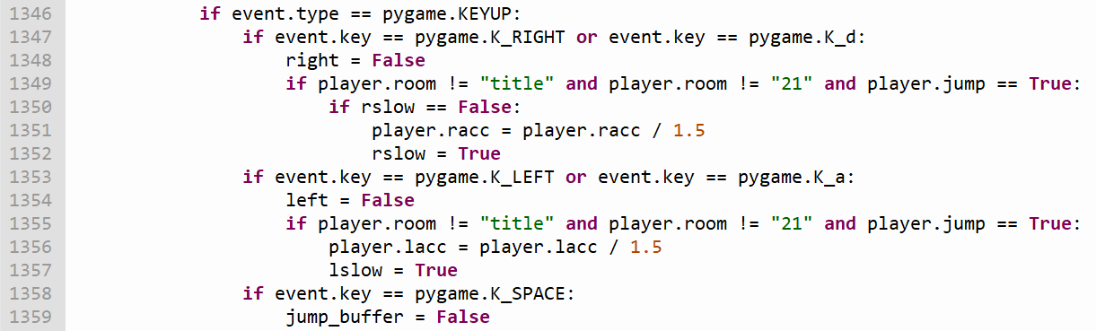

When the player lets go of either the right arrow key or D/the left arrow key or A, their acceleration will be divided by 1.5 and the *rslow*/*lslow* variables respectively will be set to True, activating the slowing algorithm dedicated to the direction the player was moving in (see * later in the section).



If the player holds the Space Bar down while playing the game, they will only jump once. This selection statement gives them the ability to jump again when they let go of the Space Bar.

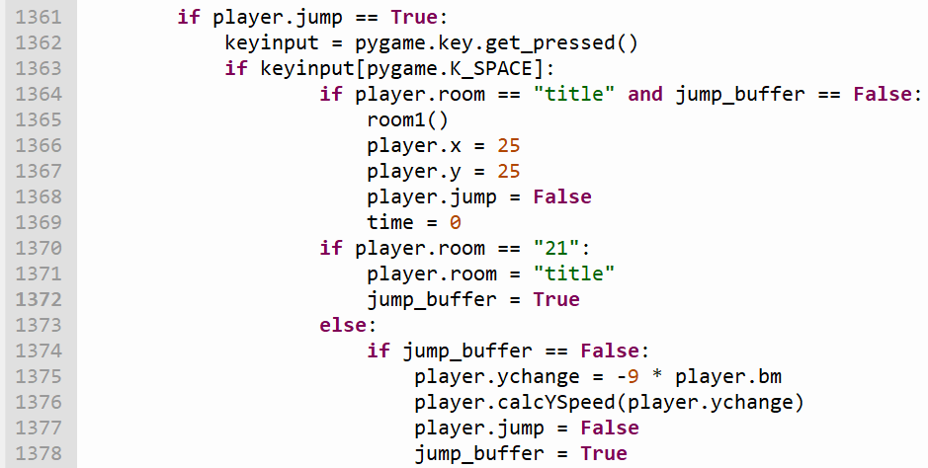

If the player presses the Space Bar while the program is open, one of three things will happen depending on whether the player is playing the game (and if they are, which room they’re in):

* If the player is on the title screen, the program will load the first room of the game’s level and reset the *time* variable so it can accurately record how long the player takes to complete the game.
* If the player is in the last room of the level, they will be sent back to the title screen. *jump_buffer* is set to True when this happens to prevent them from accidentally starting the game again while trying to return to the title screen.
* 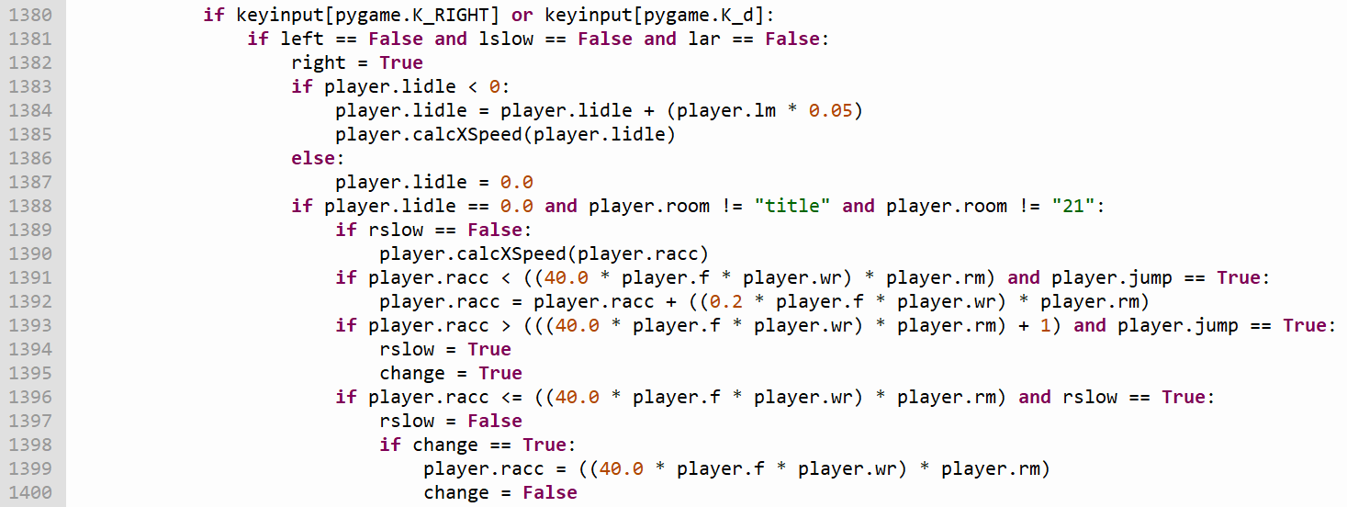If the player is at any other point in the game, the ball will jump (provided the player is on the ground).

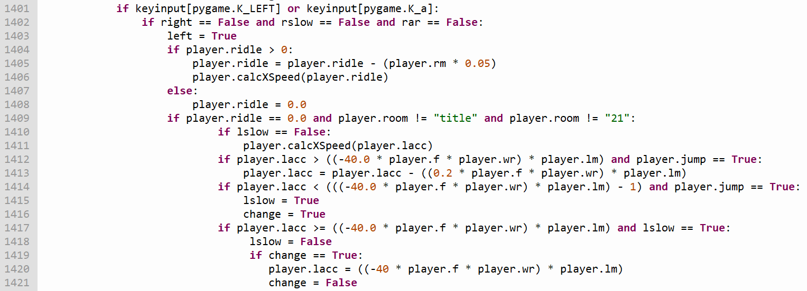

These selection statements allow the player to move left/right whenever the left arrow key or A / right arrow key or D is pressed down. The movement algorithm is executed using the following steps:

* The program checks that the player is not moving in the opposite direction to the direction they are trying to move in.
* Any idle acceleration in the opposite direction (acceleration due to gravity pulling the ball down an incline while the player is not pressing any of the movement keys) is gradually reduced until it’s equal to 0.
* The maximum speed the player can travel at on the ground they’re currently on top of is calculated. This value is determined by the friction applied by the ground, the resistance applied by the substance they're travelling through, and the incline of the ground in the chosen direction. If the player is travelling to the right, both their current and maximum speeds will be positive (and negative if the player’s travelling to the left).
* While the movement key is held, the value of the player’s acceleration will gradually increase/decrease (depending on whether they’re travelling right or left respectively) by a value determined by the same factors as their maximum speed. This value will continue to increase/decrease until either the value becomes equal to the maximum speed or the player lets go of the movement key they’re holding.

If the player’s acceleration is greater/lower (depending on whether they’re travelling right/left respectively) than the maximum speed allocated to the ground they’re on top of (which may happen if the player moves from one piece of ground to one with a less steep incline), they will gradually slow down until their acceleration is below/above said maximum, at which point they will either continue to slow down if the player has let go of the movement key they were holding, or will move at the maximum speed if they continue to hold the movement key down.

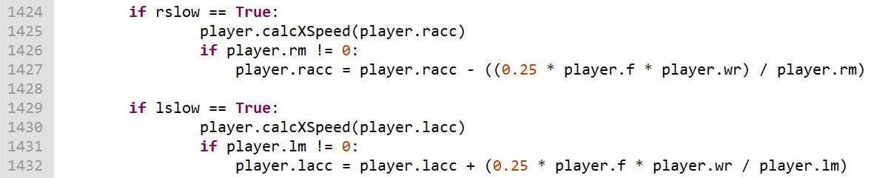

When the *rslow*/*lslow* variables are set to True (which happens when the player lets go of one of the right/left movement keys respectively), the player’s acceleration in the direction they were moving in is gradually reduced/increased until it reaches zero. The value this acceleration is constantly reduced/increased by is determined by the same factors which affect the player’s voluntary acceleration. This algorithm can be deactivated at any time by pressing the movement key respective to the slowing algorithm’s dedicated direction.

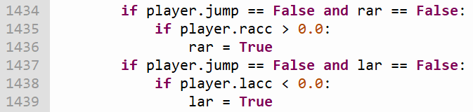

If the player is airborne and moving along the x-axis, the *rar*/*lar* variables will be set to True depending on whether the player is moving right/left respectively. This activates the algorithm for air resistance (see screenshot below).

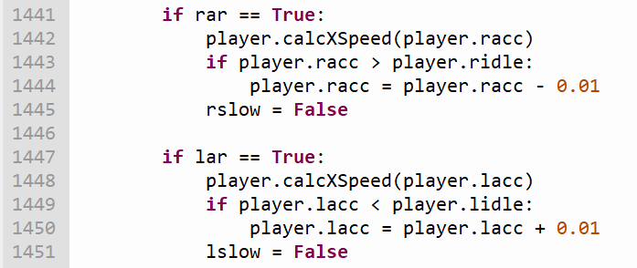

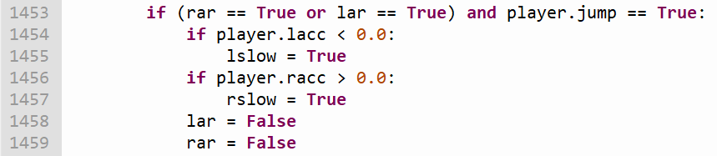If the *rar*/*lar* variables are set to True, the player will gradually slow down in the direction they’re moving, representing the effects of air resistance. To make sure that air resistance is the only thing impacting the ball’s movement while it’s airborne, the *rslow*/*lslow* variables are set to False when the player is airborne regardless of whether the player is holding a movement key or not.

These selection statements deactivate their respective air resistance algorithm and activate their respective slowing algorithm when the player lands from a jump. As mentioned previously, the player can cancel the slowing algorithms by pressing the movement key which moves the player in the slowing algorithm’s dedicated direction (or by holding said key throughout the duration of their jump).

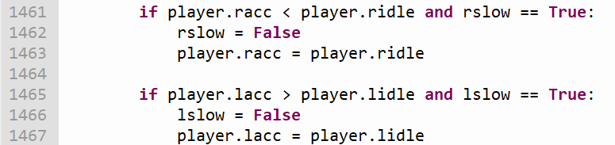

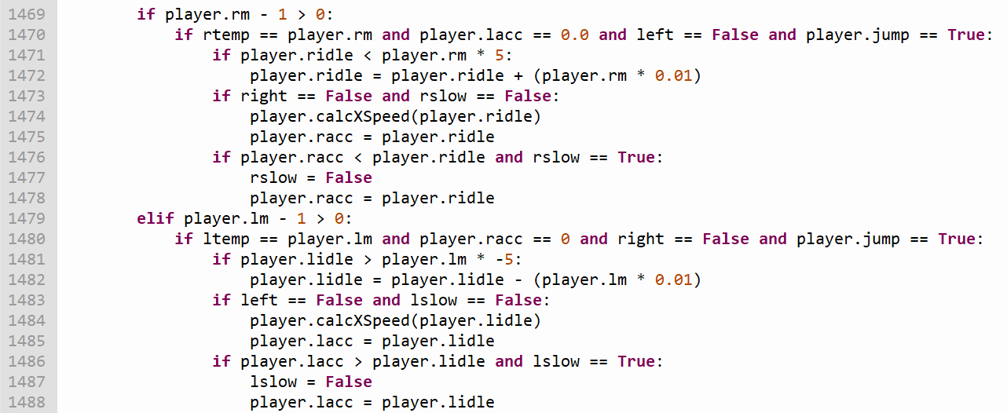If the player’s voluntary acceleration is lower than their idle acceleration in a given direction and the slowing algorithm dedicated to the direction they’re moving in is active, the player’s voluntary acceleration will be made equal to their idle acceleration and the slowing algorithm will be deactivated. These selection statements ensure that the player’s acceleration will not be set to zero if they’re on top of an incline and not pressing any of the movement keys.

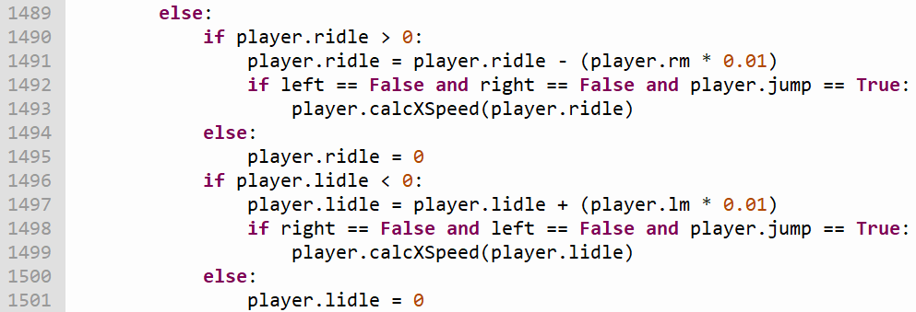

If the player is on top of an incline and isn’t pressing any of the movement keys, these selection statements will make them gradually accelerate down said incline. The rate they accelerate at and the maximum value this acceleration can reach is determined by the steepness of the ramp’s incline. If the player slows down while on top of an incline, their speed will only be reduced to the value of the idle acceleration.

When the player moves from an incline to a flat piece of terrain, these selection statements will make their idle acceleration slowly go back to zero.

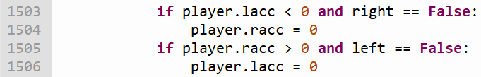

If the player is moving to the left/right, their acceleration to the right/left will be set to 0. This makes sure the player is only moving in one direction at a time.

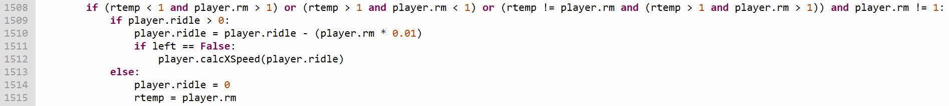

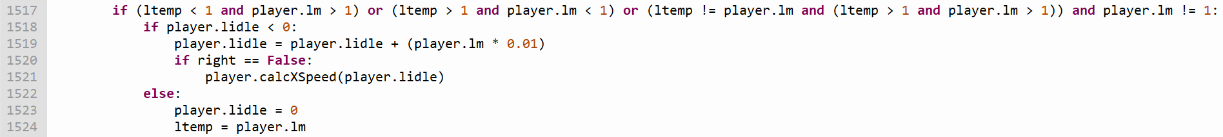

If the player moves from one ramp to one with an incline that ascends in the opposite direction to the incline of the ramp they were previously on top of, the player's idle acceleration is gradually reduced/increased (depending on whether the incline of the second ramp ascends to the right/left respectively) until it reaches zero before the new ramp's idle acceleration is applied.

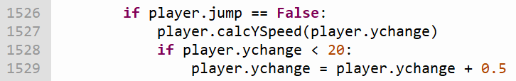

The code above increases the player’s acceleration towards the ground while they’re airborne. This value stops increasing either when it reaches the set limit (which represents the ball’s terminal velocity) or when the ball hits the ground again.

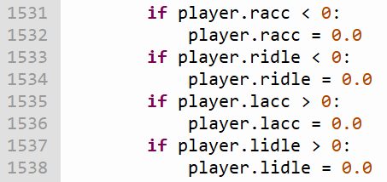

If the slowing algorithms cause the player's acceleration in a certain direction to go beyond their minimum (zero), these lines of code will reset their values to zero.

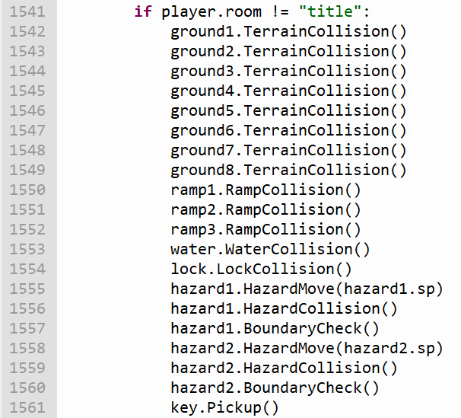.



If the player is not close to any block of terrain or ramp, they will fall until they are. When the player is close to a terrain object or a ramp object, its *ground* attribute will change from False to True.

The following sections of code set the boundaries of the game's window for each room. If the player goes past the listed coordinates, they will either be transported to another room or their acceleration in the direction they were moving in will be set to 0.

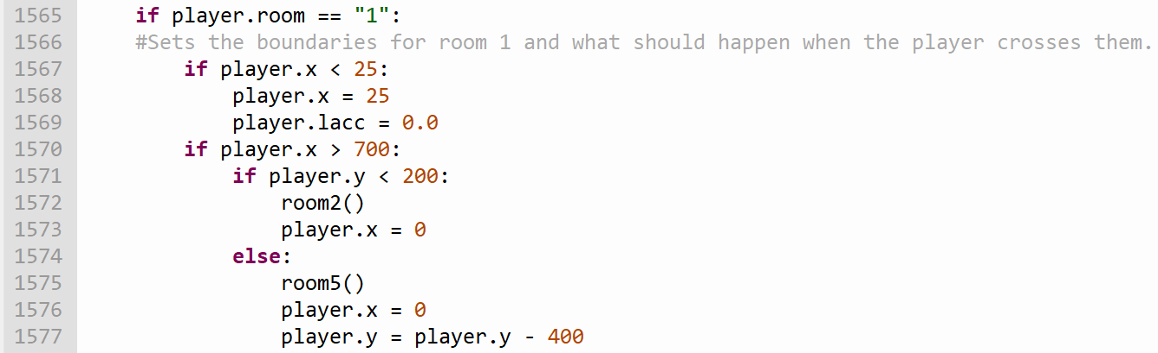Additionally, when the player moves between rooms their coordinates will be changed so they start the next room on the opposite side of the screen to the one they went through to leave the previous room.

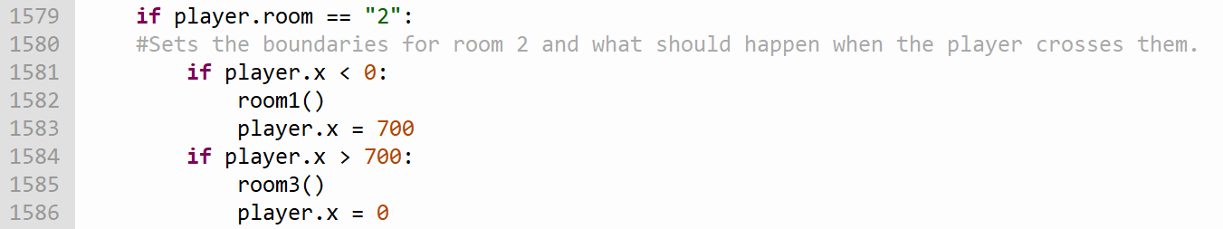

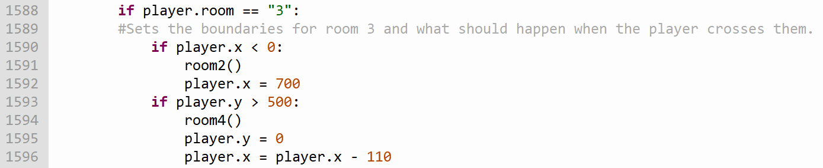

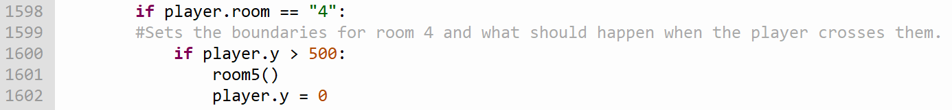

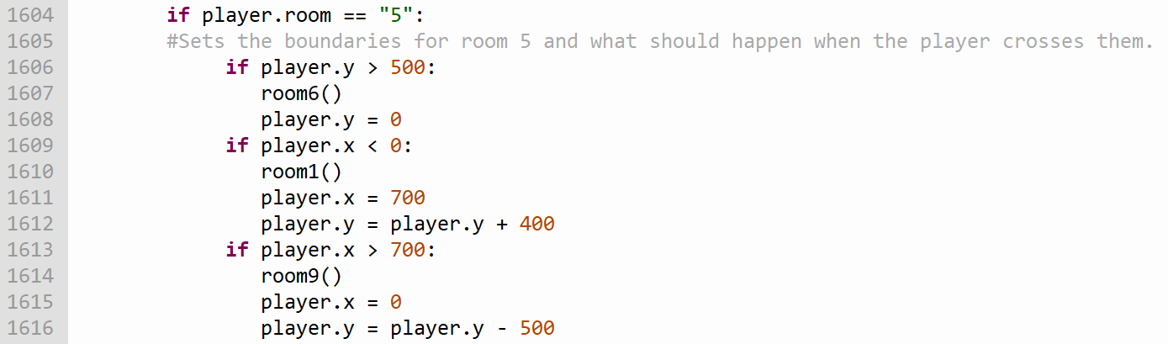

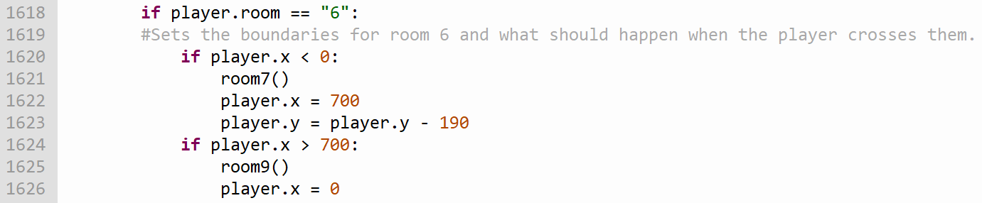

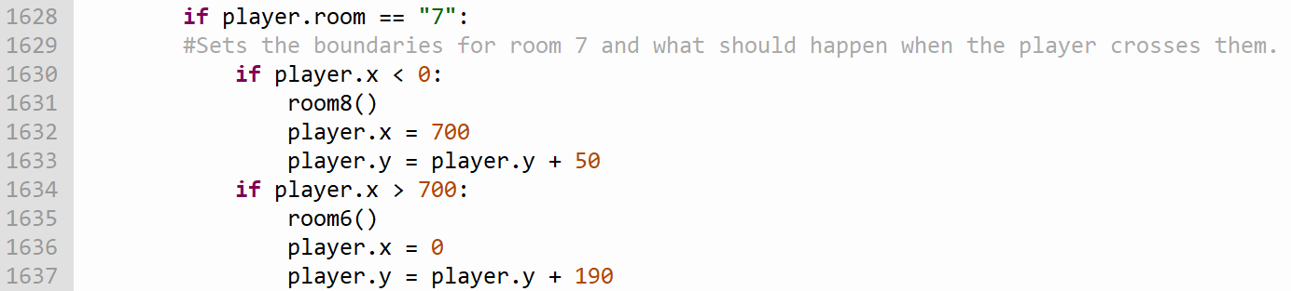

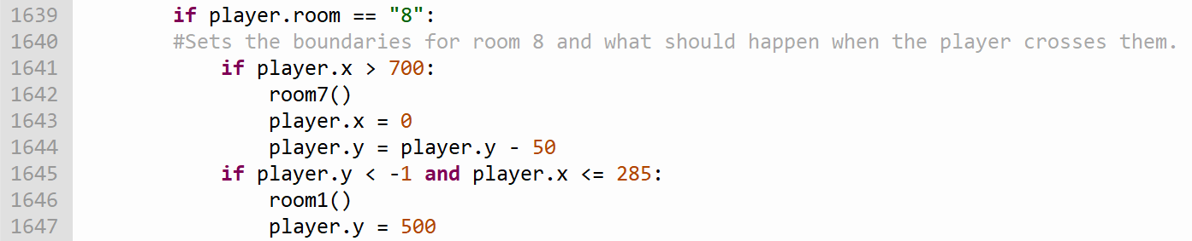

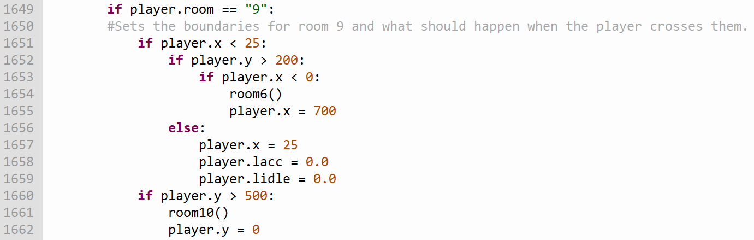

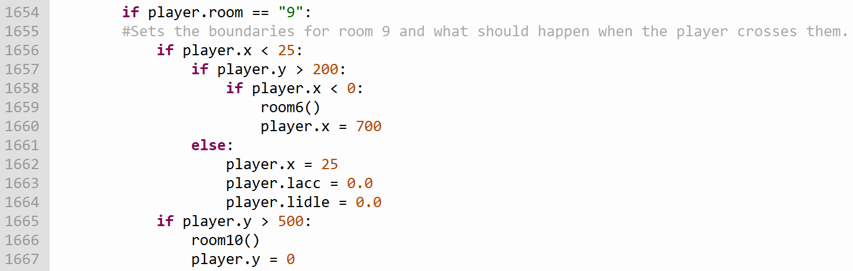

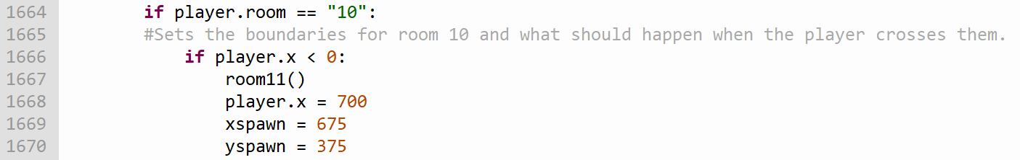

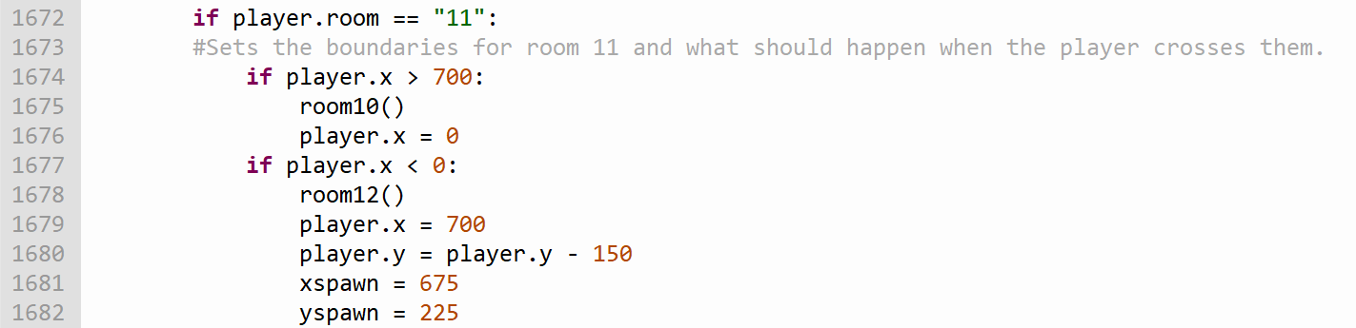

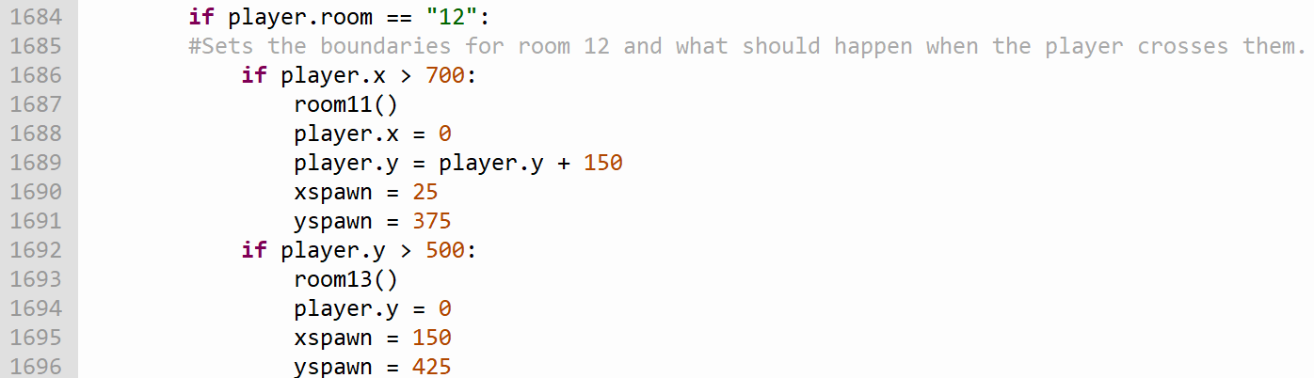

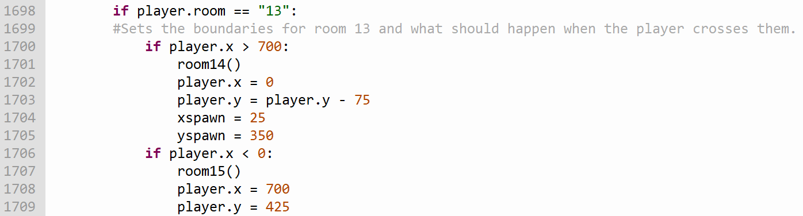

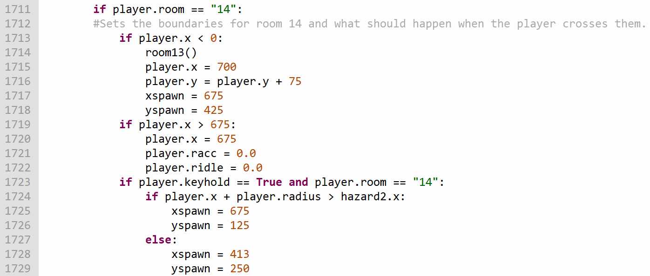

The selection statement in the screenshot above involving the *keyhold* attribute changes where the player will move to after getting hit by a hazard depending on where they are in the room, splitting the room's challenge into parts.

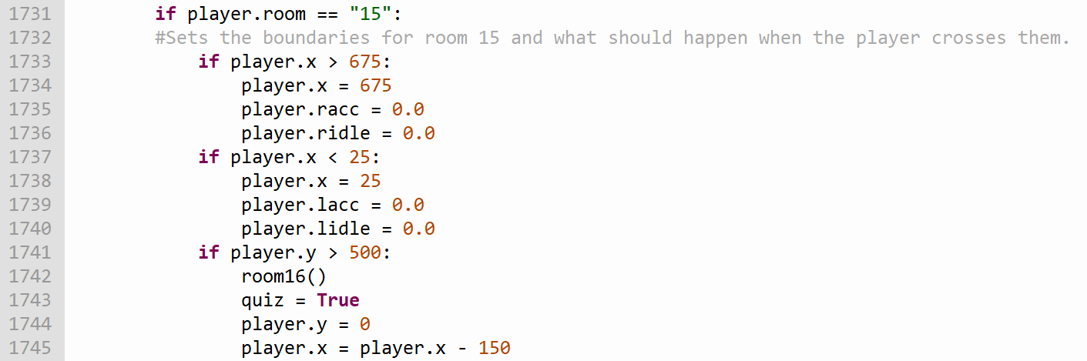

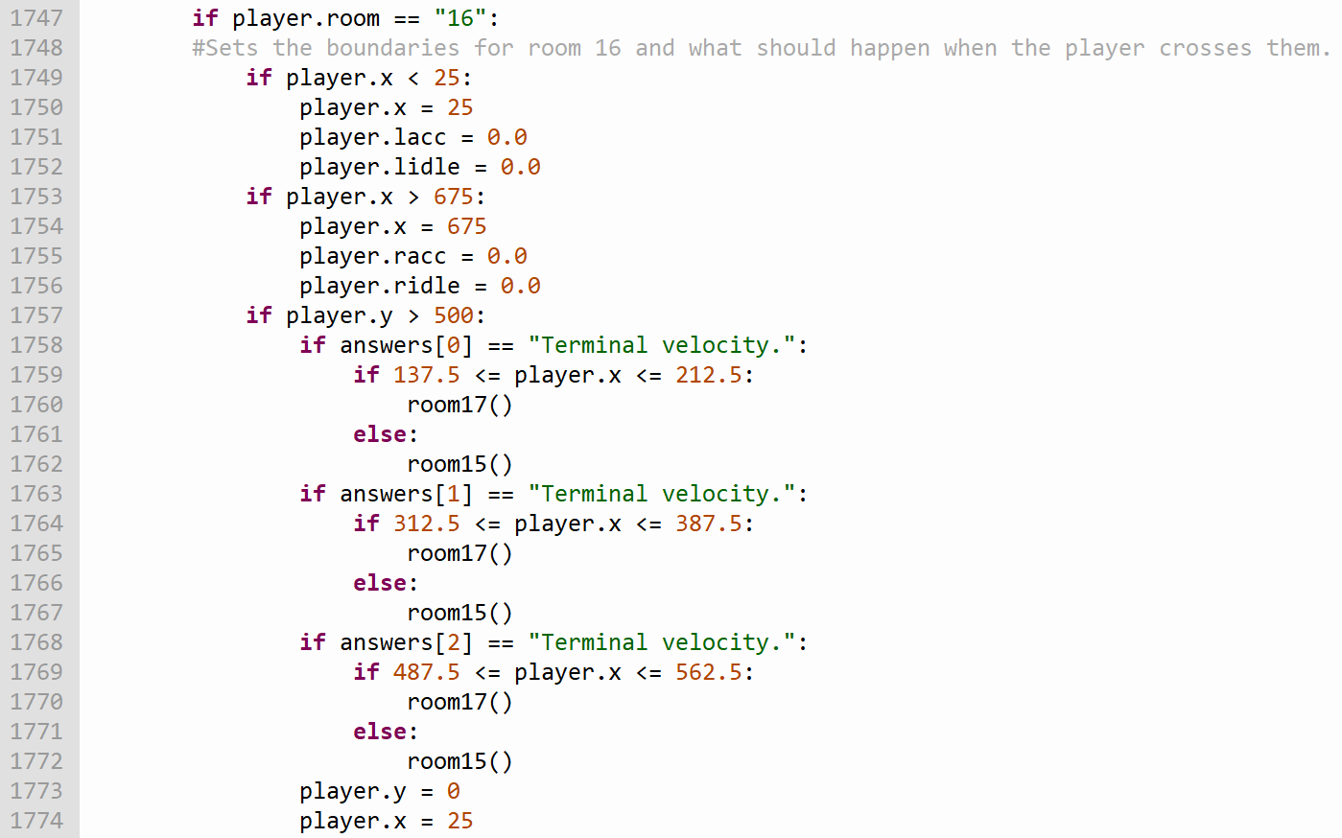Rooms 16 – 20 collectively form a quiz in which the player proceeds to the next room by answering the question in the room correctly, and has to restart the quiz from room 15 if they get a question wrong. Each room contains three holes which each correspond to one answer out of a selection of three, and the room the player is sent to when they enter one of these holes depends on whether its associated answer was the correct answer to the respective question or not.

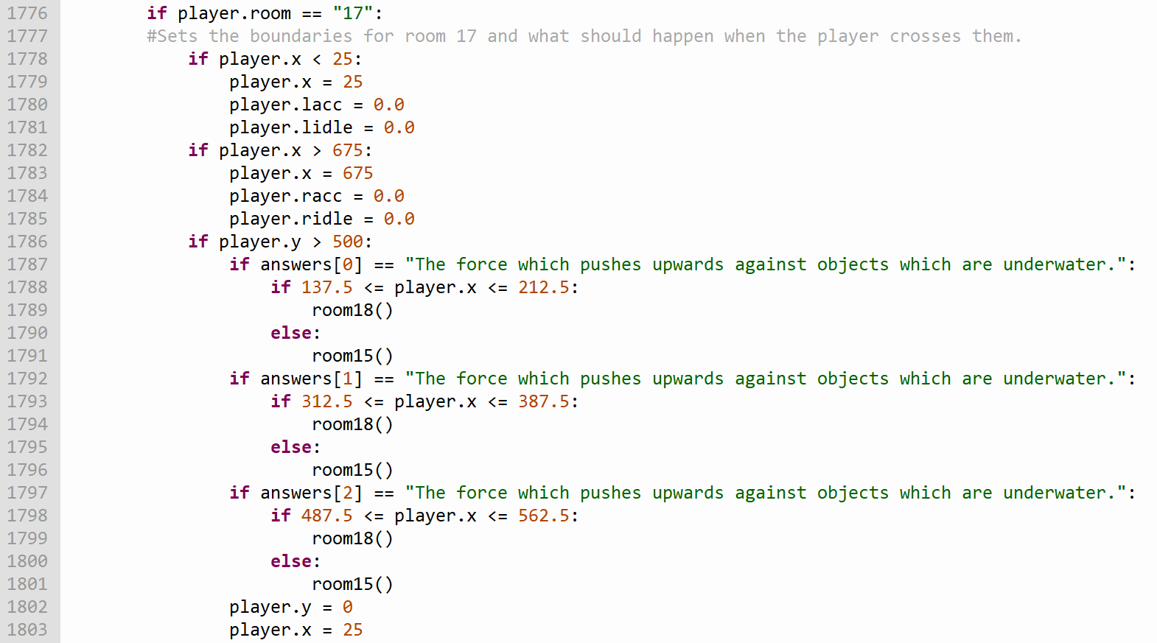

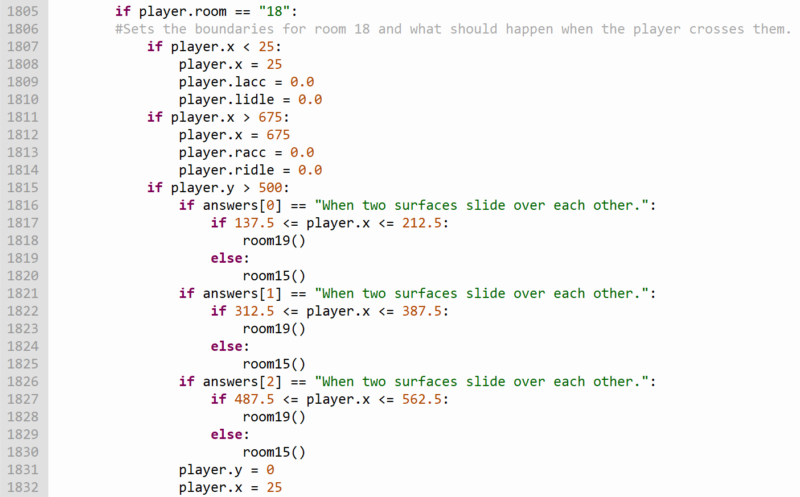

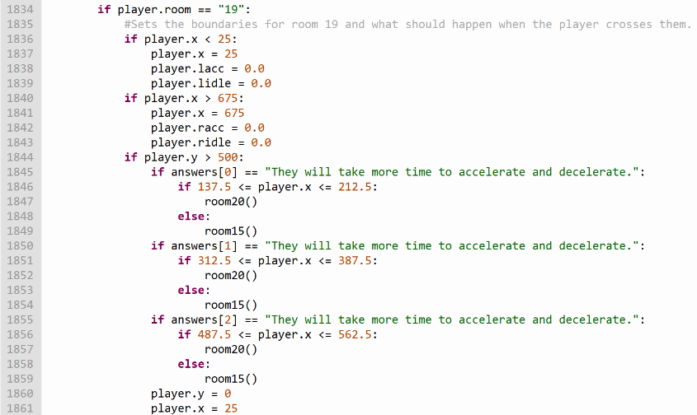

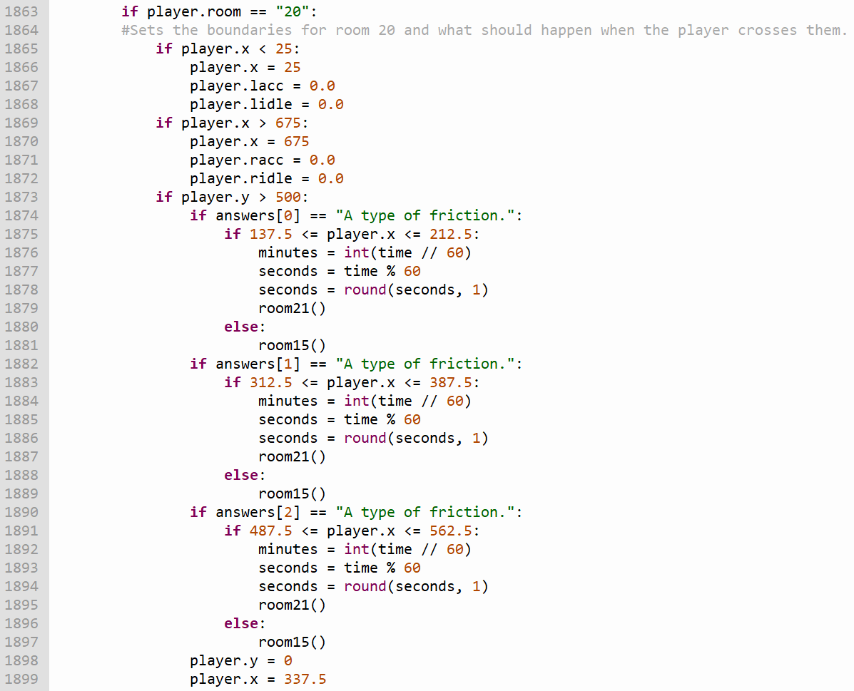

When the player guesses the answer to the question in room 20 correctly, the value of the game’s timer will stop increasing and it will be converted from seconds to minutes and seconds.

Room 21 is special, as when the player reaches it they’ve completed the game, and will be congratulated and shown how long they took to complete it. The player loses control of the ball at this point, and as the player therefore won’t be able to move, the room does not have any selection statements determining what should happen if the player leaves the screen through any of its borders. If the player presses the Space Bar while in this room, they will be sent back to the game’s title screen.



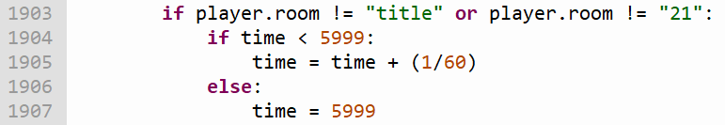This statement sets the game’s frame rate to 60 frames per second, meaning that the screen will update its display 60 times a second.

This selection statement increases the *time* variable’s value by 1/60 every frame (and as the frame rate is 60 frames per second, its value will therefore increase by 1 every second) while its value is lower than 5999 (which converts to 99 minutes and 59 seconds). Once the value becomes greater than 5999, the timer’s value is set to equal 5999 until the player completes the game and starts playing it again.

Although it’s unlikely that someone would take 99 minutes and 59 seconds (or more) to finish the game, this limit for the timer’s value is in place to ensure that the text which displays the time the player took to finish the game in room 21 will always fit on the screen.

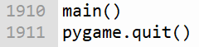

Once the *main* function has finished executing (which happens when the *done* variable is set to True), the *pygame.quit()* function causes the program to close.

## OOP Built Class Diagrams

The *Player* class is the main class of the game, representing the ball the player controls and containing attributes storing values which represent things such as the ball’s speed in both horizontal directions and whether the player has the ability to make the ball jump. All of the other classes (aside from the *Textbox* class) interact with the player class in some way.

calcYSpeed



calcXSpeed



Player Class

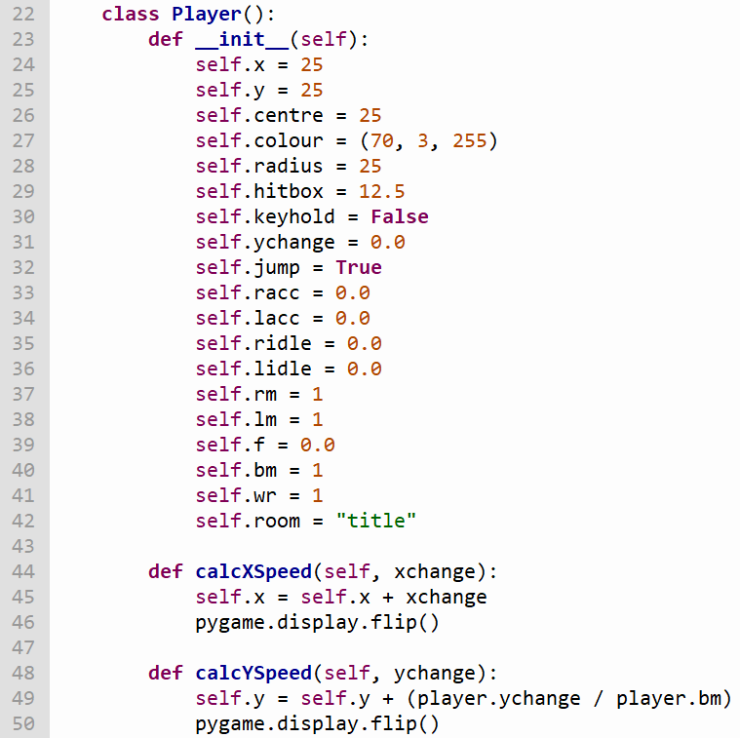

The *Terrain* class represents rectangular ground which the player interacts with. When the image of the ball the player controls overlaps with a terrain object, the *TerrainCollision* method will place the ball next to the side of the terrain object they collided with and will set their acceleration in the direction they were moving to zero. Additionally, the *Redefine* method allows the attributes of each *Terrain* object to be changed when the player moves between rooms so they can reflect the structure of the room the player is currently traversing.

Redefine



TerrainCollision



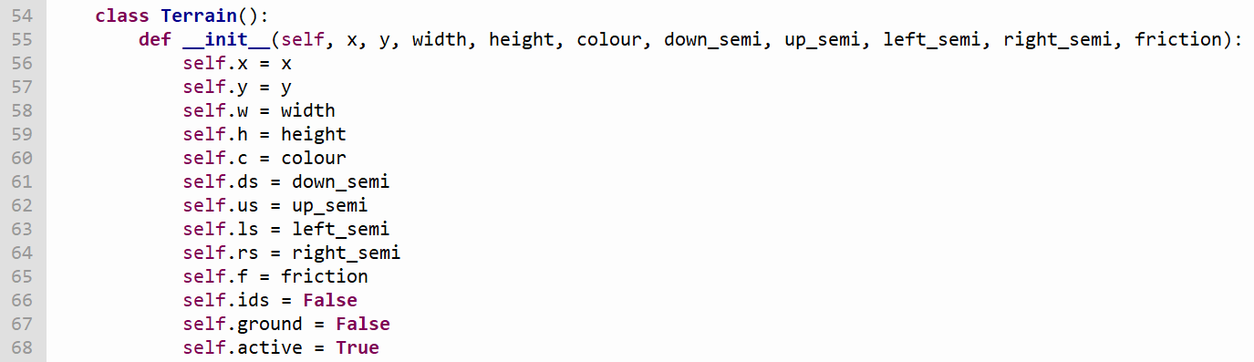

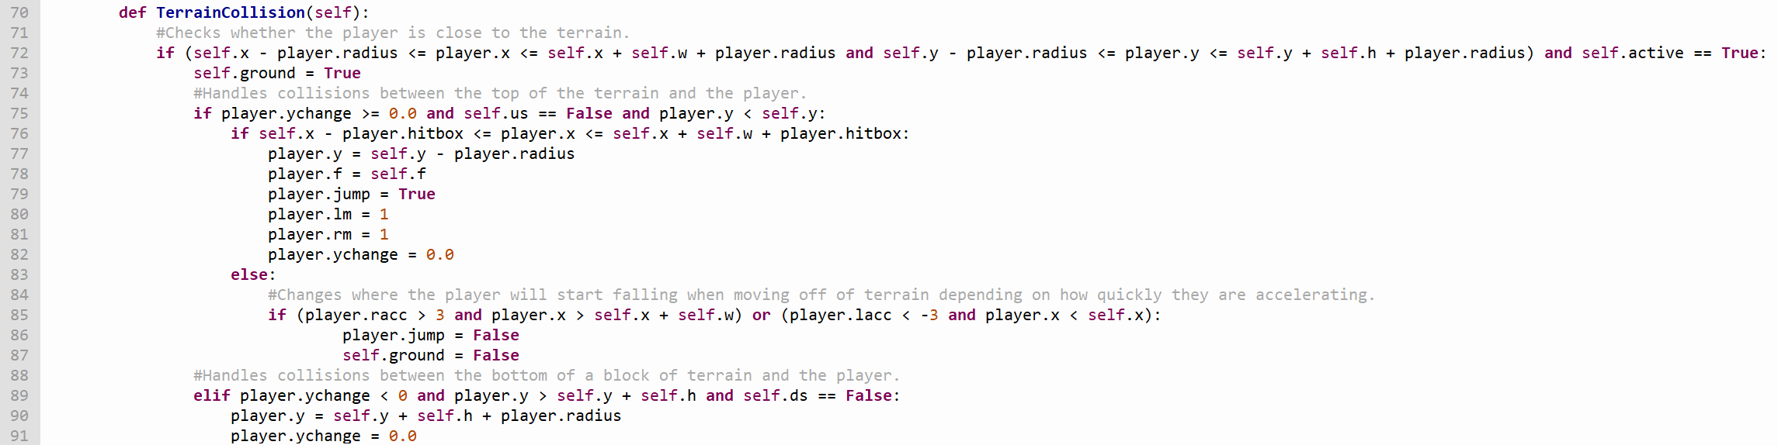

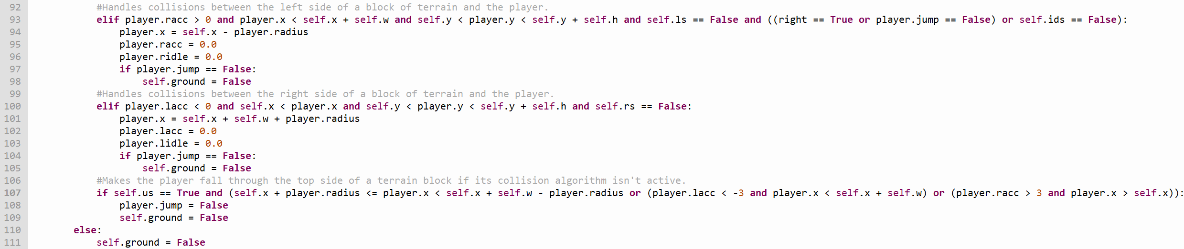

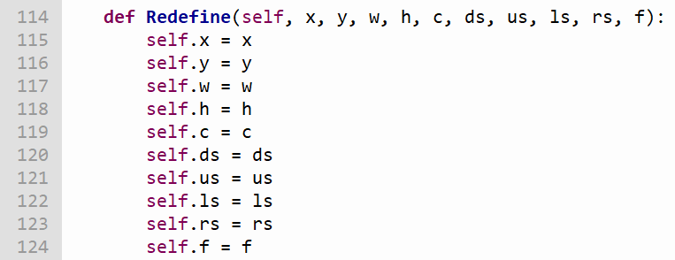

The *Ramp* class represents ground drawn as a right-angle triangle which the player can interact with. Like the *Terrain* class, *Ramp* objects have a collision method which will detect when the player is colliding with them, however when the player is on top of the hypotenuse of the triangle, the player will move more slowly when moving up its incline, more quickly when moving down its incline, and will slowly be pulled down the incline when not moving at all. Additionally, the *Redefine* method allows the attributes of each *Ramp* object to be changed when the player moves between rooms so they can reflect the structure of the room the player is currently traversing.

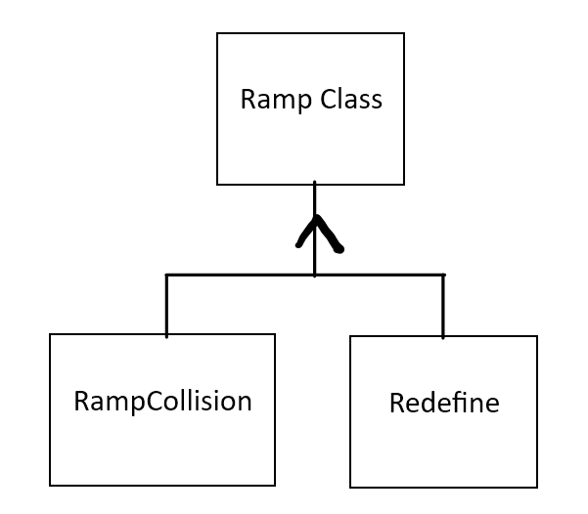

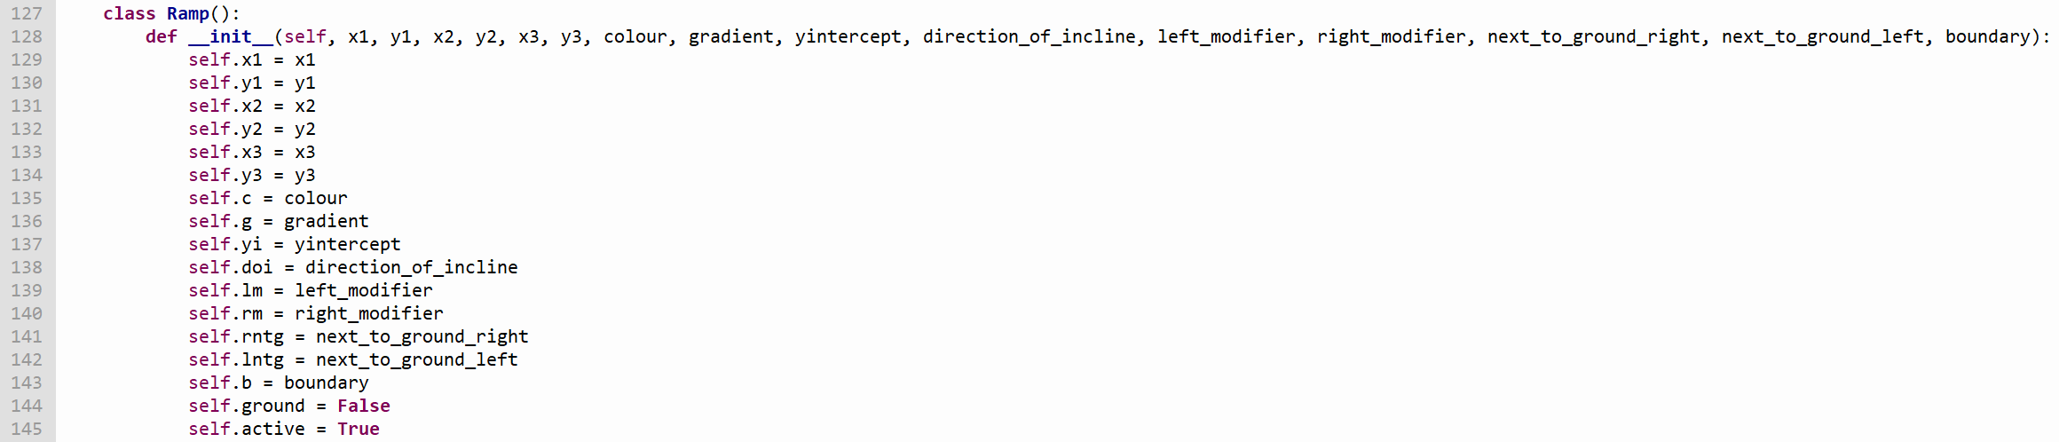

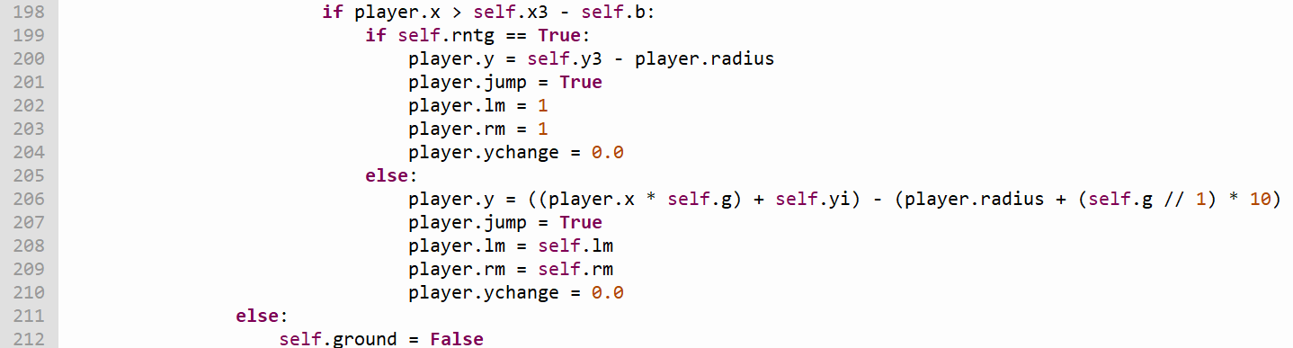

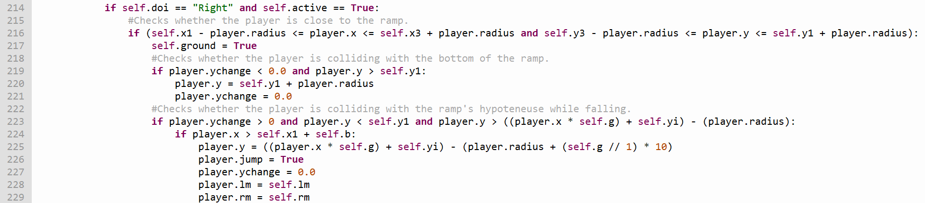

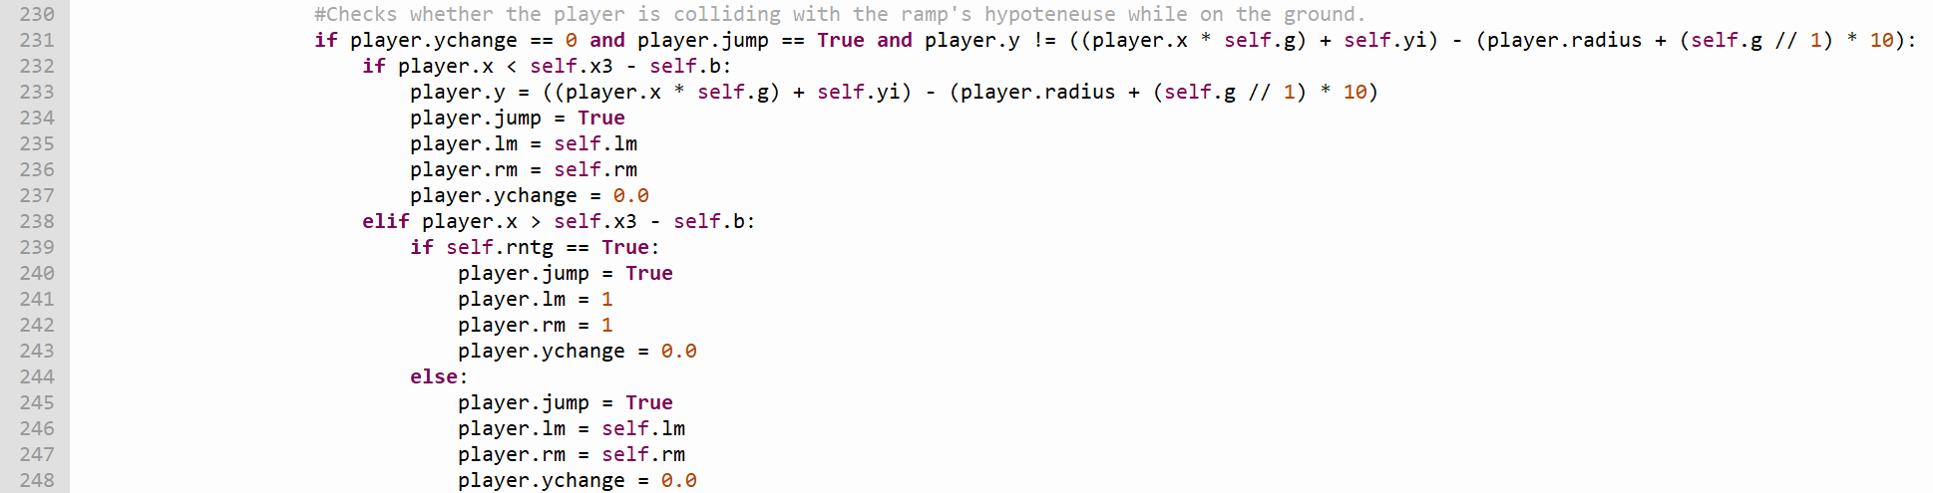

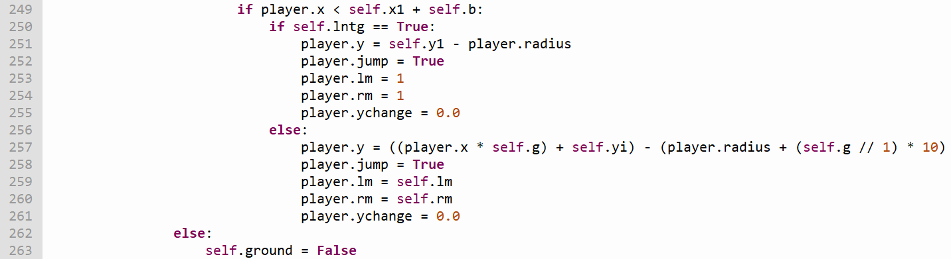

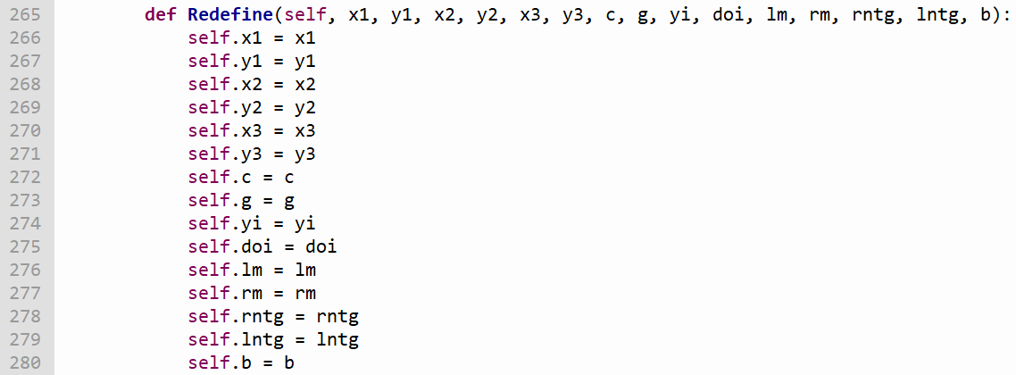

The *Hazard* class represents rectangular objects which will move the player to a specific point (e.g. the closest on-screen point to the point they entered the room from) when the player collides with them. This is done through the *HazardCollision* method. This method determines whether the player and a *Hazard* object are colliding using the player’s *hitbox* attribute instead of their *radius* attribute, an attribute which has a value that is half that of the *radius* attribute’s value. The *HazardMove* method allows a *Hazard* object to move within a range of co-ordinates, and the *BoundaryCheck* method forces the hazard to change directions when it reaches either of the limits of its range. Additionally, the *Redefine* method allows the attributes of each *Hazard* object to be changed when the player moves between rooms so they can reflect the structure of the room the player is currently traversing.

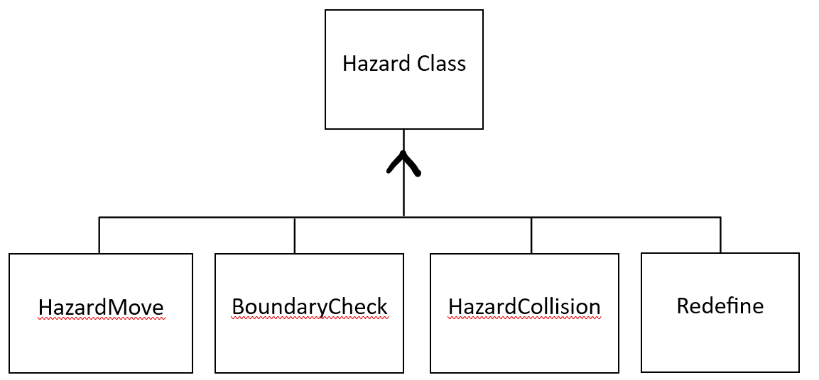

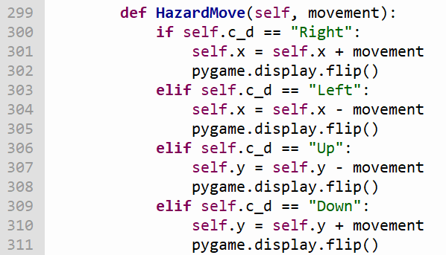

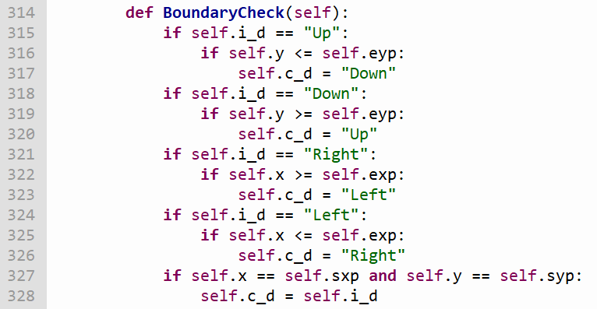



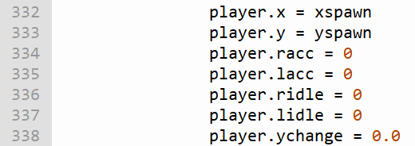

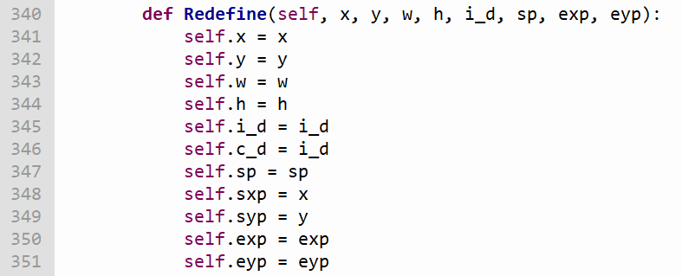

The *Lock* class represents locked barriers which block certain paths off from the player. If the player collides into a *Lock* object while the *Player* object’s *keyhold* attribute is set to True, it will be removed from the screen and the player will be allowed to pass through the area it was taking up. If the player collides into one while this attribute is set to False however, the *Lock* object will instead interact with the player in the same way that *Terrain* objects do. The *LockCollision* method determines what should happen when the player collides with a *Lock* object by checking the *Player* object’s *keyhold* attribute, setting it to False if it’s set to True when the player collides with the *Lock* object before removing the object from the screen). Additionally, the *Redefine* method allows the attributes of each *Lock* object to be changed when the player moves between rooms so they can reflect the structure of the room the player is currently traversing.

Lock Class



LockCollision

Redefine

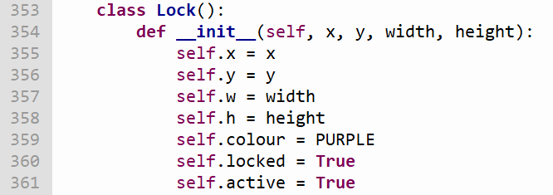



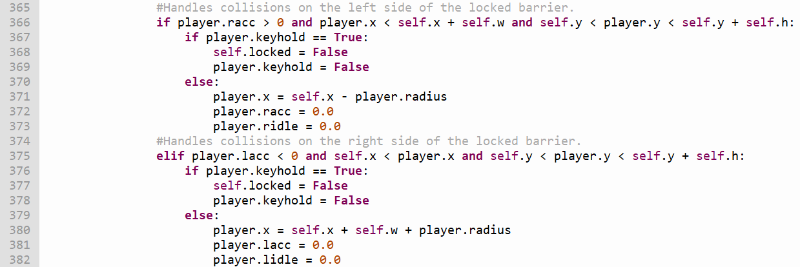

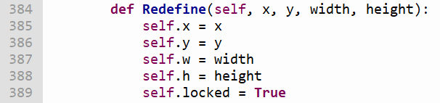

The *Key* class represents keys which the player can pick up and use to unlock *Lock* objects. When the player collides with a *Key* object, the *Player* object’s *keyhold* attribute is set to True. This attribute is checked whenever the player collides with a *Lock* object. Like with *Hazard* objects, collisions between the player and *Key* objects are detected using the player’s *hitbox* attribute instead of their *radius* attribute. If the player uses a key to remove a *Lock* object from the screen, the *Player* object’s *keyhold* attribute will be set to False again to force them to find another *Key* object in order to unlock other *Lock* objects. Additionally, the *Redefine* method allows the attributes of each *Lock* object to be changed when the player moves between rooms so they can reflect the structure of the room the player is currently traversing.

Key Class



Pickup

Redefine



# 

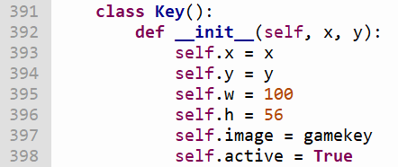



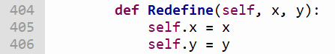

The *Water* class represents rectangular bodies of water which the player can pass through. When the player first collides with a body of water, the *WaterCollision* method will make the *Player* object’s *ychange* attribute gradually decrease for a short while, and afterwards the method will change the *Player* object’s *wr* (water resistance) and *bm* (buoyancy modifier) attributes so the player takes longer to accelerate in both horizontal directions, jumps higher, and falls back to the ground more slowly. When the player leaves the body of water, this method will divide the *Player* object’s *ychange* attribute by 2.5 so the player doesn’t gain a sudden increase in speed when they exit it. Additionally, the *Redefine* method allows the attributes of each *Water* object to be changed when the player moves between rooms so they can reflect the structure of the room the player is currently traversing.

Water Class



WaterCollision

Redefine



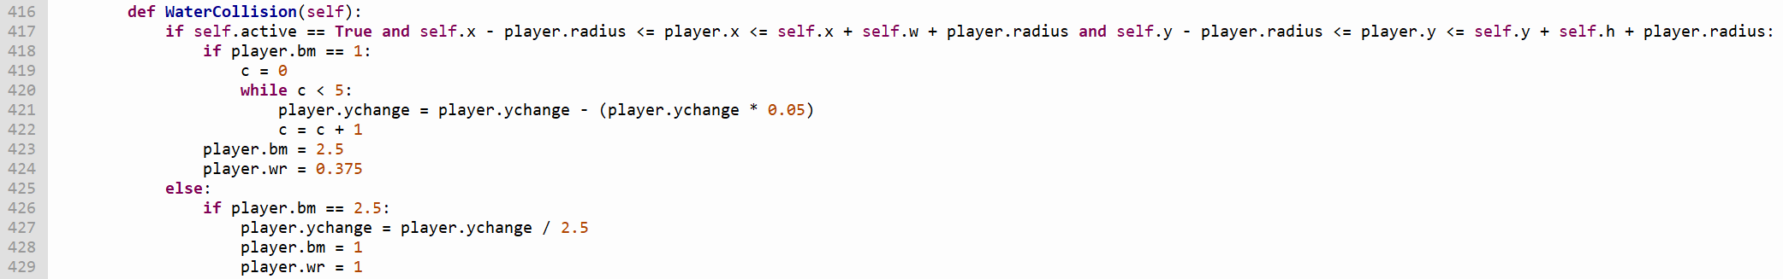

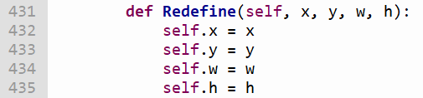

The *Textbox* class represents boxes of text which explain how elements of the game work to the player, along with which forces they represent and what they do. *Textbox* objects are the only objects in the game which don’t interact with the *Player* object, and are displayed onto the screen using the *Write* method. Additionally, the *Redefine* method allows the attributes of each *Textbox* object to be changed when the player moves between rooms so they can reflect the structure of the room the player is currently traversing.

Textbox Class



Redefine



Write



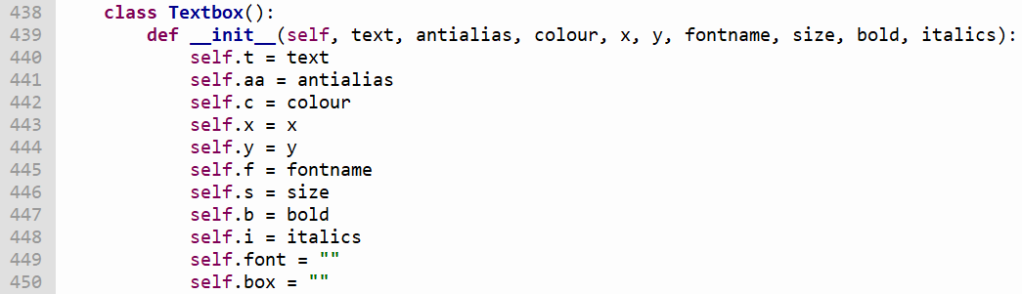

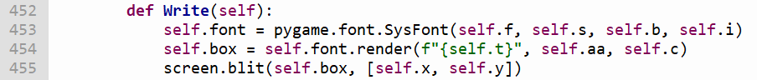

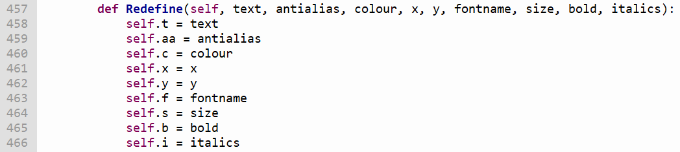

# Testing

## Main Test

To show that I have met the important goals in my analysis, I have created the following video showcasing the game and how I satisfied each of my goals in the table below. Each objective in the table has a timestamp referring to where its solution is demonstrated in the video.

<https://youtu.be/3ZTYO4K0t6Q?si=Fky8z6BGEZFVZakd>

|  |  |
| --- | --- |
| Summary of Analysis Task(s) | Timestamp |
| Split the level up into various rooms, with each room being connected to each other through offscreen points where the currently displayed room will be changed if the player comes into contact with them. The player’s coordinates should also be updated when they touch these points so they start on the opposite side of the screen to the one they just left (e.g. if they leave a room from the right side of the screen, they should start the following room on the left side of the screen). | (Evidence for this goal is shown throughout the video) |
| Create a title screen which will allow the player to start the game. | 0:19 |
| Create a level in which the player descends from its top to its bottom, with wide horizontal sections to create variety such that the vertical platforming doesn’t get repetitive. | 0:44 |
| Create the ball which the player will control, and give it the ability to move left with the left arrow key / A, move right with the right arrow key / D, and jump with the Space Bar. The player should gain speed while they hold one of the movement keys until they reach their top speed, and should gradually slow down until they come to a stop once they let go of said key. Additionally, the ball should be able to jump using the Space Bar, and should accelerate toward the ground whenever it is midair. The ball should only be able to move in one direction at a time, shouldn’t be able to move while airborne, should only be able to jump while it’s on the ground, and shouldn’t be able to jump multiple times by holding the Space Bar. | 1:17 |
| Create terminal velocity by making the player’s vertical speed stop increasing once it hits a certain limit while they’re airborne, and air resistance by making the player’s horizontal speed constantly decrease while the player is airborne. | 2:13 |
| Create different kinds of terrain. Terrain should have collision algorithms preventing the player from passing through it, and each type of terrain should have its own level of friction (with ice having a low one and regular terrain having a normal one by comparison). Lower friction should give the ball a decreased rate of acceleration and deceleration, along with a lower top speed. | 2:45 |
| Create a text box system which is used to explain the game’s mechanics along with the forces showcased in each room. | 3:04 |
| The collision algorithm for each of a terrain piece’s sides should have the ability to be deactivated, allowing the player to pass through them if needed. | Described at 3:17, shown at 4:23 – 4:24 |
| Create ramps which affect the ball’s movement by slowly pulling it towards the ramp’s bottom, along with making it move more quickly down the slope and more slowly up the slope. These features represent the effects of gravity while the ball is on an incline. | 3:41 |
| Create keys which are required to unlock barriers so the player can pass through the area they barricade. These barriers should remove the key from the player when they are unlocked. | 4:30 |
| Implement friction into the game. Lower friction should result in the player having a lower top speed, along with lower rates of acceleration and deceleration. Different types of terrain should have different levels of friction (e.g. ice should have a lower level of friction than regular terrain). | 5:20 |
| Add hazards which if touched, force the player to restart the room they're currently in from the point they entered the room from. There should be hazards with set movement patterns (e.g. up and down, back and forth) as well as stationary ones. | 5:38 |
| Add water as a different substance for the ball to travel through. Water should increase the effect of resistant forces in both x-axis directions, however it should also slow the ball’s descent while midair and allow for the ball to jump higher (representing the effects of buoyancy on the ball). | 5:59 |
| Showcase the effects of travelling through different substances (e.g. water). | 6:18 |

## Secondary Tests

For this section, I’ve decided to run tests with the intent of causing errors in the program to see how they are handled. If the program can’t handle the errors produced efficiently, its code will be updated to amend this. Each test has been recorded and made part of a video, which can be viewed using the link below. The timestamp of each test in the video is noted in the following tables.

<https://youtu.be/Q0hDKMmT5tQ?si=EnEfqPo7-WxPTKrC>

|  |  |
| --- | --- |
| Test No. | 1 |
| Objective(s) Being Tested | Split the game’s level up into various rooms, with each room being connected to each other through off-screen points which, if the player comes into contact with them, will cause the room currently being displayed to change. The player’s coordinates should be updated when they touch these points so they start on the opposite side of the screen to the one they just left (e.g. if they leave a room from the right side of the screen, they should start the following room on the left side of the screen).  Create different kinds of terrain. As a general principle, terrain shouldn’t allow the player to pass through it, and should reset the player’s acceleration in the direction they were moving should they collide with the terrain as a result of said acceleration. |
| Purpose of Test | To test what will happen when the player goes to coordinates they shouldn’t be able to access while playing the game. |
| Description of Test | Using functions specifically made to test the game, I will send the player to coordinates they should not be able to access while playing the game (e.g. the inside of blocks of terrain, outside a screen border they shouldn’t be able to pass through) to see how the game handles this. |
| Test Data | *player.x = 725* (The point at which the player will be past the right screen border and completely off-screen)  *player.x = -25* (The point at which the player will be past the left screen border and completely off-screen)  *player.y = -25* (The point at which the player will be past the top screen border and completely off-screen)  *player.y = 525* (The point at which the player will be past the bottom screen border and completely off-screen)  *player.y = 25* (These coordinates will place the player inside a block of terrain in room 6)  All of these values are erroneous data in the context of this test, as the player’s coordinates will be set to these values in rooms where they should not be able to access these coordinates (e.g. although *player.y* could have a value of 25 in other parts of the game (making it typical data in those parts), in room 6 the player should not be able to reach these coordinates, and therefore in that room it would be erroneous data). |
| Expected Result | If sent inside pieces of terrain, the player should be pushed out of the terrain using one of the collision algorithms. If the player is sent off the screen and outside a border they shouldn’t be able to access, they shouldn’t be able to return to the screen. |
| Actual Result | If the player somehow gets inside a terrain block, they will not be sent back outside it unless the player either moves to the right (which will move them to the left side of the terrain block), moves to the left (which will move them to the right side of the terrain block), or jumps (which will cause them to jump and fall until they either collide with the top of the terrain block or collide with another piece of ground below them).  If the player somehow goes outside the top screen border and is above terrain placed at this border, they will not be able to return to the screen unless there is a gap in the terrain which they can fall through. If the player passes the border and is not above any terrain placed on top of it, they will simply fall back onto the screen.  If the player somehow goes outside any of the other screen borders, they will not be able to return to the screen. Additionally, if they go outside the left screen border the image of the ball will be smeared across the screen. |
| Timestamp in Test Video | 0:00 |

|  |  |
| --- | --- |
| Test No. | 2 |
| Objective(s) Being Tested | Create keys which are required to unlock barriers. |
| Purpose of Test | To test what will happen if the player tries to play the game when the key image isn’t downloaded. |
| Description of Test | I will be running the program on a machine which doesn’t have the key image downloaded to see how the programs handles this. |
| Test Data | None |
| Expected Result | The game will crash when the player opens the program. |
| Actual Result | The game will crash when the player opens the program. |
| Timestamp in Test Video | 2:23 |

|  |  |
| --- | --- |
| Test No. | 3 |
| Objective(s) Being Tested | Create keys which are required to unlock barriers.  Create barriers which can only be passed through if the player is holding a key, removing said key from the player’s inventory when the player comes into contact with them. |
| Purpose of Test | To test whether keys reappear after they have been used to unlock a barrier (and whether barriers relock themselves if this is the case). |
| Description of Test | I will collect the first key and use it to unlock the first barrier in the game, then go back to the location of the first key to see whether it returns there. |
| Test Data | None |
| Expected Result | The key will return to its original location and the barrier will be re-locked. |
| Actual Result | The key will return to its original location and the barrier will be re-locked. |
| Timestamp in Test Video | 2:53 |

|  |  |
| --- | --- |
| Test No. | 4 |
| Objective(s) Being Tested | Create a stopwatch which records how long the player takes to beat the game each time they play it, showing this time to them when they complete it. |
| Purpose of Test | To test whether the timer will stop increasing once it reaches 5999 (which will round down to 59 minutes and 99 seconds). |
| Description of Test | I will set the game’s timer to 5999 and start the game. I will then leave the player in room 1 for a few seconds so the game’s timer has time to increase, printing the timer while the player is in this room so I can see if it increases past its initial value. |
| Test Data | *time = 5999*  As this value lies exactly at the upper limit for the time variable, this data is extreme data. |
| Expected Result | The *time* variable will stay at a value of 5999, and will not increment past this value. |
| Actual Result | The *time* variable will stay at a value of 5999, and will not increment past this value. |
| Timestamp in Test Video | 3:36 |

|  |  |
| --- | --- |
| Test No. | 5 |
| Objective(s) Being Tested | Create ramps which affect the ball’s movement while it is travelling along their slope by slowly pulling it towards the ramp’s bottom. Ramps should also allow the ball to move more quickly down their slope and more slowly up their slope (representing the effects of gravity while the ball is on an incline). |
| Purpose of Test | To test what happens when the player tries to change their acceleration while they are being affected by idle acceleration. |
| Description of Test | I will place the ball on a ramp and let its idle acceleration increase for a few seconds, then try to change it using the movement keys. I will do this test once with the ball still being on the ramp when I press the movement keys, and again with the ball having left the ramp when I press the movement keys. |
| Test Data | None |
| Expected Result | The player will begin accelerating from the speed of their idle acceleration if they try to move in the direction that it’s acting in, and will have to wait for the ball to slow down until it becomes stationary before they can start moving in the opposite direction. |
| Actual Result | Idle acceleration works as described above. |
| Timestamp in Test Video | 4:09 |

|  |  |
| --- | --- |
| Test No. | 6 |
| Objective(s) Being Tested | Create different kinds of terrain. As a general principle, terrain shouldn’t allow the player to pass through it, and should reset the player’s acceleration in the direction they were moving should they collide with the terrain as a result of said acceleration.  Create ramps which affect the ball’s movement while it is travelling along their slope by slowly pulling it towards the ramp’s bottom. Ramps should also allow the ball to move more quickly down their slope and more slowly up their slope (representing the effects of gravity while the ball is on an incline). |
| Purpose of Test | To test what happens when the player collides with the side of a ramp. |
| Description of Test | I will move the player into the corner of a ramp to see how the game handles the collision between the two objects. |
| Test Data | None |
| Expected Result | The player’s acceleration in the direction they were moving in will be cancelled and they will be placed next to the corner of the ramp they collided with, afterwards falling until they come into contact with another piece of terrain. |
| Actual Result | The player will pass straight through the side. |
| Timestamp in Test Video | 4:55 |

|  |  |
| --- | --- |
| Test No. | 7 |
| Objective(s) Being Tested | Create a 2D platforming game in Python which teaches the user about various forces. |
| Purpose of Test | To test what happens when the program is run through methods other than running it through Thonny’s interpreter. |
| Description of Test | I will try running the game through other methods (e.g. Python itself, Visual Studio Code’s interpreter, IDLE’s interpreter) to see whether it functions in the same way that it does when run in Thonny’s interpreter. |
| Test Data | None |
| Expected Result | The program will work in the same way that it does when run in Thonny’s interpreter. |
| Actual Result | The program crashes when run directly in Python for unknown reasons, will run identically to when it is run in Thonny, and will crash when run in Visual Studio Code as the IDE cannot import the pygame library. |
| Timestamp in Test Video | 5:27 |

|  |  |
| --- | --- |
| Test No. | 8 |
| Objective(s) Being Tested | Allow the player to make the ball they control move left with the left arrow key or A and make it move right with the right arrow key or D. |
| Purpose of Test | To test what happens when the player tries to move in two directions at once. |
| Description of Test | I will try pressing two movement keys which move the player in opposite directions at the same time and see how the game handles this. |
| Test Data | *keyinput[pygame.K_RIGHT]*  *keyinput[pygame.K_LEFT]*  Both of these values are typical data, as they are values which will be used in the program whenever the player presses the right/left movement keys respectively. |
| Expected Result | The player will move right, since the code for movement to the right is above the code for movement to the left in the for loop which detects inputs from the keyboard. |
| Actual Result | The player will move right, since the code for movement to the right is above the code for movement to the left in the for loop which detects inputs from the keyboard. |
| Timestamp in Test Video | 6:38 |

|  |  |
| --- | --- |
| Test No. | 9 |
| Objective(s) Being Tested | Create subroutines containing each of the game’s rooms, running the one which corresponds to the room the player should be going to whenever they leave the screen in the room they’re currently in and updating their coordinates accordingly. |
| Purpose of Test | To test what happens when the player enters room 21 while accelerating (since the player is not supposed to have control over the ball at this point, nothing is coded to happen when the player crosses one of the screen’s borders, and therefore if the player can somehow cross one of them this may cause errors). |
| Description of Test | I will use a function to place the player at the point which they start traversing room 21 from and set their acceleration to the right/left to its maximum at the same time to see if the player crosses the right/left screen border respectively. |
| Test Data | For testing the right screen border:  *room21()*  *player.x = 337.5*  *player.y = 0*  *player.racc = 10.0*  For testing the left screen border:  *room21()*  *player.x = 337.5*  *player.y = 0*  *player.lacc = -10.0*  The values of *player.racc* and *player.lacc* are erroneous data in this context, as the player should not be able to accelerate at this speed in either direction when they enter room 21. |
| Expected Result | The player will slow down to a complete stop before they cross any of the screen’s borders. |
| Actual Result | When moving to the right/left, the player will cross the right/left screen border respectively, and cannot return to the screen nor restart the game by pressing the Space Bar (since inputs from the keyboard are only registered if the ball is on the ground or the player is on the title screen). |
| Timestamp in Test Video | 7:05 |

## Improvements From Tests

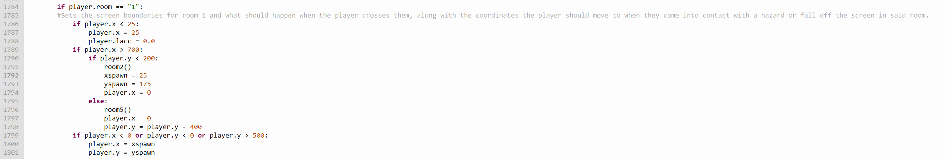As a result of my findings from test 1, I’ve decided to code an error handling method for when the player passes screen borders they shouldn’t be able to access in a given room. When the player enters any room in the game, the *xspawn* and *yspawn* variables will be set to the x and y coordinates the player should be moved to if the player manages to pass one of these screen borders. These coordinates correspond to the closest point on the screen to the point the player entered the room from. Here’s an example of this method being implemented in room 1:

* (In room 1, the player should only be able to move so far left as to keep the entire ball on-screen, and therefore they shouldn’t be able to cross the left screen border.)

The *xspawn* and *yspawn* variables are also used by hazards, and therefore the point the player is moved to when this error handling method is executed will be changed if the player passes a checkpoint.

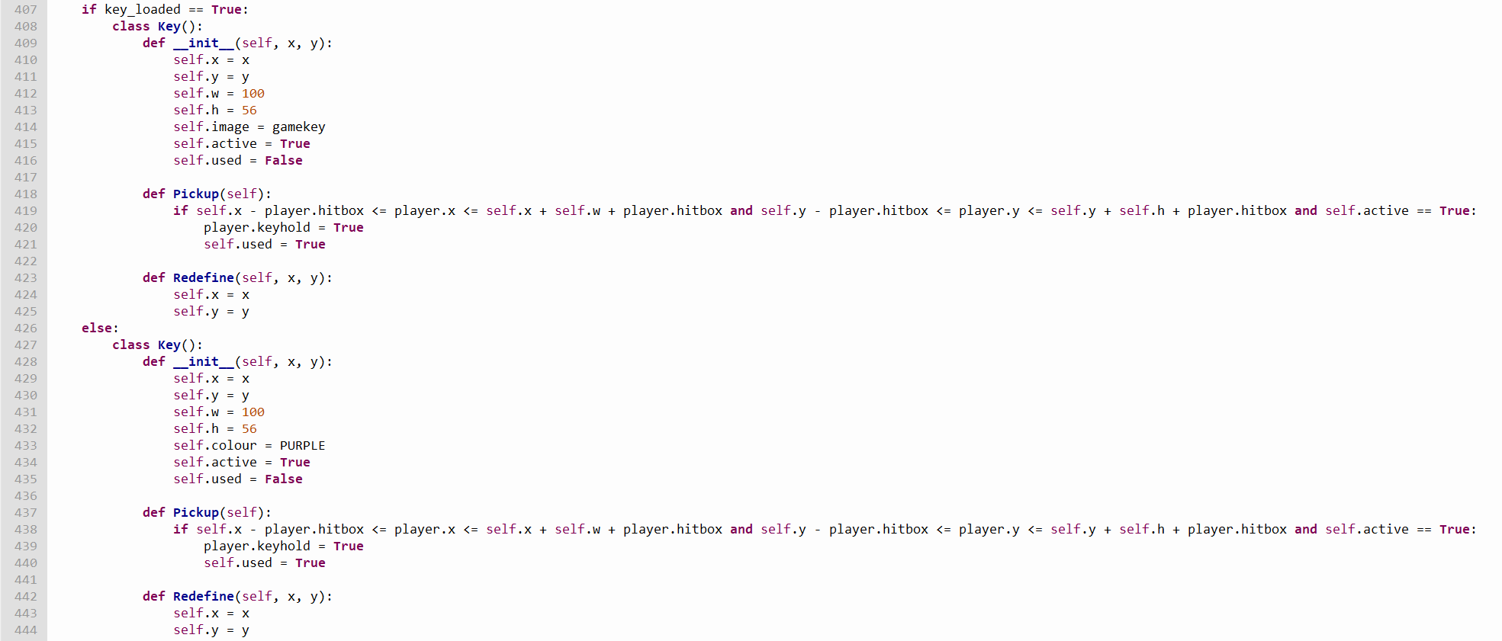Following from the results in test 2, I’ve implemented an error handling method which will replace the key image with a purple square if the player doesn’t have the key image downloaded or stored in the same file location as the program:

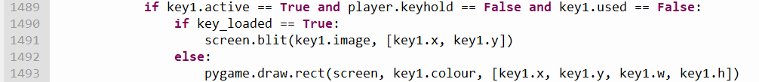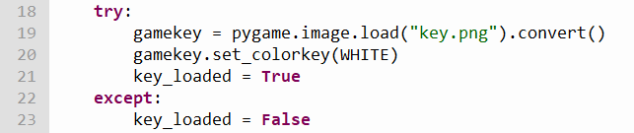*(the *used* attribute is explained later in the section, along with the reason why there is more than one *Key* object now.)

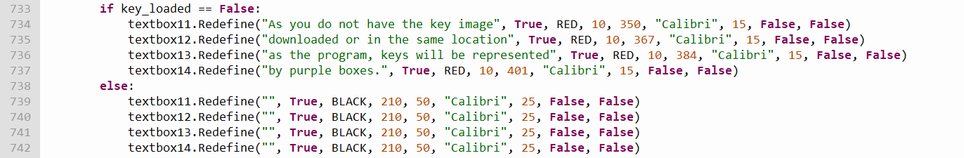I’ve also created more *Textbox* objects so the program can inform the player that they don’t have this image downloaded when they reach the first room with a key inside:

The purple rectangles used to replace the key image may look bigger than they should be, however this is because they have the same dimensions as the key image (which has a transparent background, meaning that you wouldn’t notice the image overlapping the ground where the rectangle does). This is to ensure that the player’s experience is the same regardless of whether they have the key image downloaded or not.

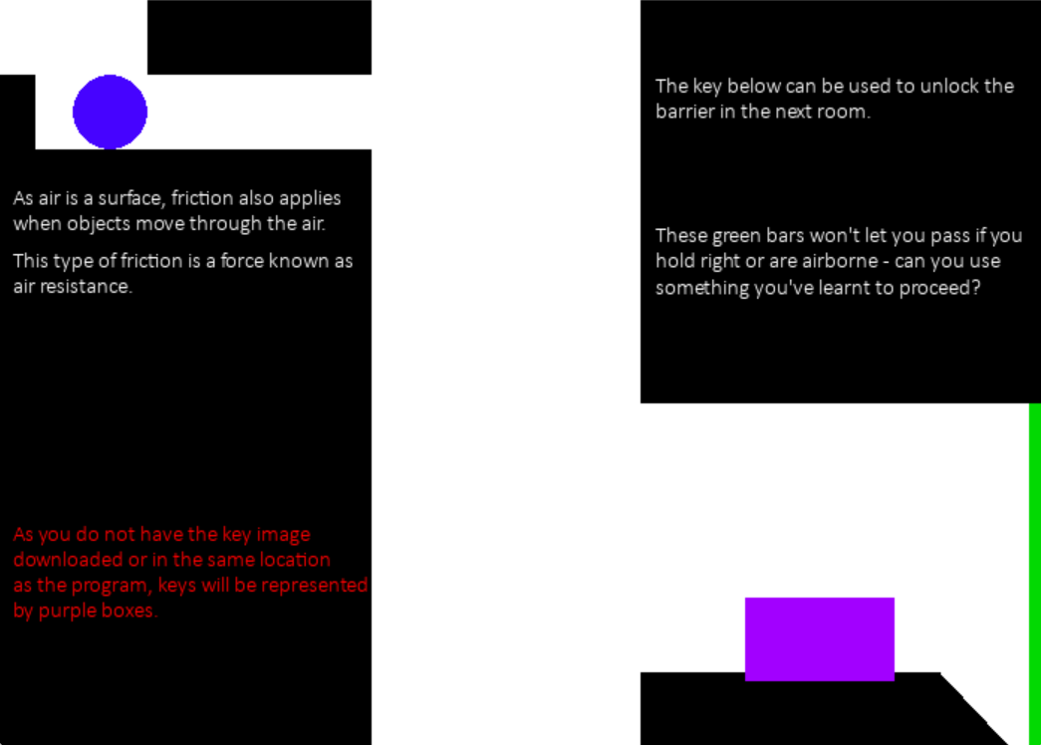cAfter concluding test 3, I realised that if the player left a room with a locked barrier after unlocking it, upon re-entering the room the barrier would be locked again. Thinking that this would be unfair on players, I decided to make it so locked barriers will remain unlocked after the player has unlocked them, but to counter this each key can only be picked up and used once. To make this work, I had to make *Key* and *Lock* objects for each key and locked barrier in the game, and had to change the attributes and methods of both classes. The changes to the *Key* class can be seen below:

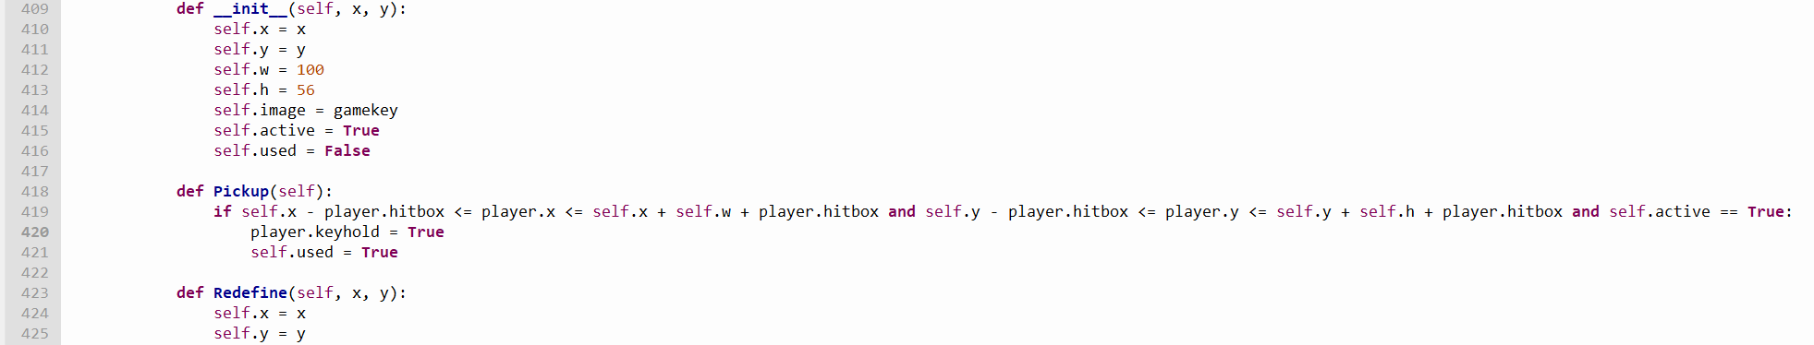The *used* attribute will stop a key object from being drawn on the screen if the player has already picked it up.

In order to make it so locked barriers wouldn’t re-lock themselves if the player left a room with one in after unlocking it, I removed the part of the class’s *Redefine* method which resets the value of its *locked* attribute:

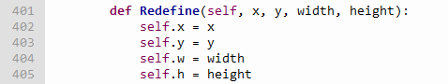

As a side effect of changing these classes, I had to rework the method which draws room 14 so the room would continue to look how it does when the player has grabbed the key inside it should they decide to re-enter it. This in turn caused me to have to change the *Redefine* method in the *Hazard* class, removing the *sp* attribute from it and instead just redefining the attribute outside of the method whenever it needed to be changed:

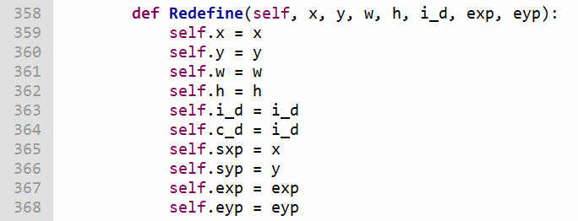

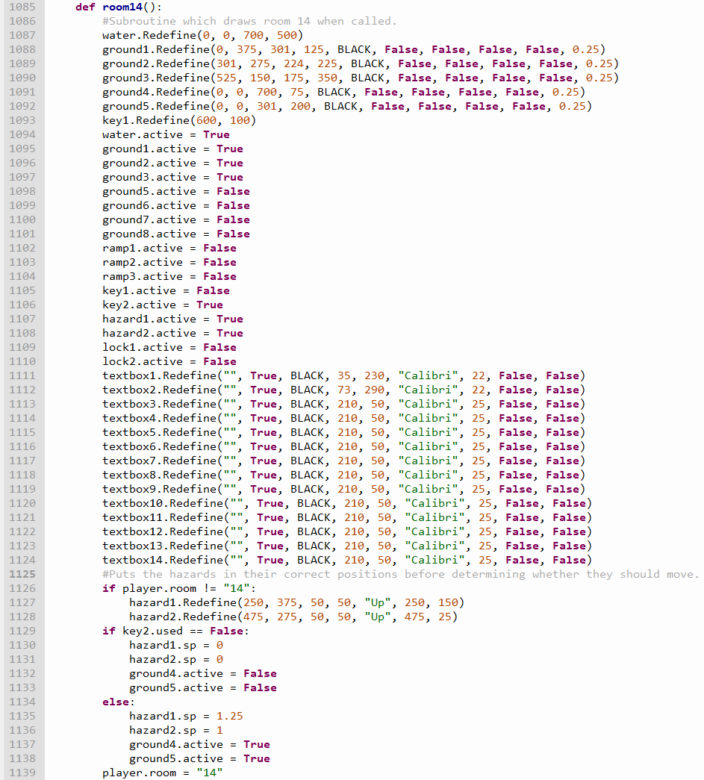

This then caused one of the hazards in room 14 to move outside of its set range when returning to its starting point, so I had to change the code in the *BoundaryCheck* method to accommodate this:

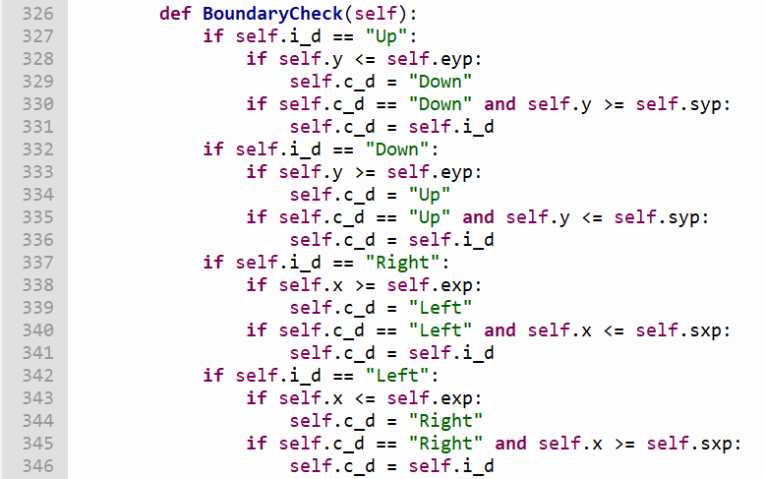

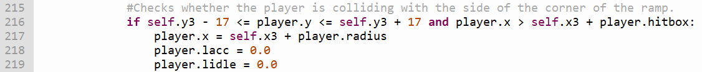Conducting test 6 made me realise I hadn’t accounted for what would happen if the player collided with the side of a ramp instead of its hypotenuse, so I added to the *RampCollision* method with the following code. The first screenshot corresponds to code which handles collisions with the side of the ramp for ramps with an incline that ascends to the left, whereas the second screenshot corresponds to code which handles collisions with the side of the ramp for ramps with an incline that ascends to the right:

Test 7’s results indicate that while the program works when run using certain methods (e.g. Thonny’s interpreter, IDLE’s interpreter), it doesn’t when run using others (e.g. Visual Studio Code’s interpreter, running the game directly through Python). I think this is because the latter methods cannot load the pygame library, so this isn’t something that I’m going to worry about trying to fix.

After doing test 8, I decided to add some code which prevents the player from moving at all if they press movement keys which act in opposing directions at the same time. This selection statement will only affect the player if both keys are pressed at the exact same time – otherwise the player will just move in the direction allocated to the key they press first, and the other key will have no effect until the player becomes stationary again.

Test 9 made me realise that if the player somehow moves past the left and right screen borders in room 21, they would not only not be able to return to the screen, but would also not be able to restart the game without closing its window (since the game only detects inputs from the player while they’re on the ground, and they therefore can’t reset the game using the Space Bar if they fall off said ground). Although I don’t think the player would be able to gain the speed necessary to do so before entering the room while playing the game, in order to make sure I’ve prepared for all possible situations I made the game reset all of the player’s acceleration attributes when they enter room 21 (and while I was doing so, made the game reset all of the player’s acceleration attributes whenever they move between rooms in the quiz portion of the game):

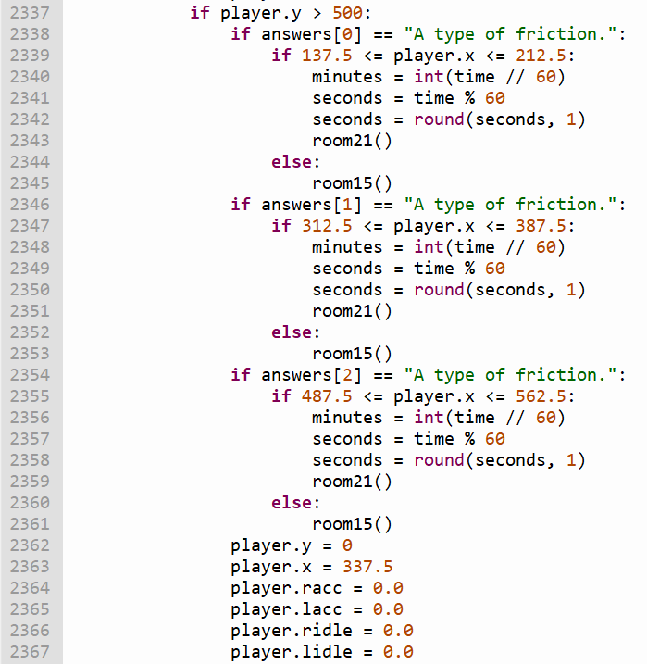

# Evaluation

## Self-Evaluation

|  |  |  |  |
| --- | --- | --- | --- |
| Main Objective | Secondary Objectives | Performance Criteria | Evaluation |
| Create a ball which the player can control. | Allow the player to make the ball move left with the left arrow key or A and make the ball move right with the right arrow key or D. | The ball should accelerate when the player holds one of the movement keys until it reaches its top speed (at which point it should continuously move at that speed), and when the player lets go of that movement key the ball should gradually decelerate until it comes to a stop.  Additionally, the ground in the level should apply friction to the ball, decreasing its rate of acceleration and rate of deceleration along with its top speed. | This objective has been fully completed.  Additionally, the player can only move in one direction at a time – this means that if they were moving left and wanted to move right, holding either of the right movement keys wouldn’t do anything until the ball had come to a stop once they’d let go of the left movement key.  In the context of the game, the movement keys add a force to the ball which makes it move, and therefore after further thought I believe I should’ve also made the ball decelerate faster than it normally would if the player holds a movement key which would make the ball move in the opposite direction to the one it was moving in before decelerating. |
|  | Allow the player to make the ball jump with the Space Bar, and make the ball accelerate toward the ground whenever it is midair. | The player should only be allowed to jump while they are on the ground, and shouldn’t be able to jump multiple times in succession by holding the Space Bar.  If the player was moving to the left or right before jumping, they should keep their current momentum, but should also gradually slow down while midair (representing the effects of air resistance).  Furthermore, their vertical speed should stop increasing once it reaches a certain value (representing the ball’s terminal velocity). | This objective has been fully completed. |
| Create a level in which the player descends from its top to its bottom, with wide horizontal sections to create variety such that the vertical platforming doesn’t get repetitive. The horizontal sections will also make it much easier to design a fun and interesting level while demonstrating the chosen elements of physics to students. | Split the level up into various rooms, with each room being connected to each other through off-screen points which, if the player comes into contact with them, will cause the room currently being displayed to change. The player’s coordinates should be updated when they touch these points so they start on the opposite side of the screen to the one they just left (e.g. if they leave a room from the right side of the screen, they should start the following room on the left side of the screen). | Create subroutines containing each of the game’s rooms, running the one which corresponds to the room the player should be going to whenever they leave the screen in the room they’re currently in and updating their coordinates accordingly.  Each room should have different conditions so they can display each force implemented into the game throughout its duration. The first few rooms should be plainly designed so the player can see how the extra elements in the later rooms change how the forces affect the player’s movement. | This objective has been fully completed.  In addition to what’s listed in the objective, I’ve also created an error handling method which will move the player back to the point they started the room from if they pass through a screen border they weren’t supposed to be able to access. |
|  | Create keys and barriers. Barriers should only allow the player to pass through them if the player is holding a key, and the game should remove said key from the player’s inventory when the player comes into contact with them. |  | This objective has been fully completed. |
|  | Add hazards which if touched, force the player to restart the room they're currently in from the point they started the room from. | There should be hazards with set movement patterns (e.g. up and down, back and forth) as well as stationary ones. | This objective has been fully completed.  In order to make one section in the game’s level easier, I added a checkpoint which, if the player passes it, will be where they will be moved to when they collide with a hazard in that room. |
|  | Create different kinds of terrain. As a general principle, terrain shouldn’t allow the player to pass through it, and should reset the player’s acceleration in the direction they were moving should they collide with the terrain as a result of said acceleration. | Regular terrain should set a standard for friction.  Ice terrain should have lower friction than regular terrain, giving the ball a decreased rate of acceleration and deceleration along with a lower top speed.  Additionally, each collision algorithm for the terrain’s sides should have the ability to be deactivated, allowing the player to pass straight through the terrain from that side.  Create ramps which affect the ball’s movement while it is travelling along their slope by slowly pulling it towards the ramp’s bottom when the player isn’t moving it themselves. Ramps should also allow the ball to move more quickly down their slope and more slowly up their slope. These features represent the effects of gravity while the ball is on an incline. | This objective has been fully completed. |
|  | Add water as a different substance for the ball to travel through. Water should increase the effect of resistant forces in both x-axis directions (representing the effects of air resistance), however it should also slow the ball’s descent while midair and allow for the ball to jump higher (representing the effects of buoyancy on the ball). |  | This objective has been fully completed. |
| Create a text box system which can be used to explain the game’s mechanics along with the forces showcased in each room. |  | The text boxes should offer explanations which are brief enough to make them fit on the screen and easy to read without being so brief that the player can’t understand the concepts being explained. | This objective has been fully completed. |
| Create a title screen which will allow the player to start the game. |  |  | This objective has been fully completed. |
| Create a quiz which will test the player on the material they’ve learnt after they complete the level portion of the game, allowing them to progress each time they answer a question correctly. |  |  | This objective has been fully completed. |
| Create a stopwatch which records how long the player takes to complete the game each time they play it, showing this time to them when they complete it. |  |  | This objective has been fully completed. When the player enters the final room of the game, they are shown the amount of time they took to complete both the level and the quiz in minutes and seconds. This timer will stop increasing once it reaches 99 minutes and 59 seconds to ensure that it can fit on the screen. |
| Create a pause menu which will allow the player to restart the level. |  |  | This objective has not been achieved. I decided to prioritise other objectives in my set of ones which I could complete if I had time, and as a result I never implemented this into the game. |
| Create a local leaderboard which stores the player’s best times for completing the level. |  | This leaderboard should be stored in a database which updates every time the level is cleared, and the game should require the player to enter their initials when they complete it so they can identify their time on the database. | This objective has not been met for the same reasons as the one above. |
| Create an options menu which allows the player to change the resolution of the game’s display window. This options menu could be accessed from the title screen or the pause menu. |  |  | This objective has not been met for the same reasons as the one above. |

## Independent Feedback

To determine whether the project was successful and what I could do to make it better, I had three Year 10 students at my school who take Physics as a GSCE play the game twice (once as if they were playing the game to learn from it, then again as if they were trying to complete it as quickly as possible) and answer the following set of questions after they’d finished playing the game. As with the interviews, each bullet point corresponds to a set of answers (e.g. i. refers to the first answer set):

1. Did you learn something that you didn’t know before from the game? If so, did the visual representation of the forces help you to understand what you learnt?
   1. Yes, I learned what buoyancy was.
   2. I didn't learn anything new in a sense, but I realised that jumping in video games is often portrayed inaccurately since in this game, trying to move while airborne doesn’t do anything.
   3. I didn't learn anything new, but the game helped me recall the things I did know. The visual representations helped a lot, as they are easier to understand than a block of text.
2. Was the game fun to play? If not, what do you think would’ve made it more enjoyable?
   1. Yes.
   2. I think it was quite fun. The only thing I would change is to use less text - as a player, I observed I didn't really read it that thoroughly. I would make the text more concise and let the player figure out how each mechanic related to the physics works, or don't include any text at all and instead make the puzzles based on the players prior understanding to physics and experimentation with things they don’t know.
   3. Yes.
3. Did you think that The text boxes introduced the forces in a way that was easy to understand while still being sufficiently detailed? If not, how could their explanations be improved?
   1. The text boxes were easy to understand, but I believe that they could be made larger in some areas.
   2. Previously mentioned in the last answer, I think that the game introducing the mechanics by itself worked fine, and in my opinion the explanations weren't very necessary to help with understanding the physics. If there had to be text boxes, I would make them shorter, possibly only providing clues to the player.
   3. They were definitely sufficiently detailed, and were always in a colour which made them easy to read.
4. Do you think any parts of the level’s design could be improved?
   1. I believe the ball is slightly too large in some areas.
   2. I think the quiz section could be done in a more creative way. Instead of jumping through holes to answer questions, perhaps the player could be presented with platforming puzzles which require knowledge previously taught in the game.
   3. I think that some of the rooms could be made less difficult.
5. If you got an answer on the quiz wrong, did redoing the questions before that question help to reinforce your learning?
   1. Yes.
   2. I don't think so, since I often found that questions I got right first try felt a little tedious to get through again, especially when I accidentally fell into a wrong hole.
   3. Yes.
6. Did you experience any bugs during your playtime?
   1. The range at which something was considered to be colliding with the ball is too large, making the ball look like it’s floating when it was positioned on the edge of a block of ground.
   2. Yes, as a result of playing the game again after someone else had done so, a piece of text before the quiz section had appeared when it wasn't meant to.
   3. No.
7. If you replayed the game to see if you could complete it in a faster time, did this help to reinforce your understanding of the forces?
   1. Yes, as there is some level of application required for completing the game quickly (e.g. the green barrier only lets you through if you aren’t midair or moving, so you can’t just hold right to run past it unlike many other obstacles in other platforming games).
   2. I don’t think so, because I had already gotten accustomed to the physics on my first playthrough, so the second time round I wasn’t learning anything new.
   3. Not really – although this was fun, it distracted me from the actual learning.

## Feedback Analysis

Looking at the feedback I’ve obtained, I believe I was successful in making the game an enjoyable experience, as all three students had positive things to say in that regard. Though, if I were to make such a game again, I would include more puzzles which require the player to use knowledge they’ve obtained from playing the game and reading The text boxes as suggested by student ii.

Although I don’t think the game is too difficult as is, this may be because I’ve been playing these types of games since I was a kid, and to someone who’s never played this genre of game before (like student iii) the game may be too challenging. Although I think it’s too late to make the game easier (since this would require redesigning certain sections and this feedback has been collected using what is more or less the final product), if I did have more time to work on the project this is an issue I would consider acting on. Similarly, I think the alternative method of testing the player suggested by student ii would be more effective than the one I’ve implemented and, given more time, is something I would implement, however this would require the quiz section to be remade from the ground up (which I don’t have time to do).

Although the quiz’s design does run the risk of being frustrating if the player keeps getting answers wrong (intentionally and unintentionally), I still think its general design is good, as this repetition helps to reinforce the player’s learning and the danger of having to redo certain questions if they get an answer wrong ensures that they are always paying attention. That being said, if I were to keep the quiz’s general structure the way it is, I would redesign it so there are bridges connecting the holes to each other, and make it so the player can only fall through said bridges if they jump while on top of them. This would ensure that the player cannot accidentally choose an answer for a question.

As for the bugs mentioned, the ball appearing to float when positioned at the edge of terrain is actually intentional, as Pygame draws circles by drawing them inside of transparent squares. Creating a collision algorithm which works with a circular boundary would require a lot of time and thought, so I decided to program the player’s collision as I have done so I could focus on the rest of the game. The issue involving the text at the beginning of the quiz section was caused by the variable which determines the text that’ll be displayed in that room not being reset to its initial value when the player restarts the game after completing it, and has since been fixed. The reception to being encouraged to finish the game as quickly as possible has been mixed, with one student saying that it helped to reinforce their understanding, another saying it had no effect, and another saying it took their attention away from the physics. I think the best way to solve this issue would be to have more puzzles throughout the level which require you to understand the physics at play to complete them (like the green barrier student i mentioned), forcing you to actively think about the forces in order to get the fastest time possible. That being said, this is a solution which will remain hypothetical since I would not be able to do this in time for the project’s deadline.

